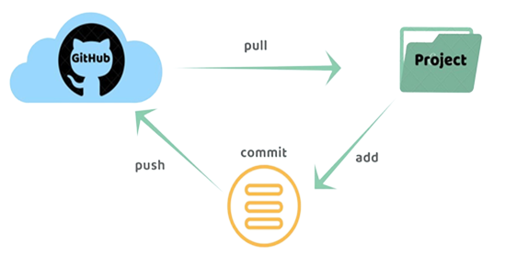

**GitHub push pull**

**Contents**

**Raising request on service central** 3

**Create Token** 7

**Create Repository** 12

Create .**gitignore** file 14

Create **Issue** 16

Create **Milestone** 17

Owner add collaborator in repository 19

Owner assign task to collaborator 21

**Add GitHub repository in Eclipse** 22

**Create Maven Project** 26

**Collaborators access the Owner task** 35

**Owner pull the code** 43

# **Raising request on service central**

You can use your existing GitHub account with GitHub organization managed by Capgemini.

This will help you to create and manage private repositories withing GitHub organization.

***Creation of public GitHub repositories on GitHub is not allowed.***

***You should not use them in Capgemini network.***

Please raise new request using below [link](https://servicecentral.capgemini.com/sc?id=sc_cat_item&sys_id=a84e818edbfe24107b72043bd396196e)..

<https://servicecentral.capgemini.com/sc?id=sc_cat_item&sys_id=a84e818edbfe24107b72043bd396196e>

**Requested for**: please enter your CG email id

Please refer screenshot for details

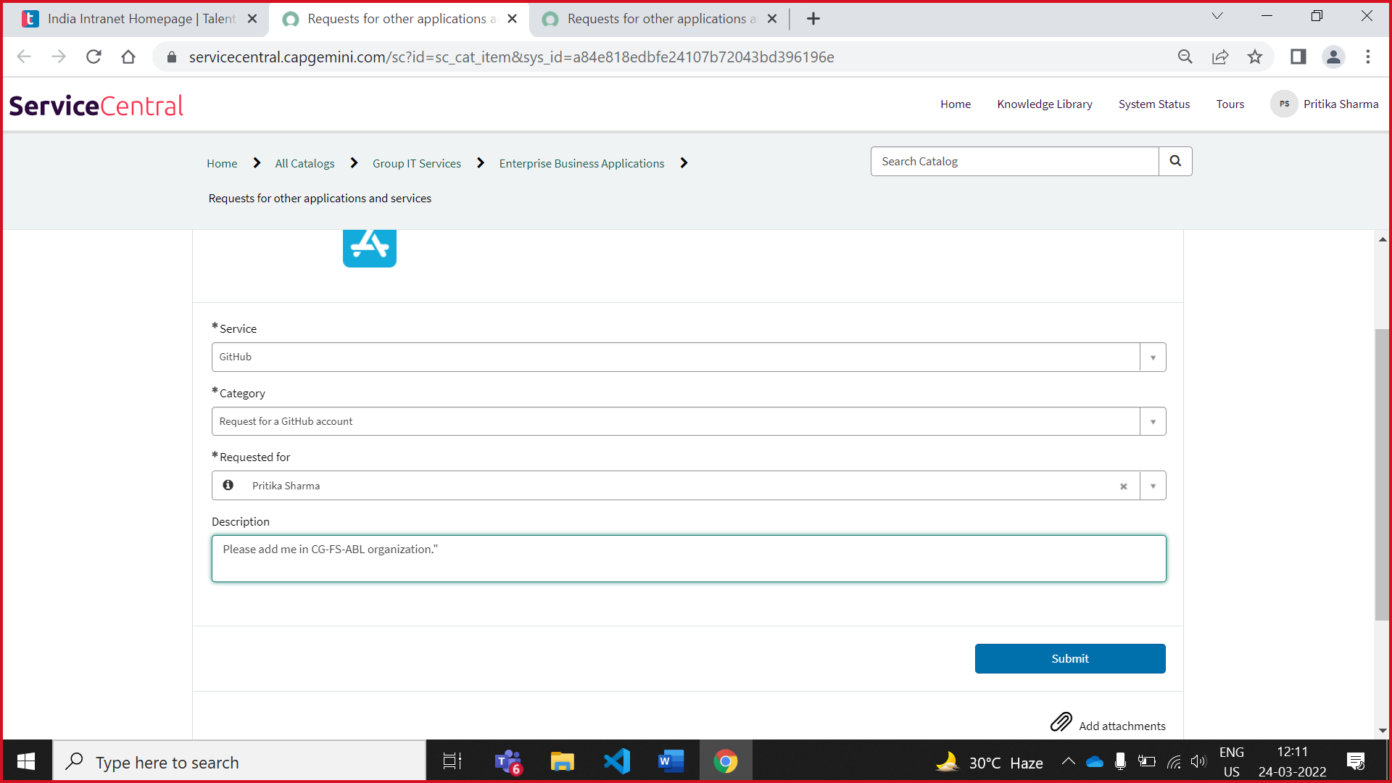

NOTE: All your GitHub org related queries should be sent to **github.support@capgemini.com**

After Raising ticket, it takes 2-4 days to add you in CG-FS-ABL organisation.

After that, you received below mail

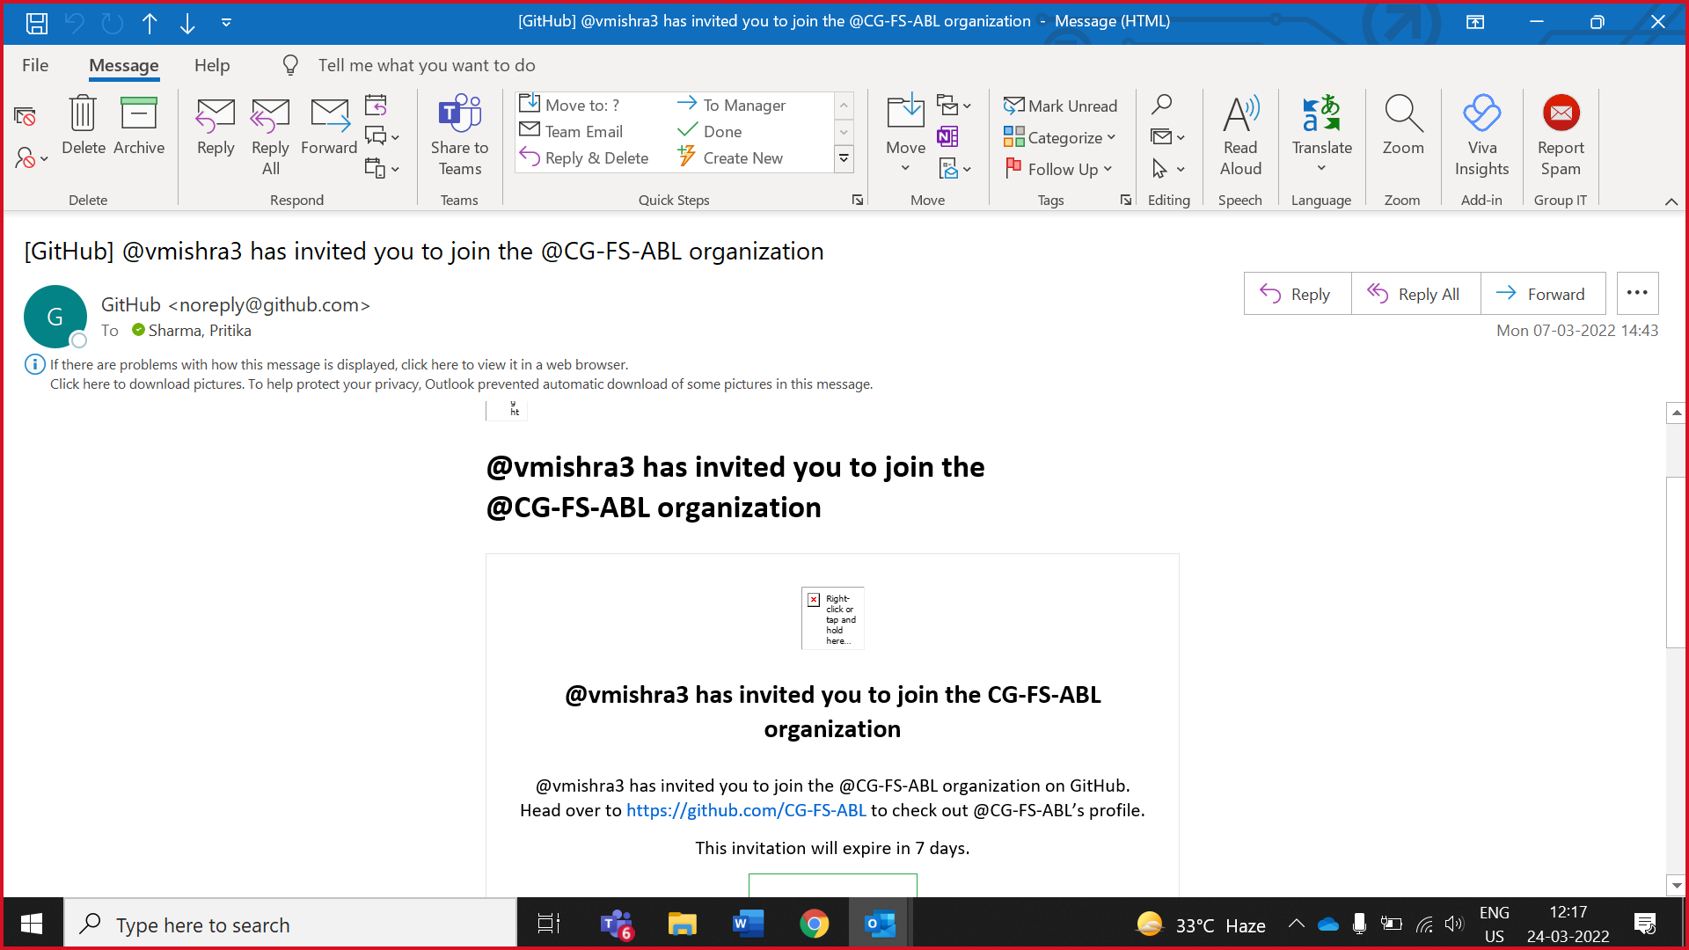

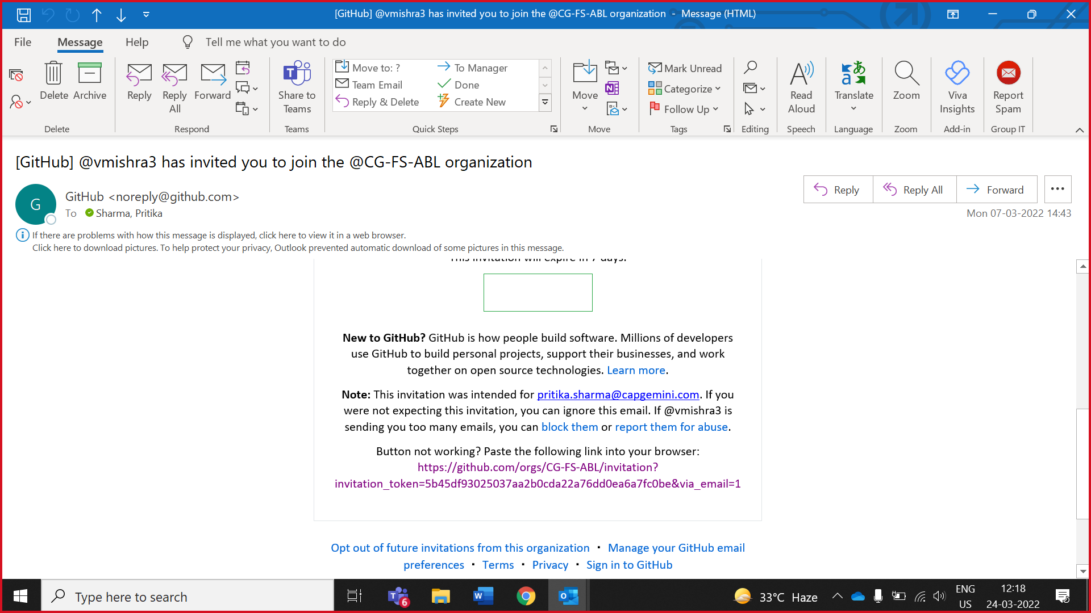

Click on that link

After click on received link need to need continue with capgemini service

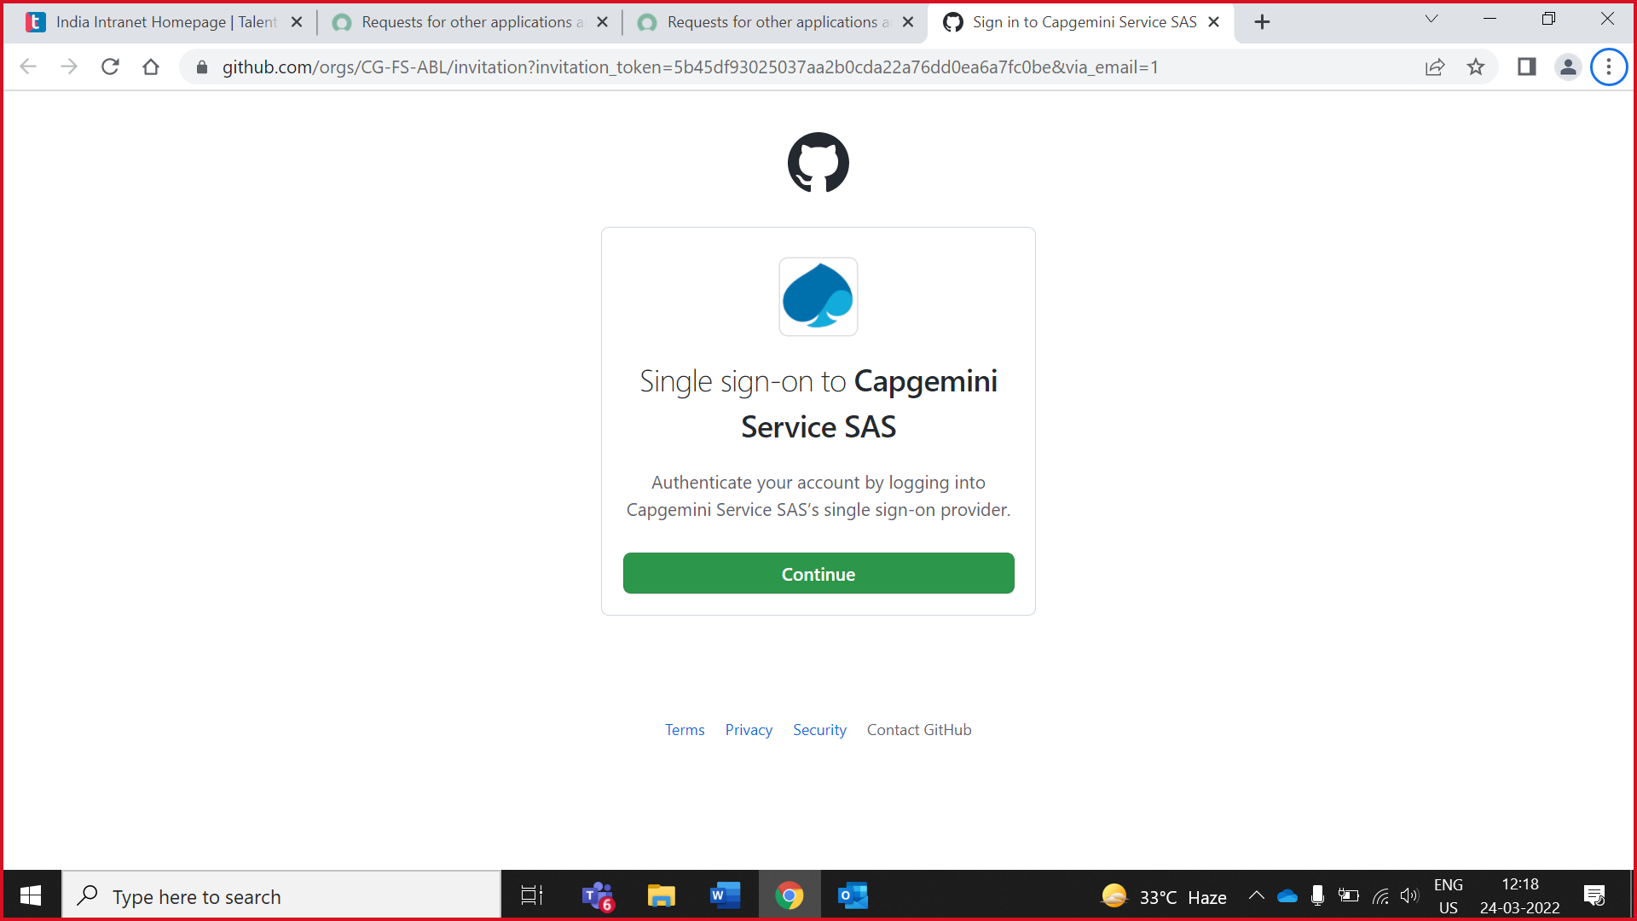

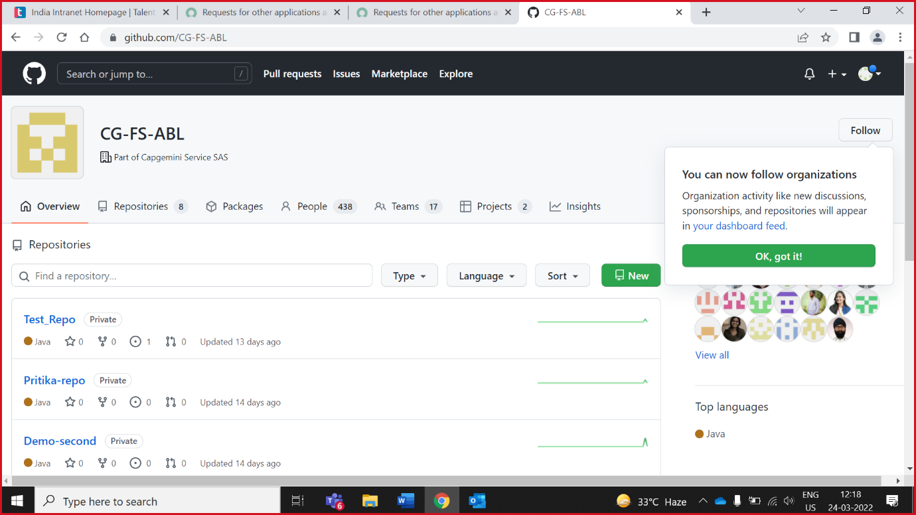

Goto your profile and check *your organisation* option is available.If that option is available you succesfully added if not you need to re-login or contact to [**github.support@capgemini.com**](mailto:github.support@capgemini.com)mail-id.

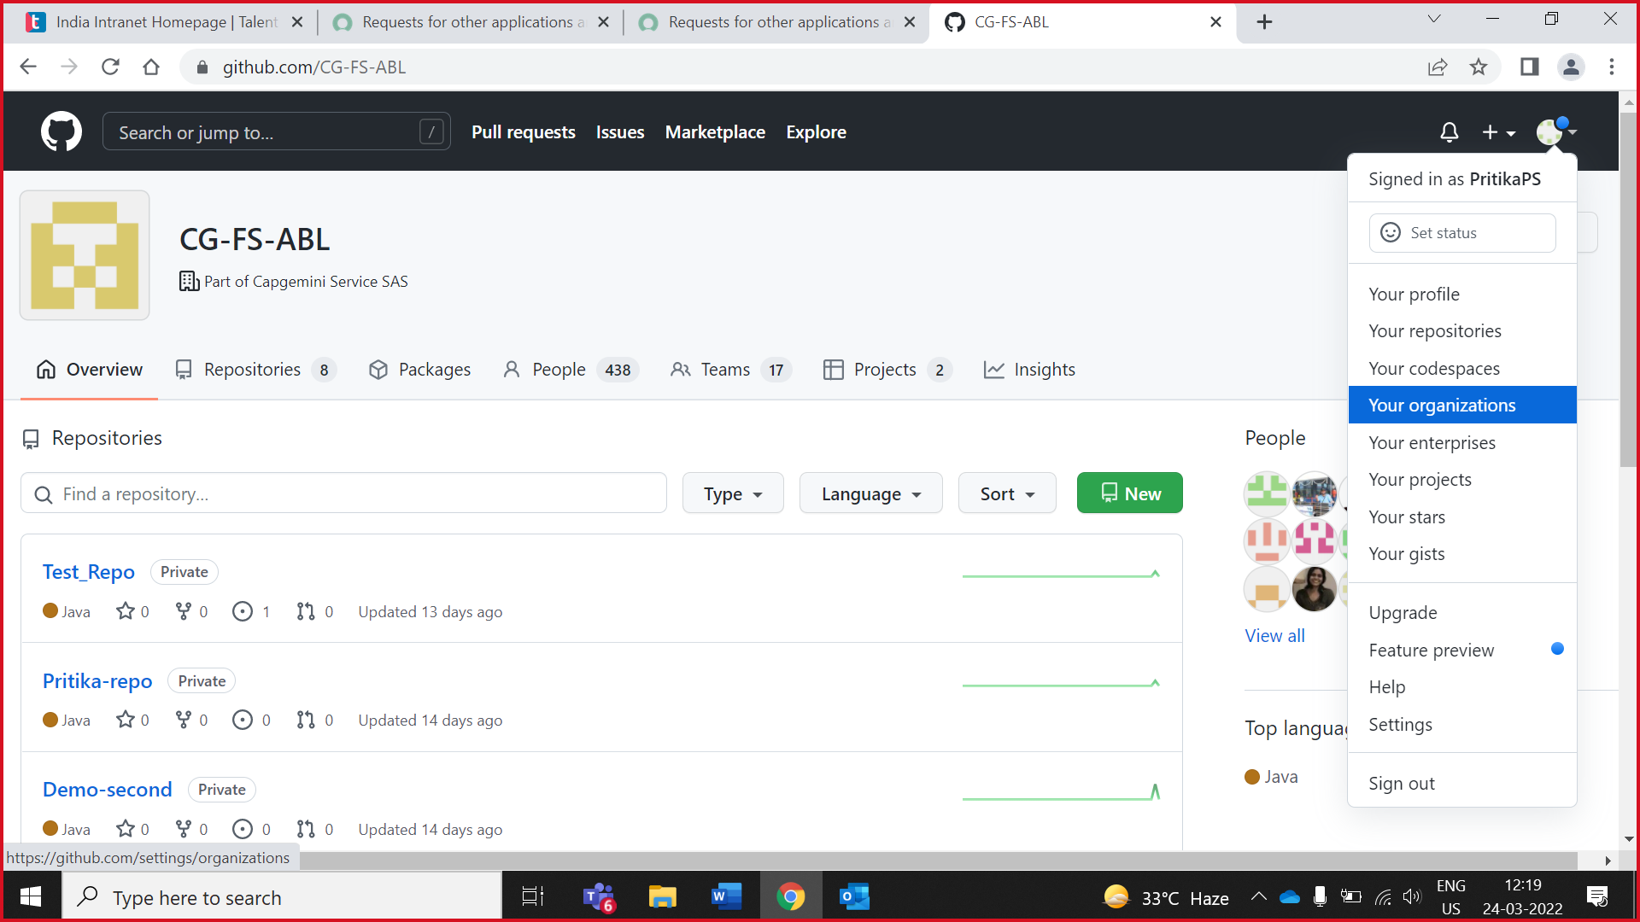

# **Create Token**

1. Click on you profile goto **settings**

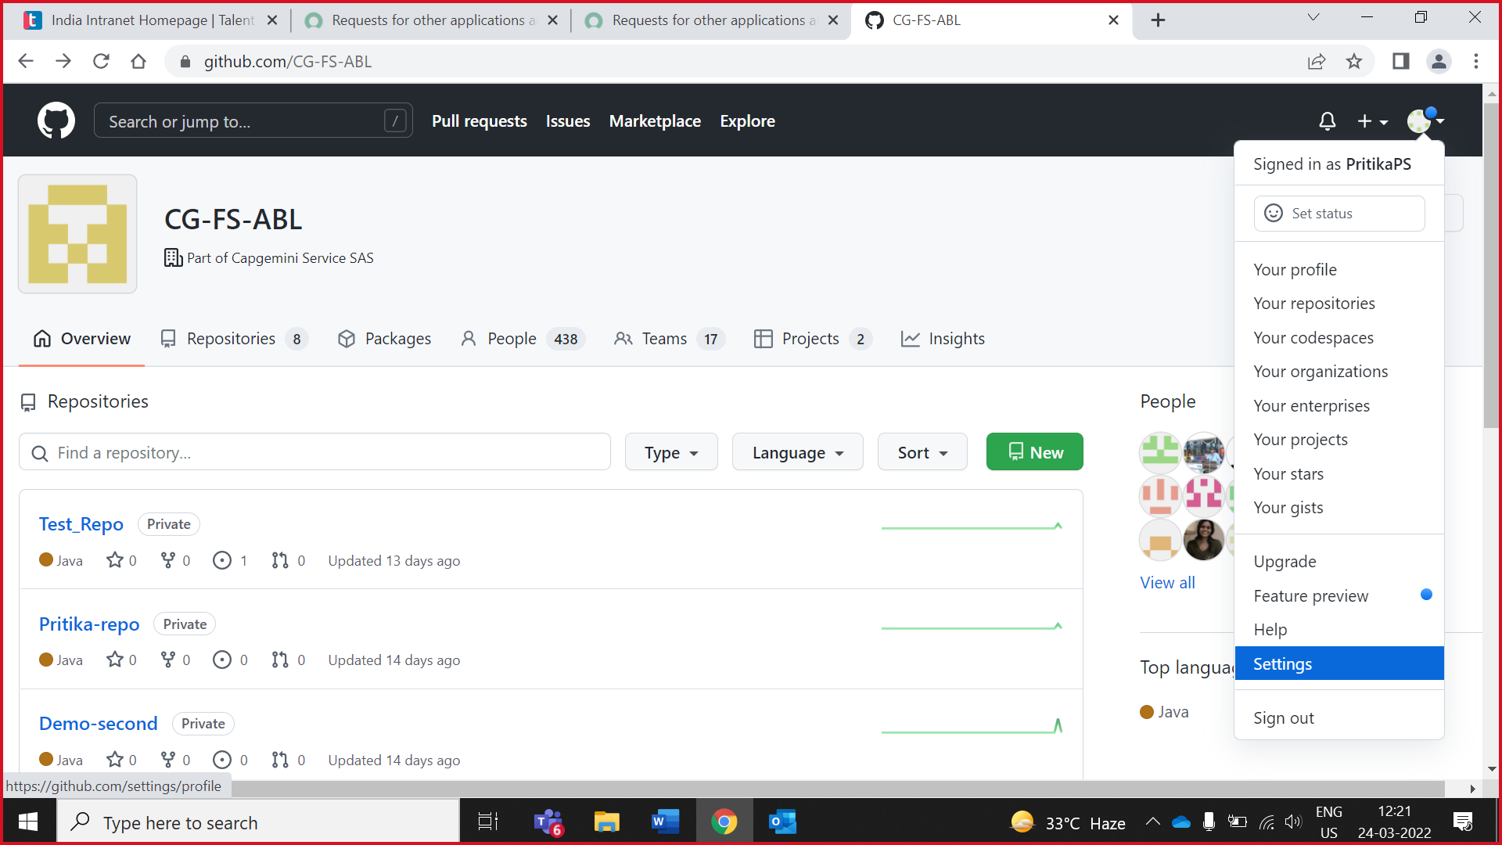

2. Scroll down and click on **Developer settings**

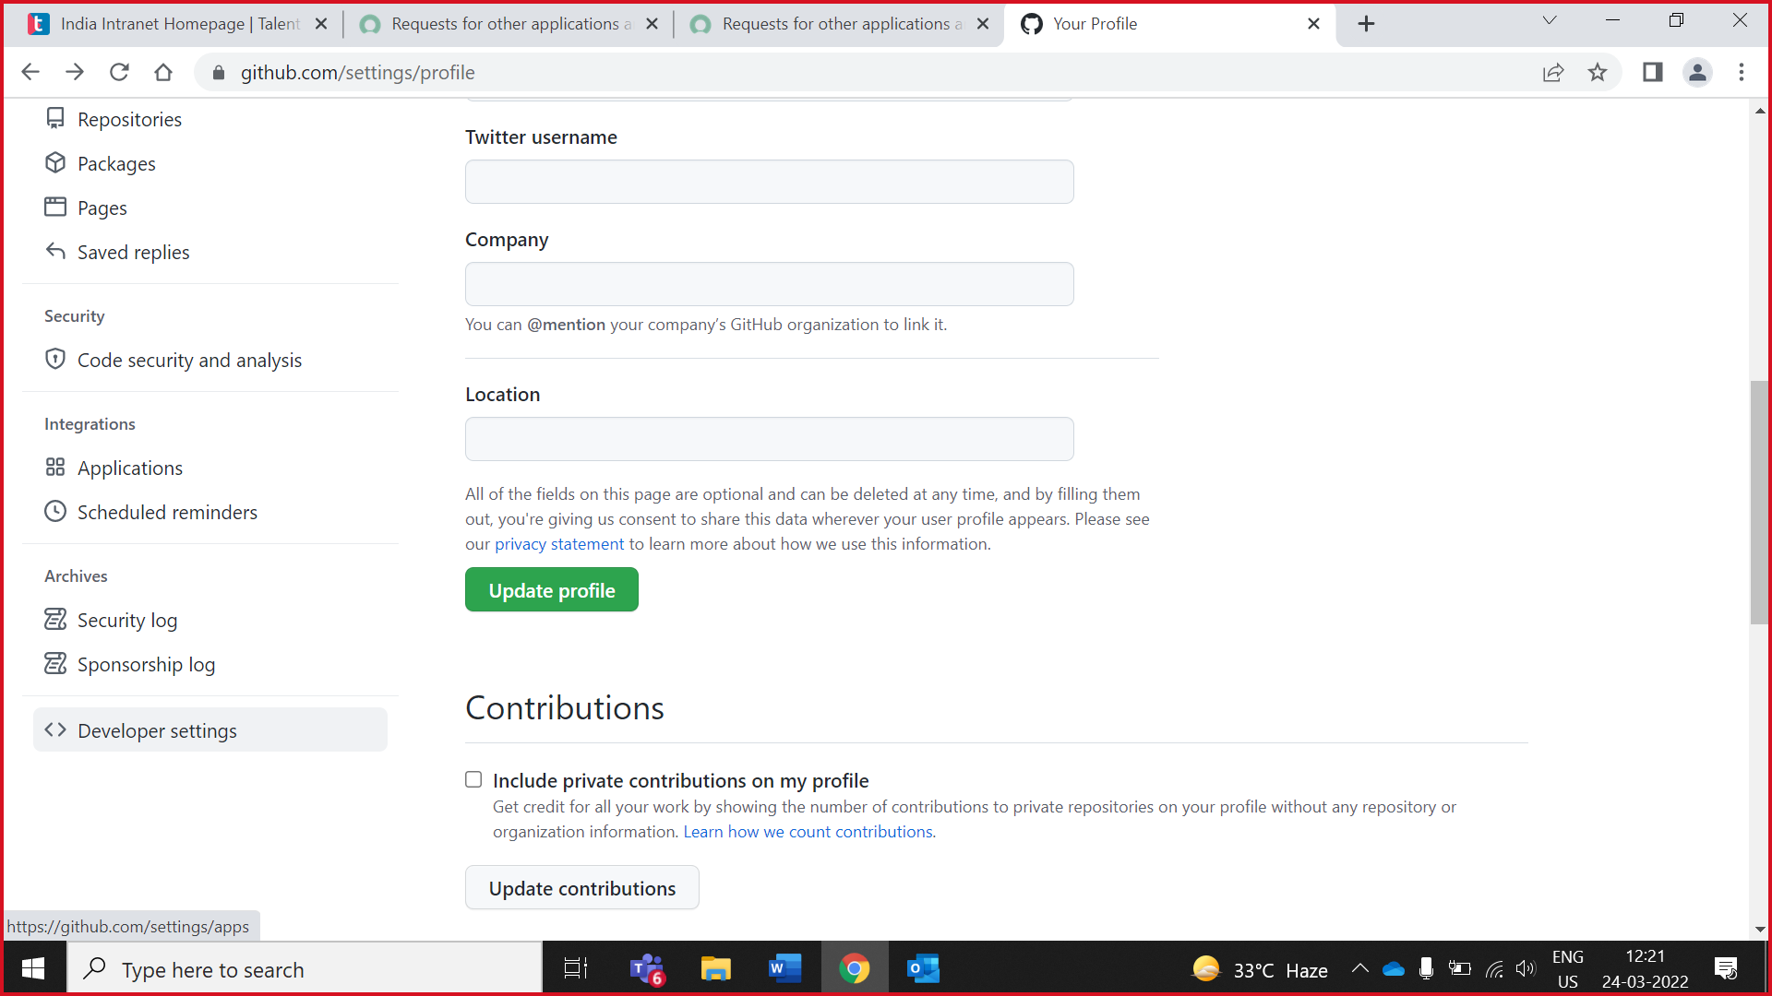

3. Click on **Personal access tokens**

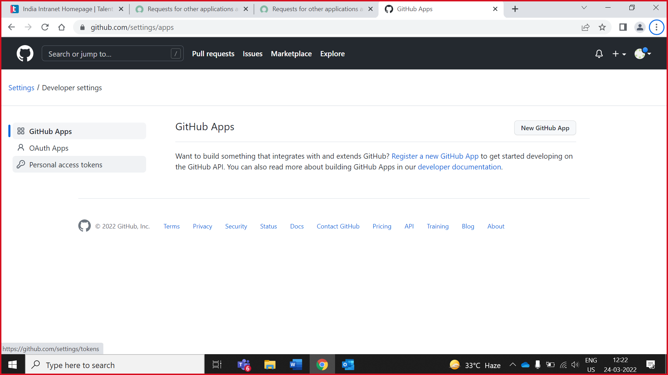

4. Click on **Generate new token**

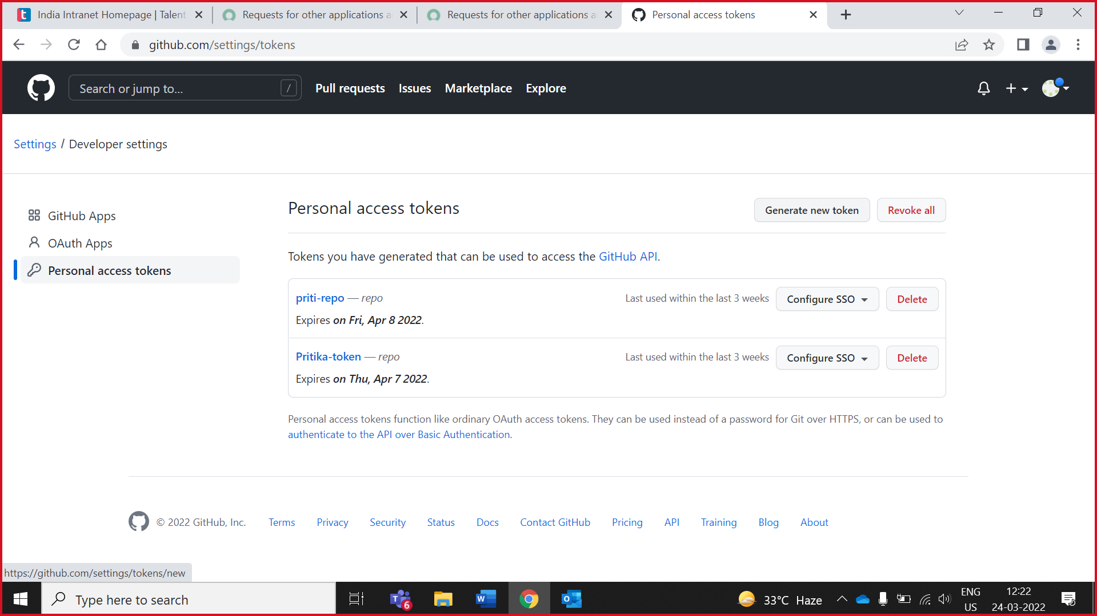

5. Enter you github account **password**

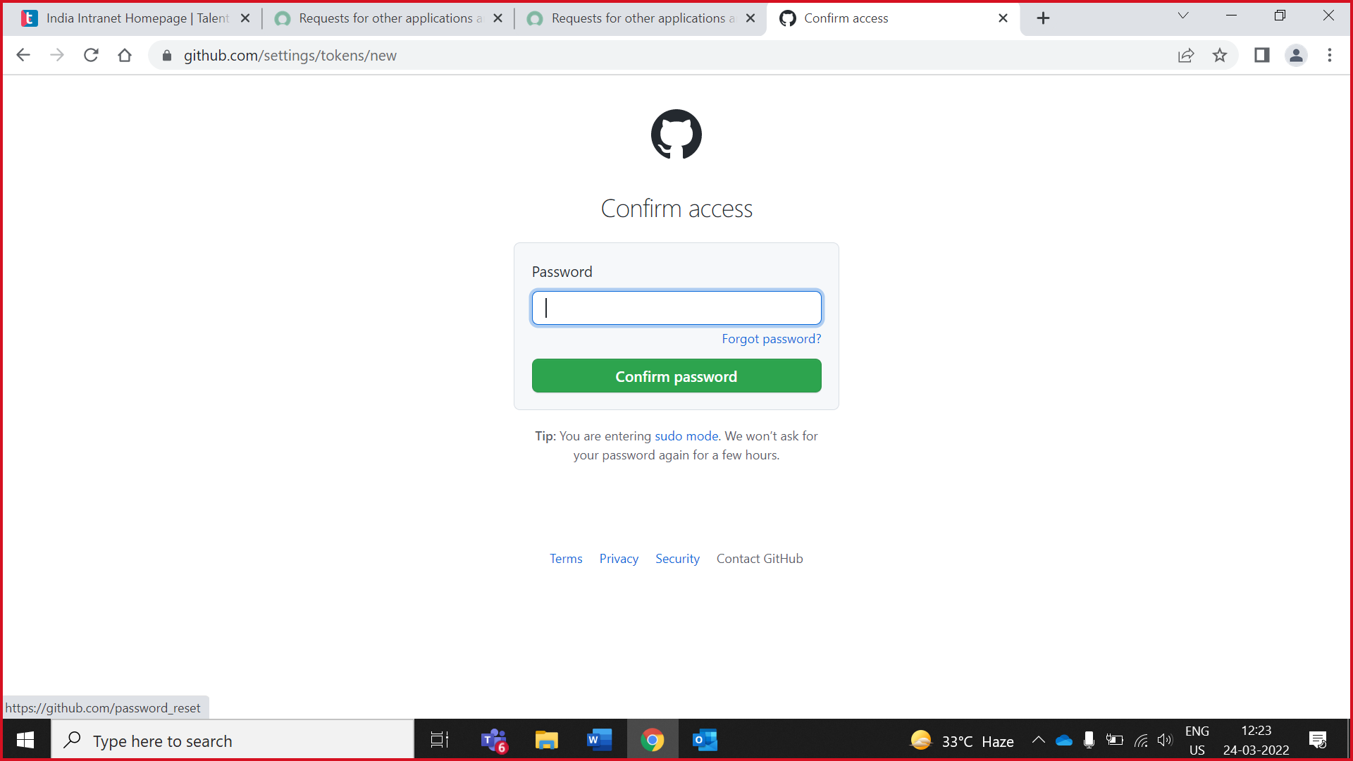

6. Give the unique token name and check the repo checkbox

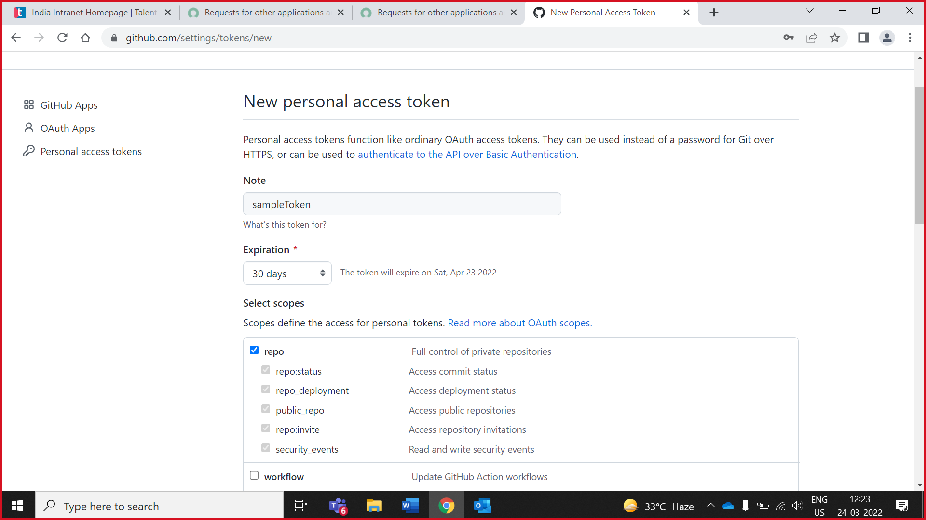

7. scroll down and click on **generate token**

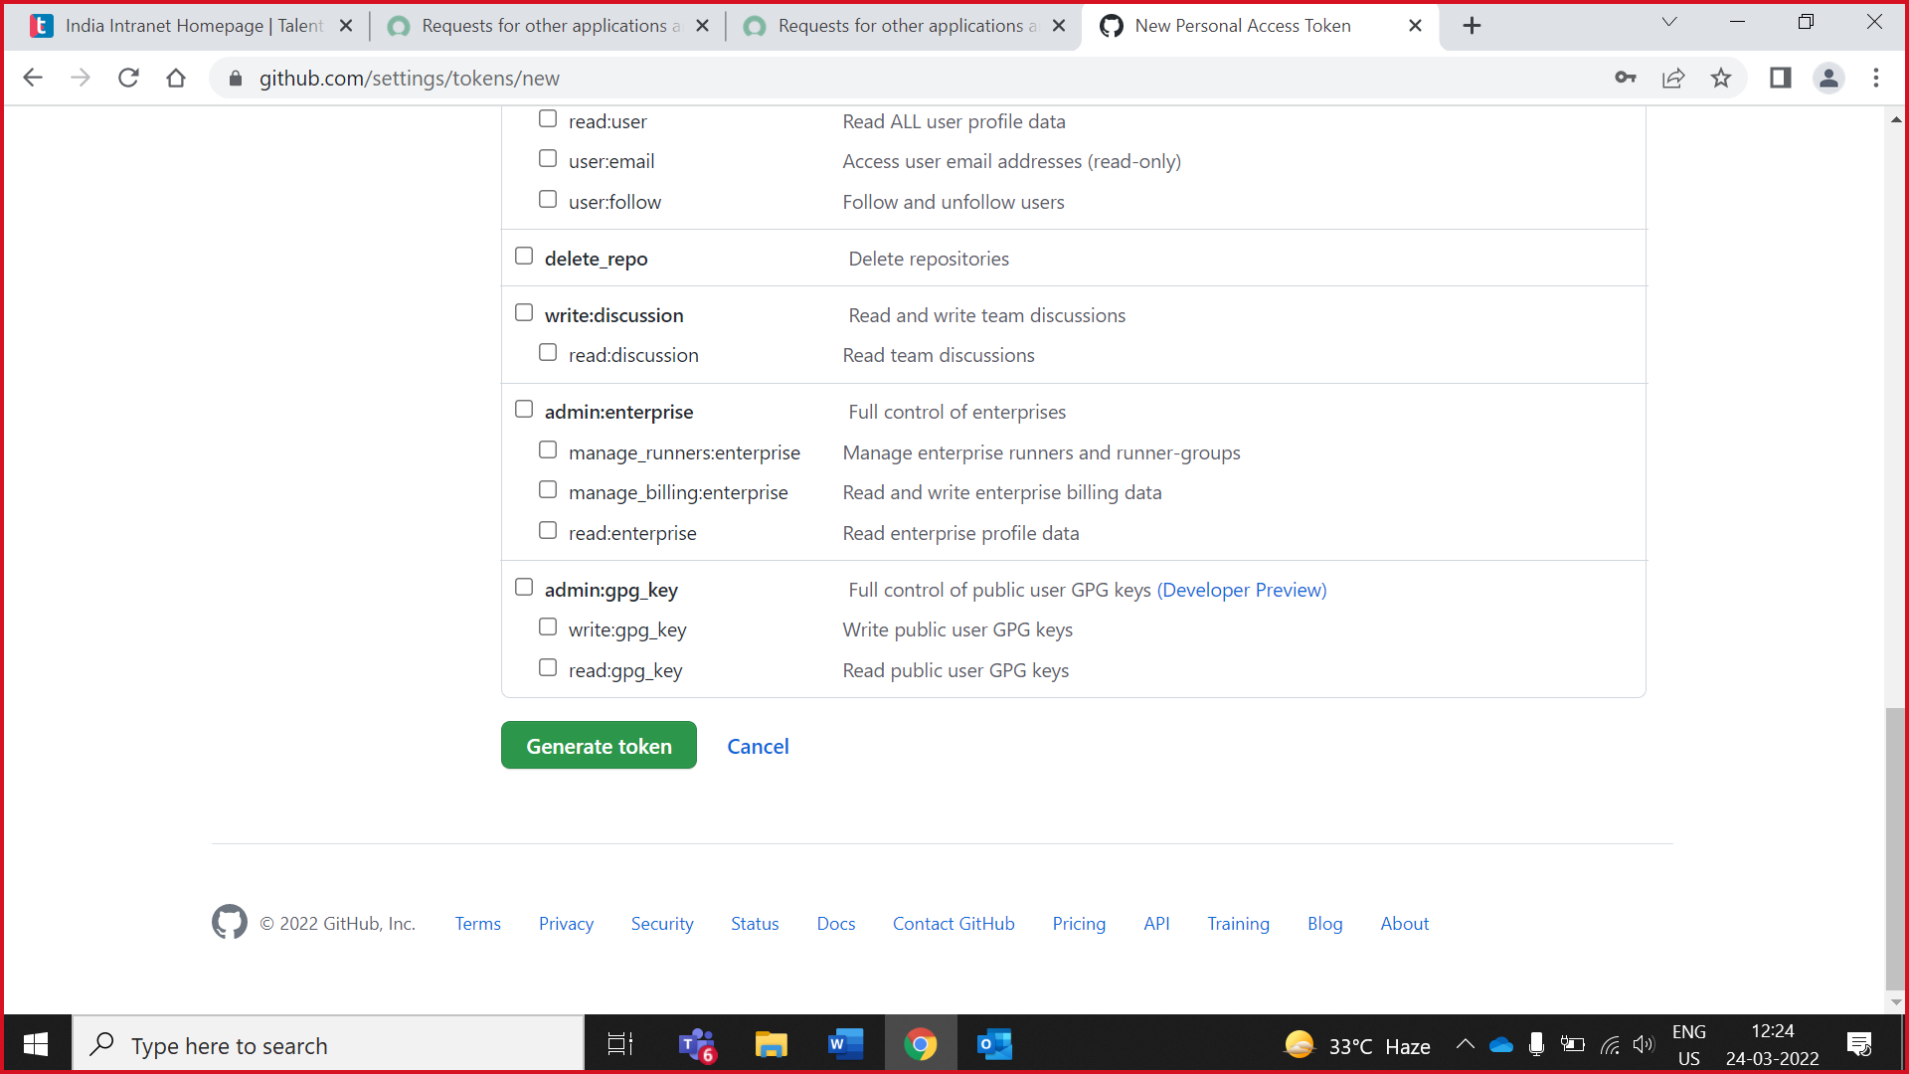

8. **Copy your token** (It’s show only once) . Make sure it copy properly or you can paste in notepad.

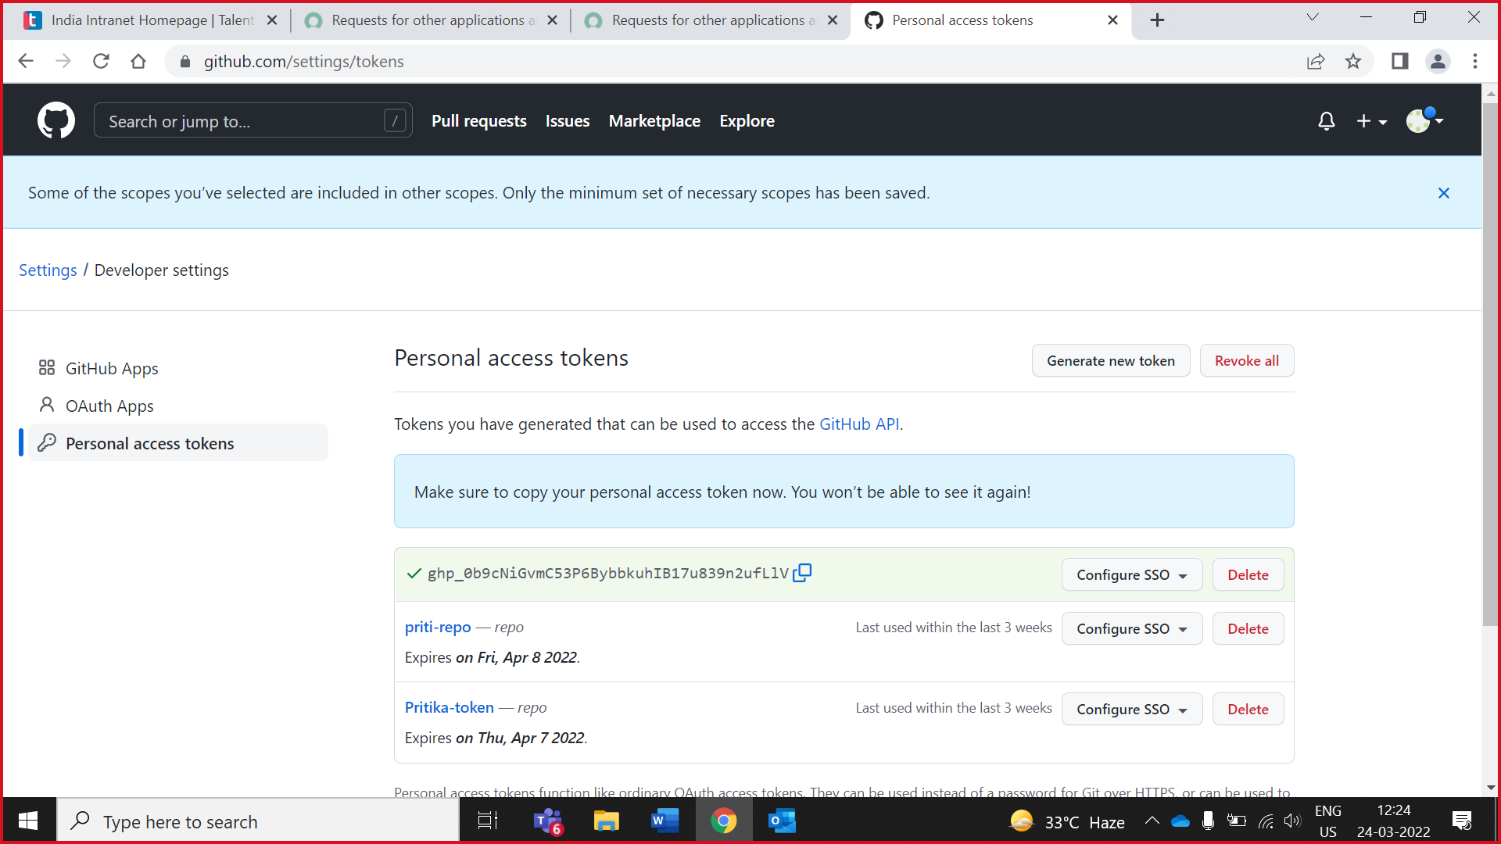

# **Create Repository**



Owners create repository/file/Issues/milestones

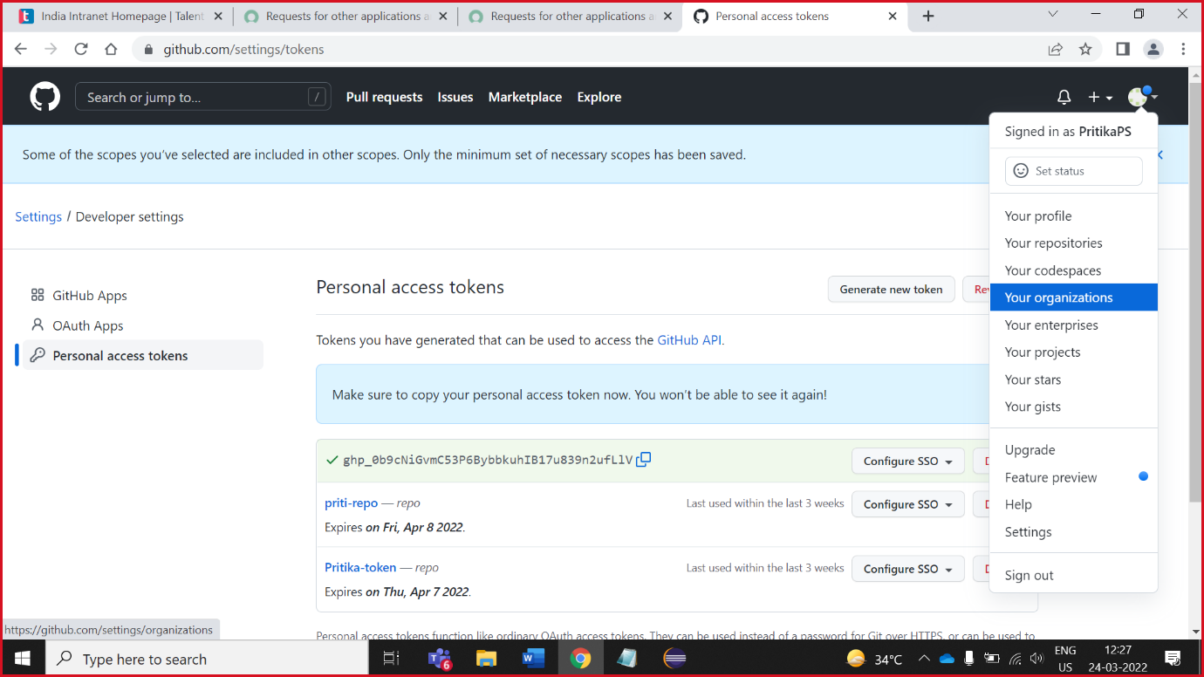1.Click on your profile goto **Your organisation**

2.Click **CG-FS-ABL**

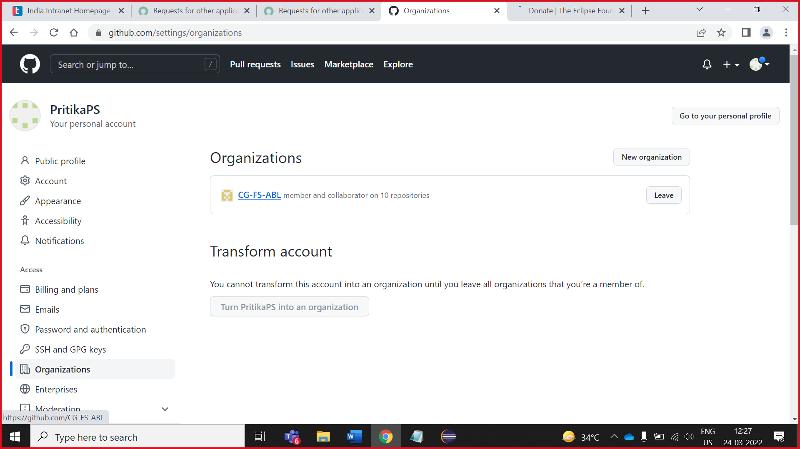

3.Click on **new**

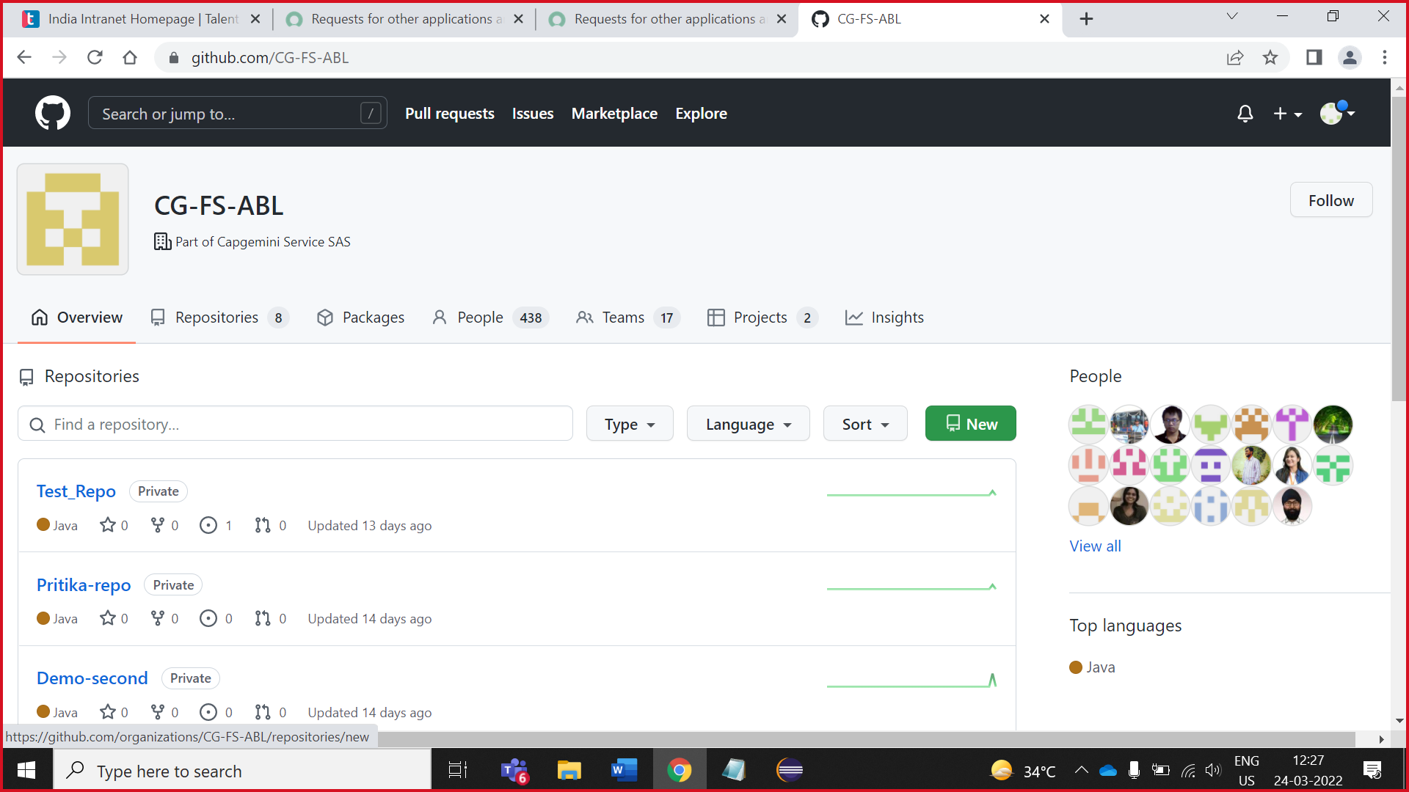

4. Make sure in Owner you select **CG-FS-ABL.**5. Scroll down click on **create repository**

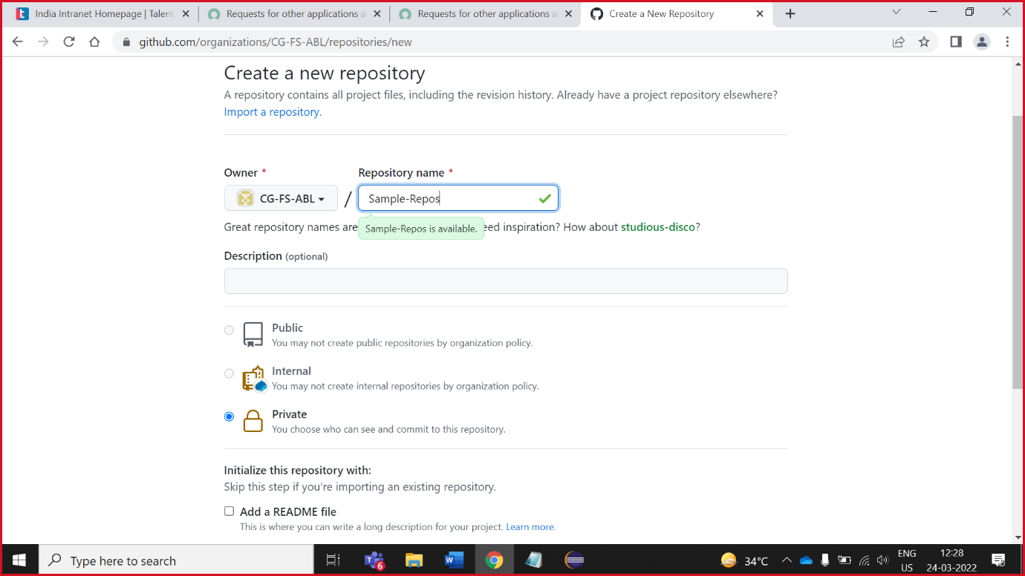

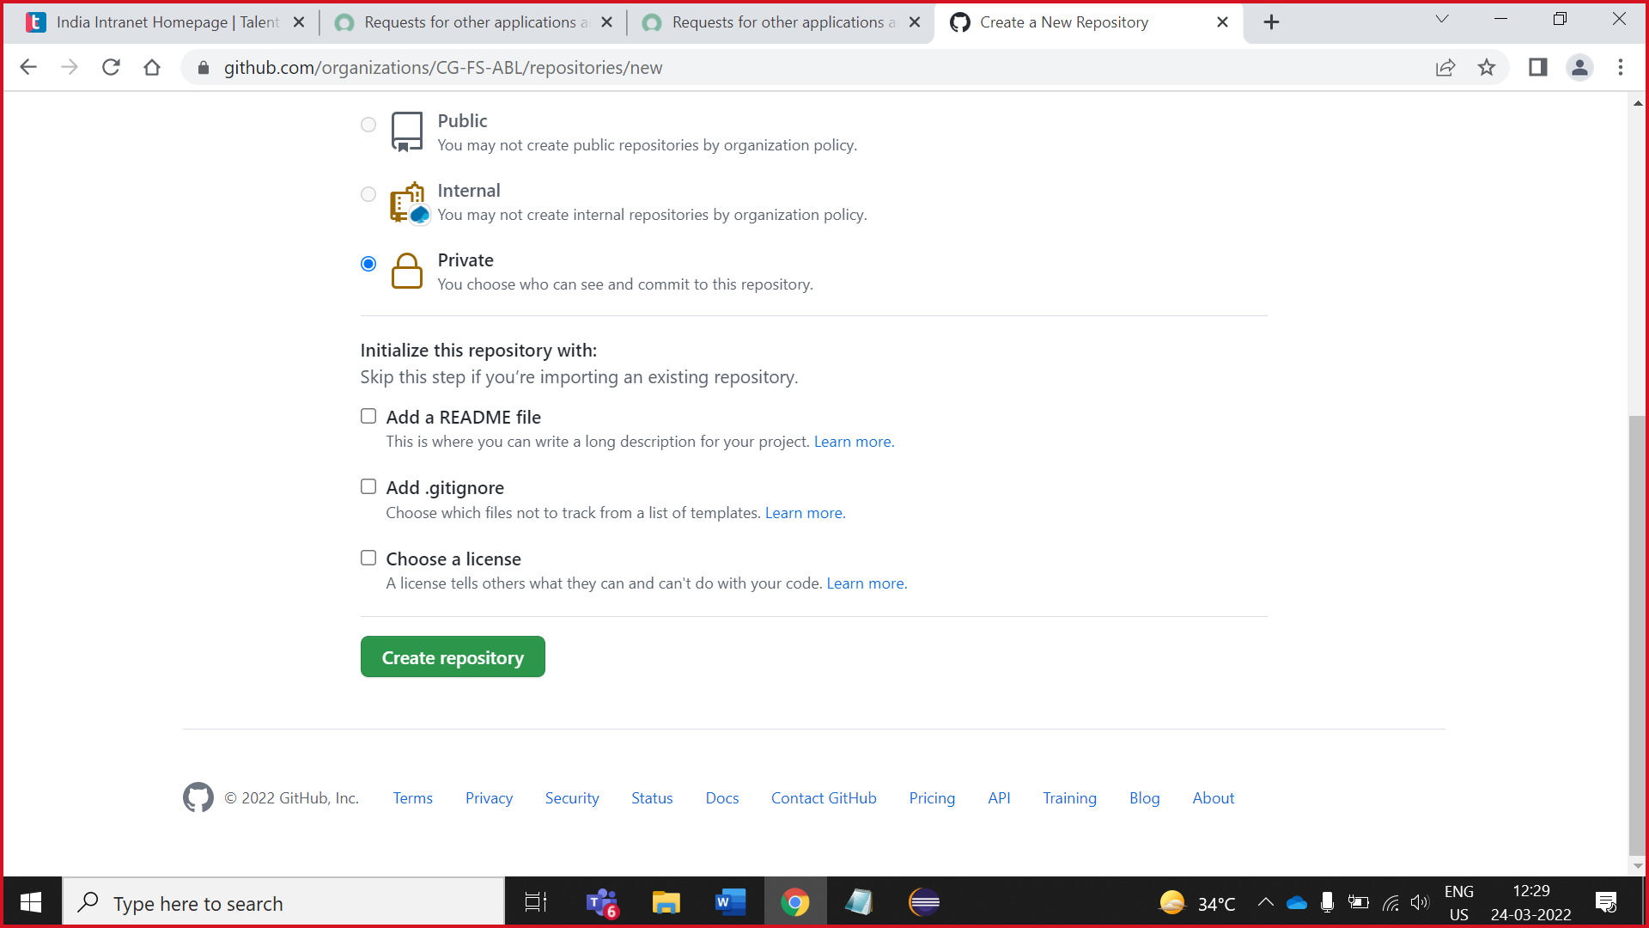

## Create .**gitignore** file

1.Click on .**gitignore or** you can create .gitignore file by click **creating a new file**

NOTE **:**  . **gitignore** file is **a text file that tells Git which files or folders to ignore in a project.**

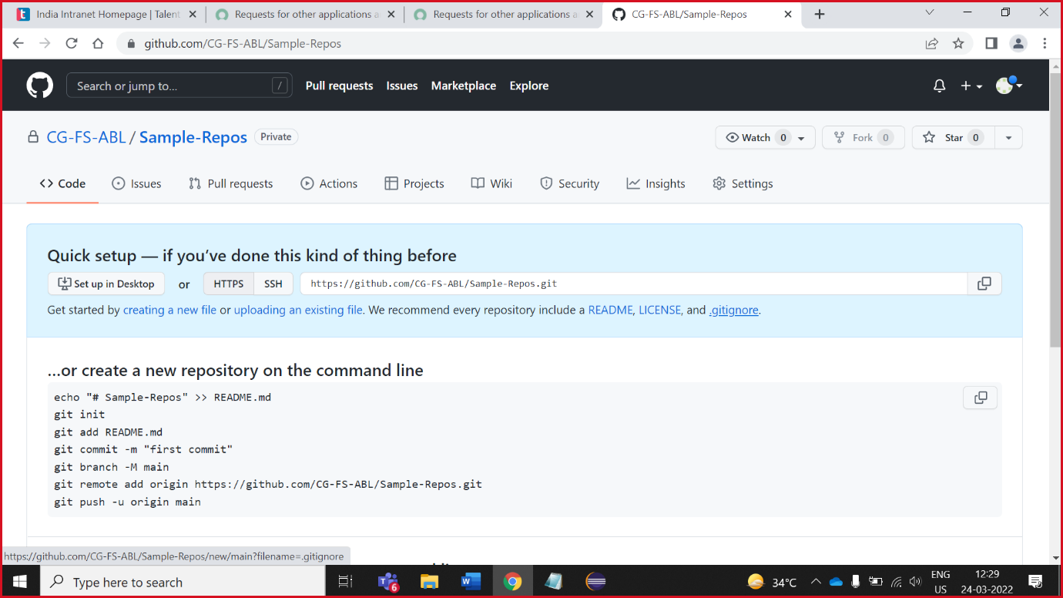

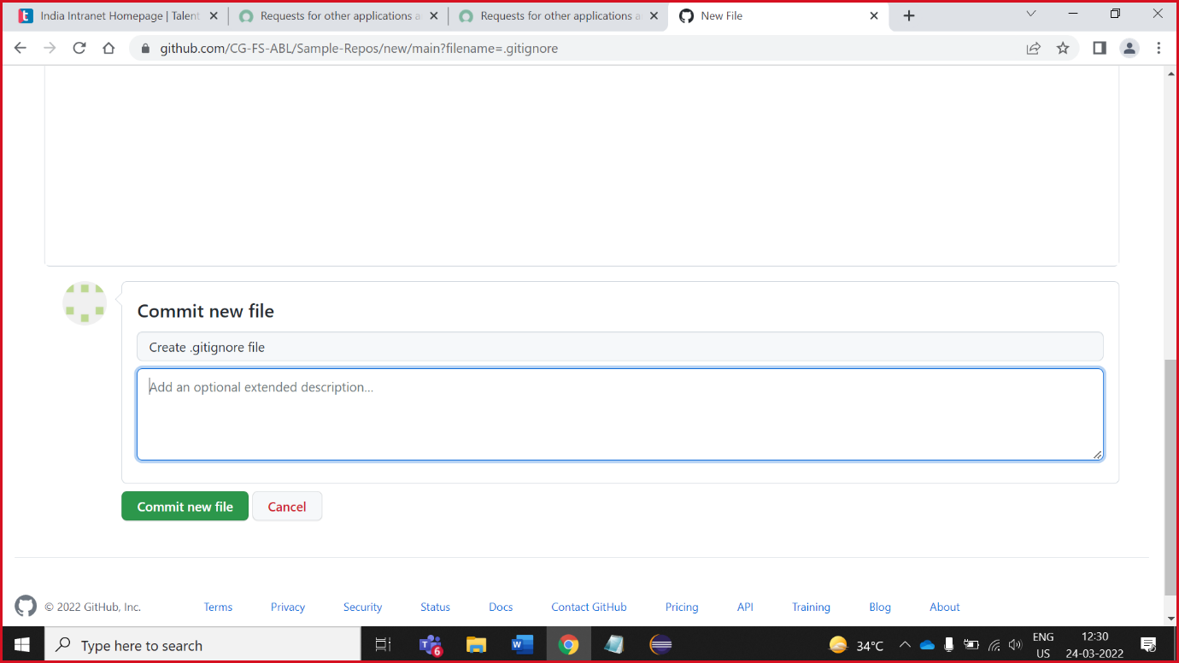2. Write code on .gitignore (which is write in below image.)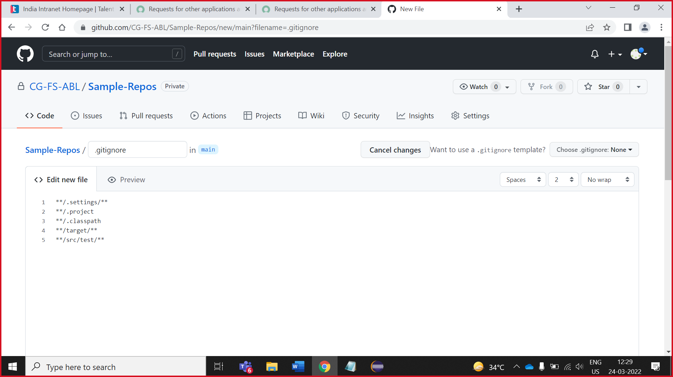

3. Write valid comment before commit the file and then click on **Commit new file.**

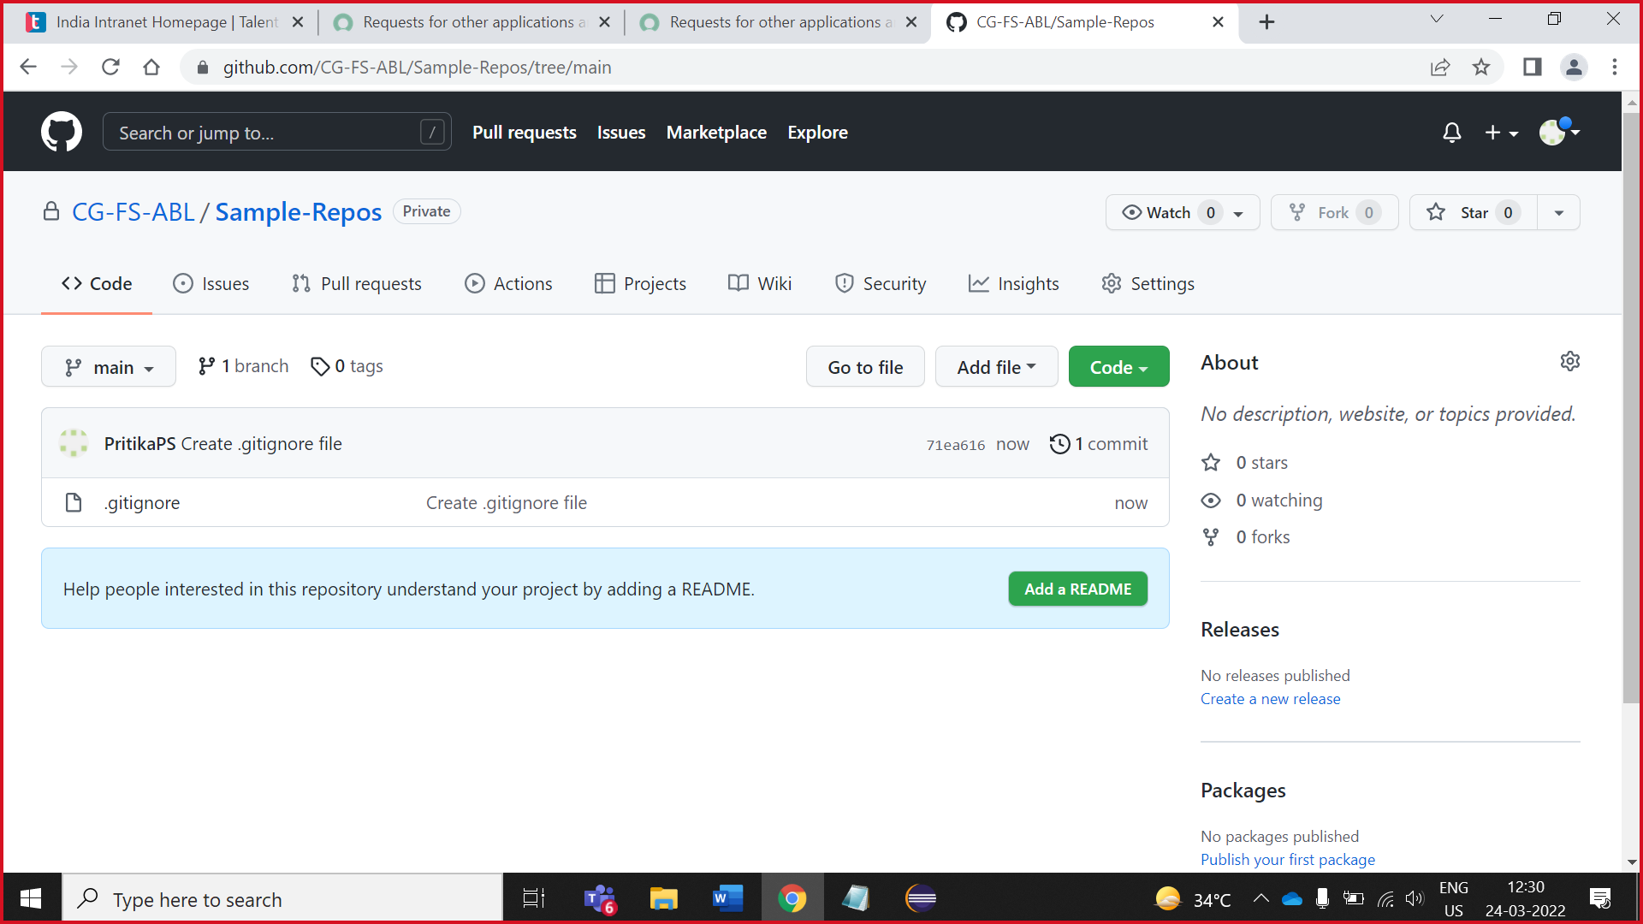

## Create **Issue**

1. Click on issues

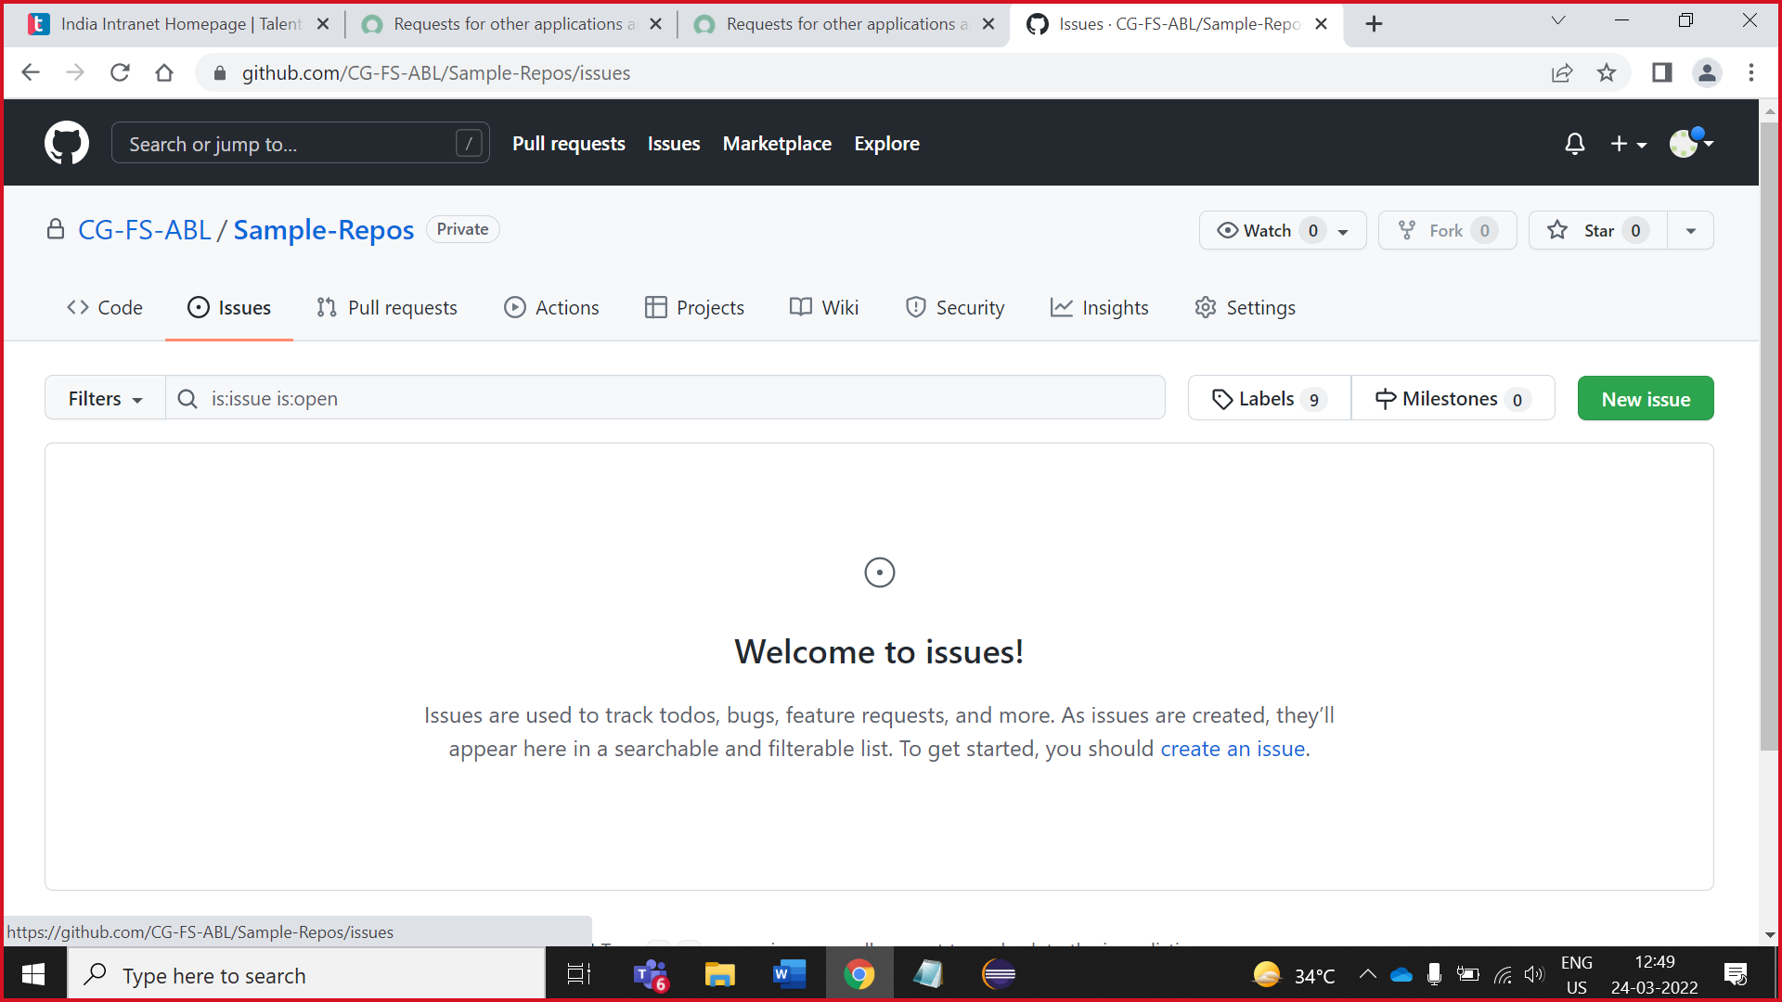

1. Write Issue heading ,discreption and click on **submit new issue.**

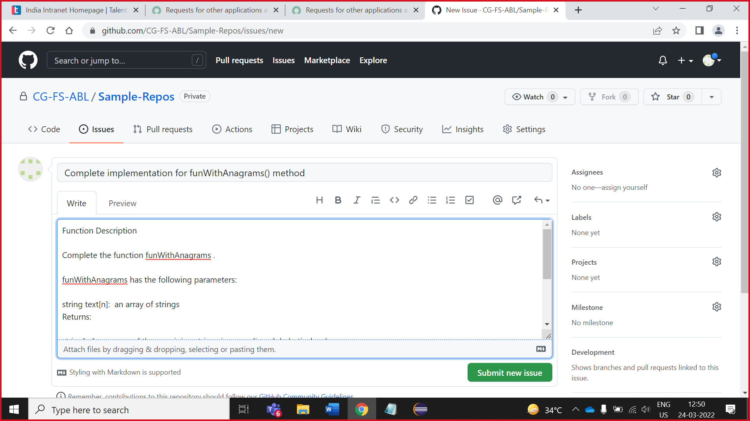

## Create **Milestone**

1. Click on issues -> **milestones**

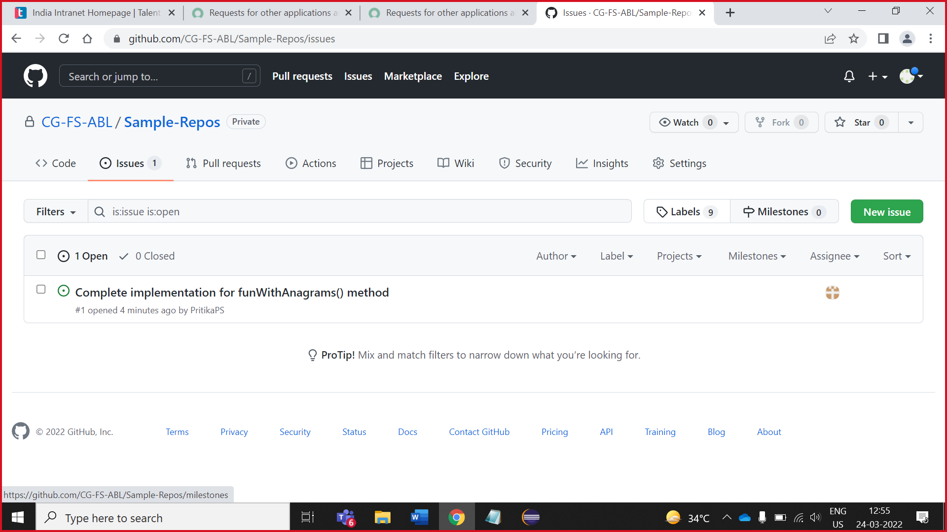

1. Click on **new milestone** or **create milestone**

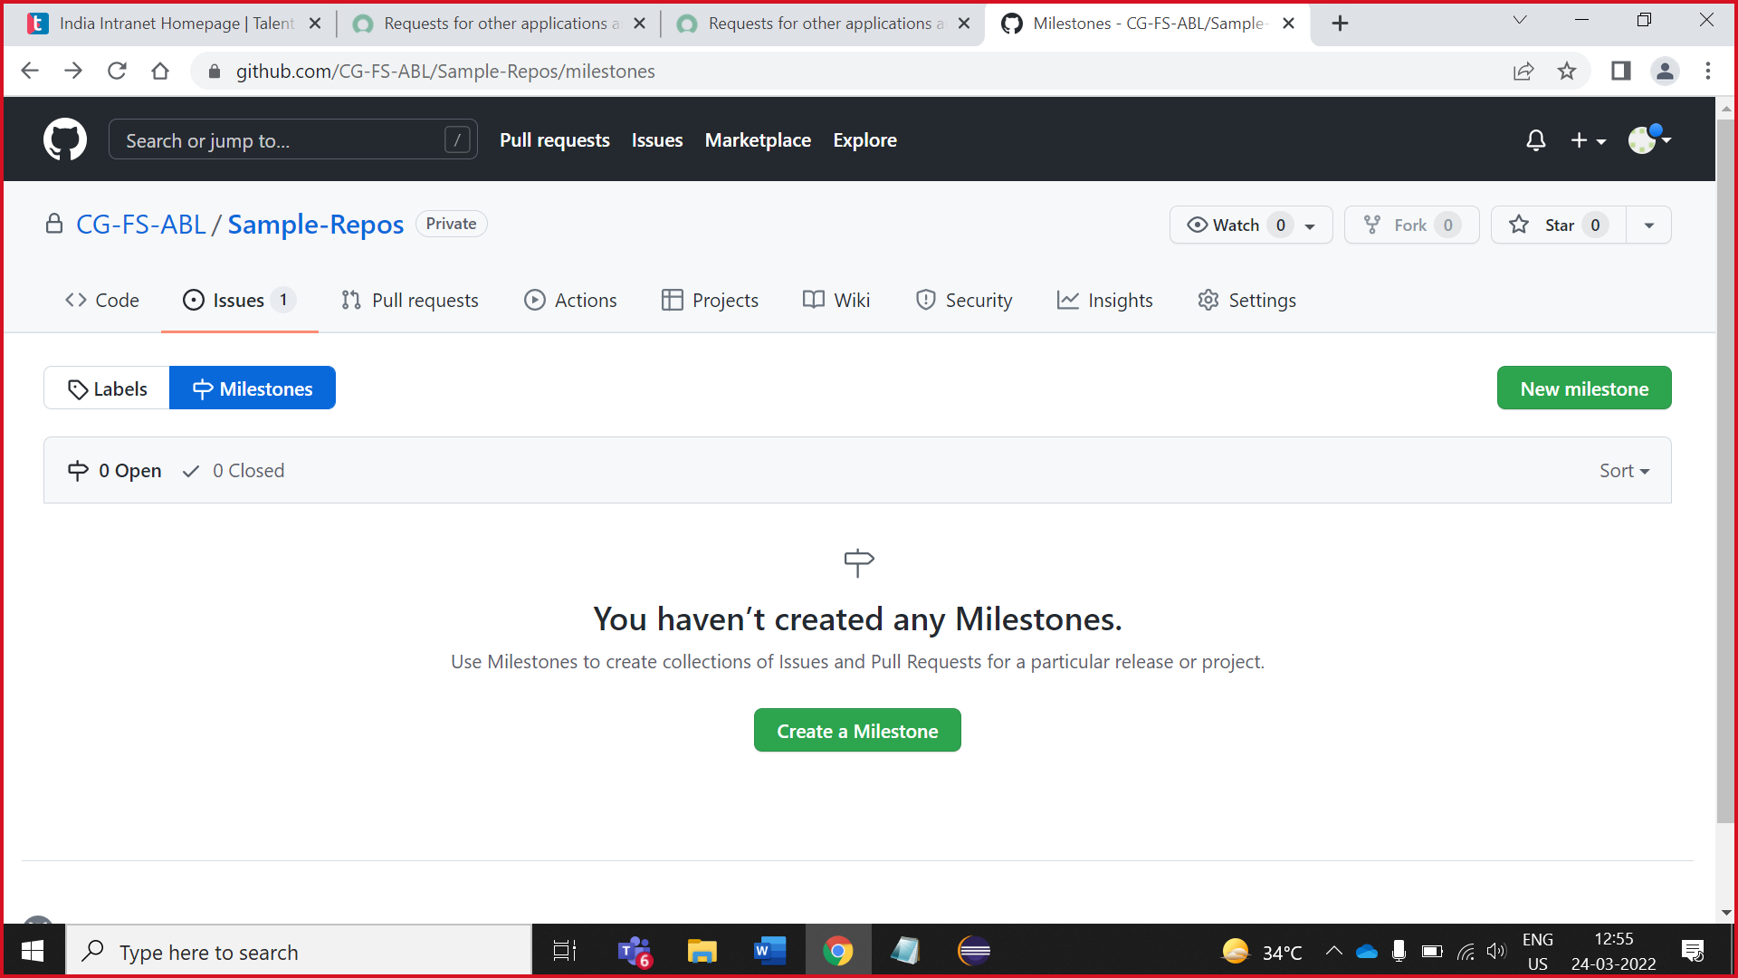

3. Write milestone title, date, description and click on **create milestone.**

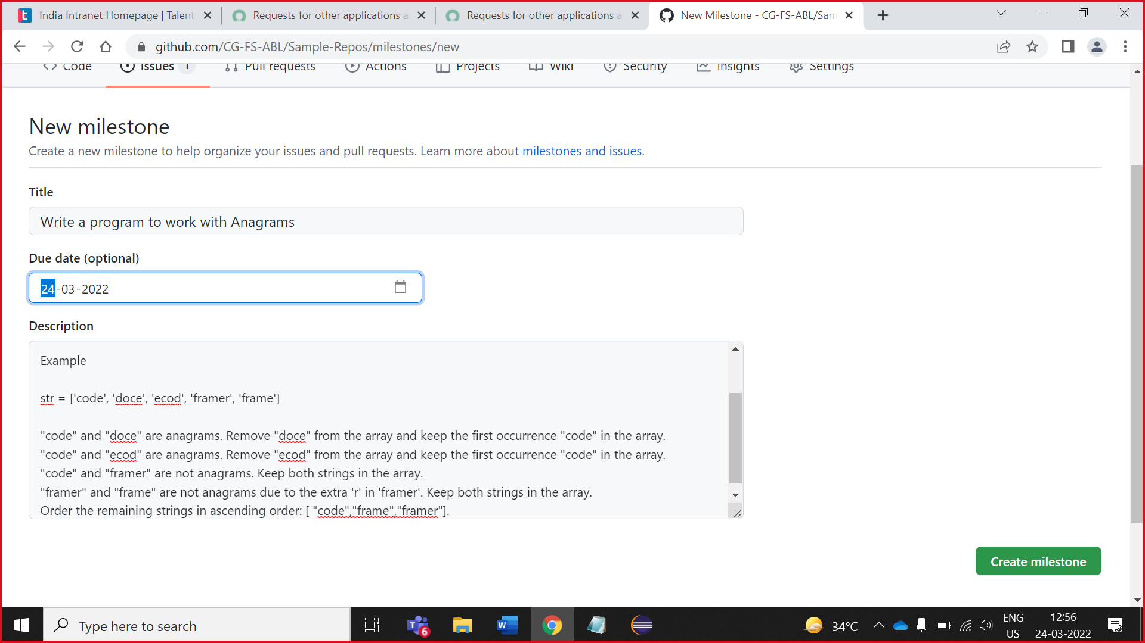

## Owner add collaborator in repository

1. Click on **settings**

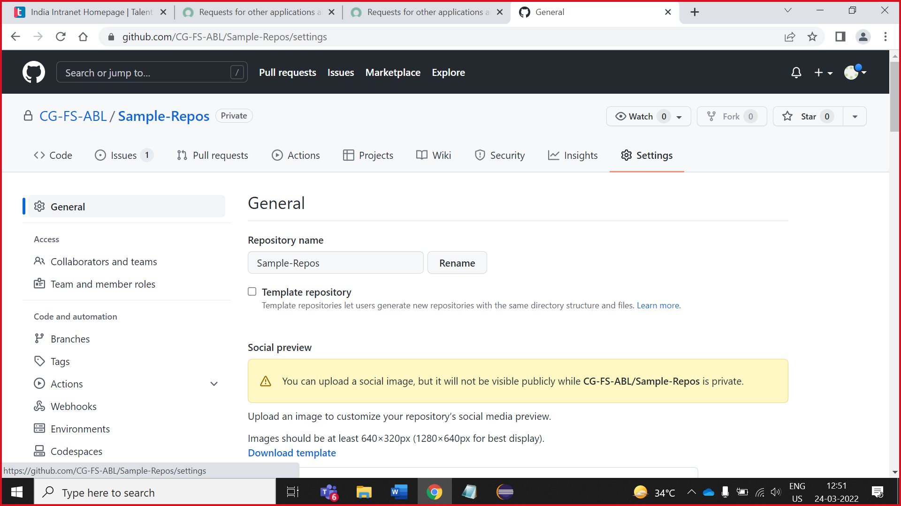

2. Click on **collaborator and teams**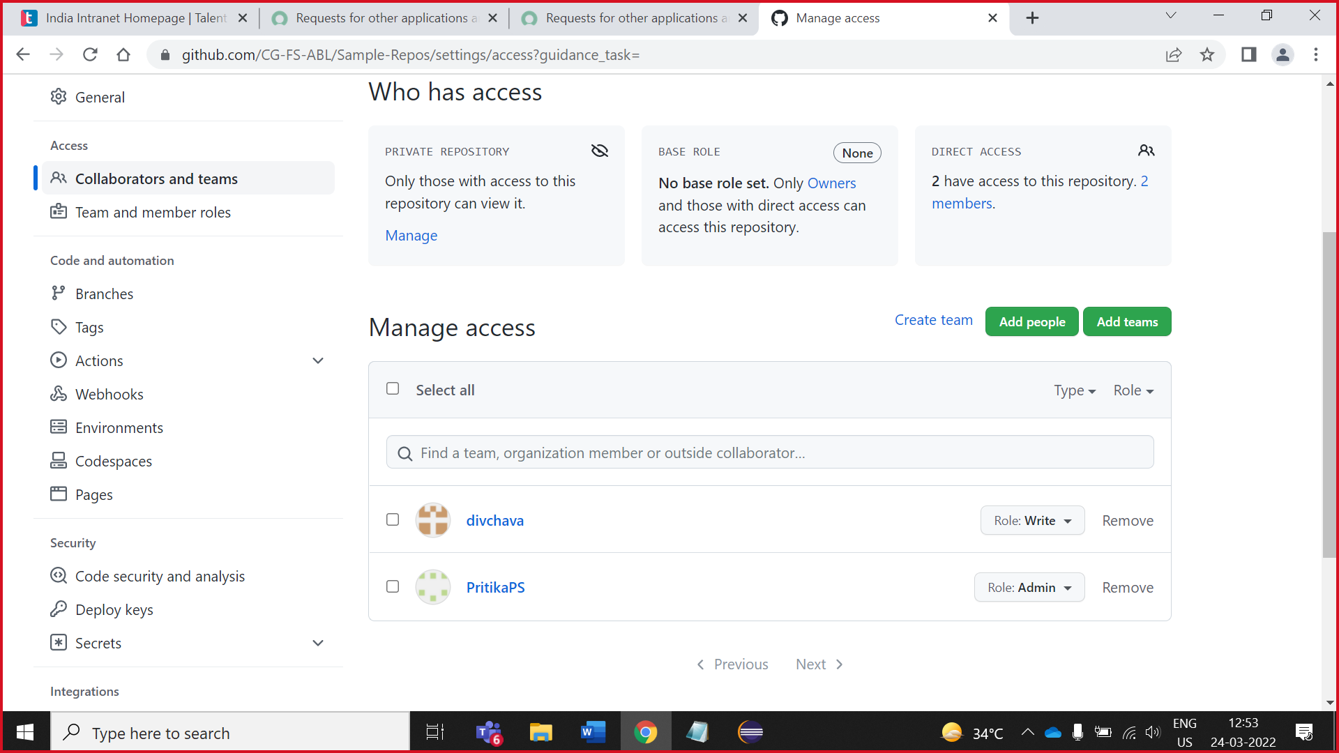

3.Click on **add people**

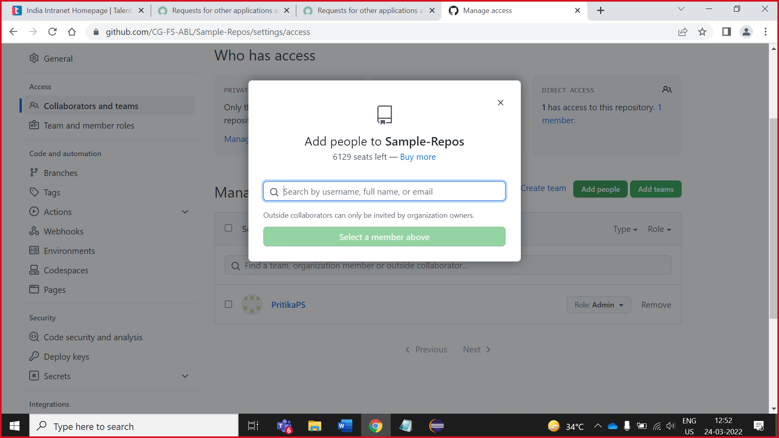

4. Search collaborator and tick on write.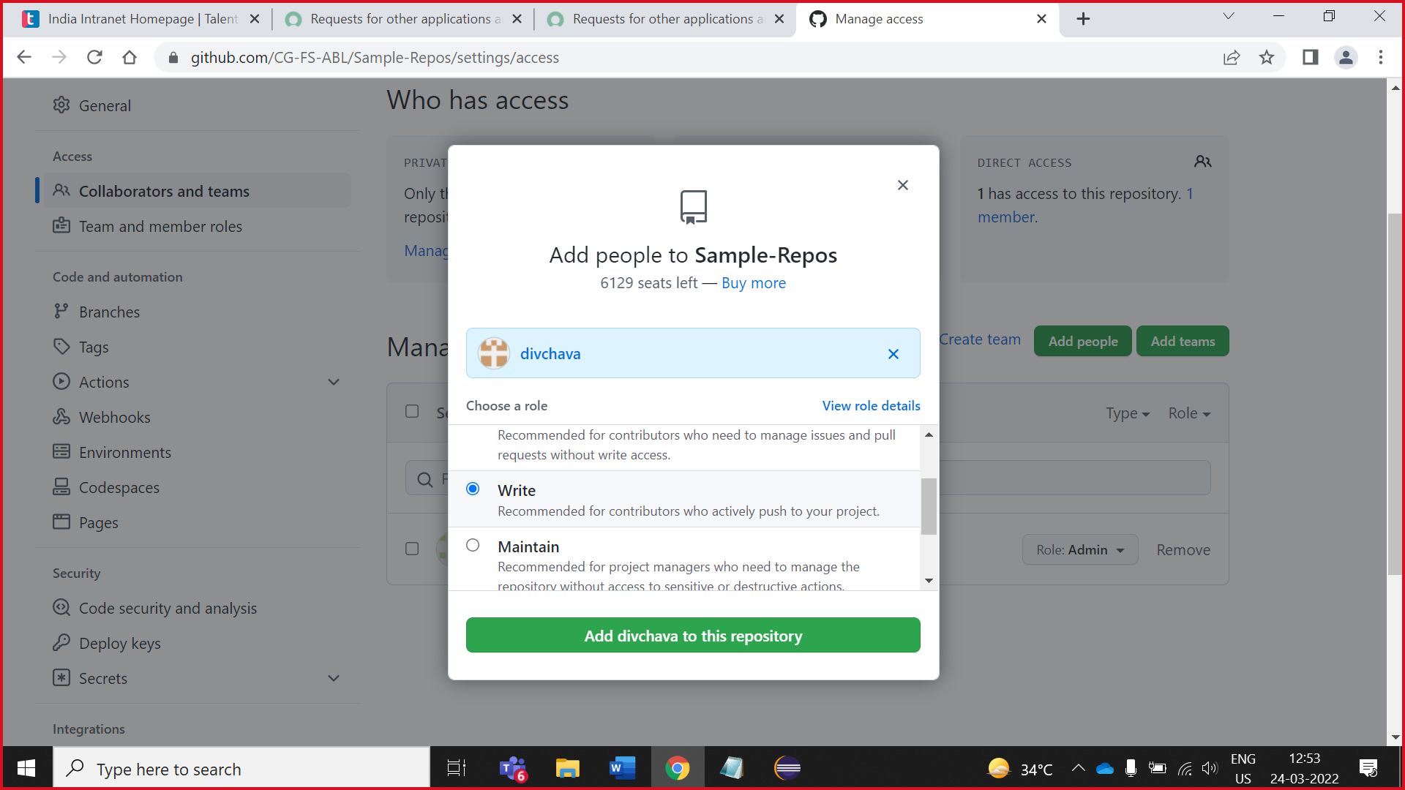

## Owner assign task to collaborator

1. Click on Issues -> complete implementation

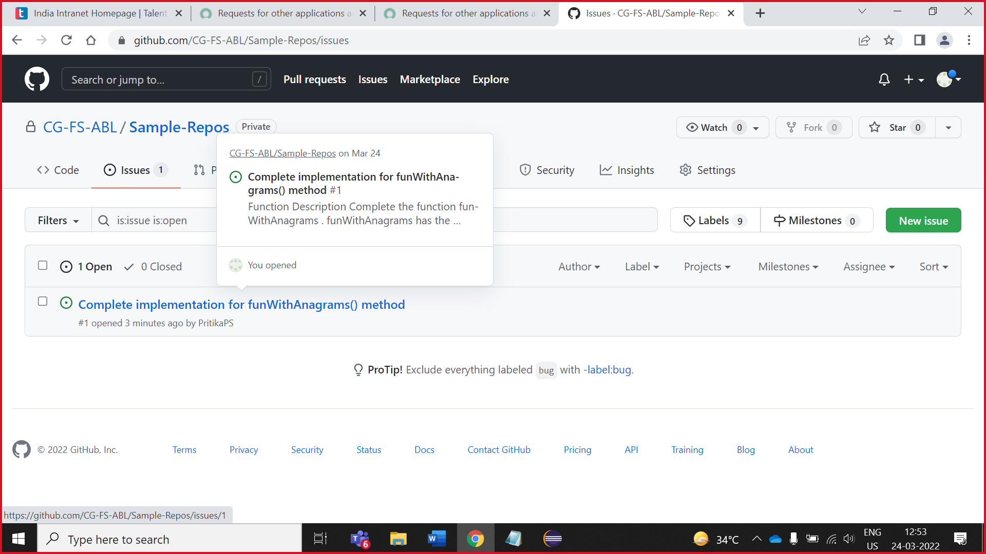

2. click on assignes and search collaborator

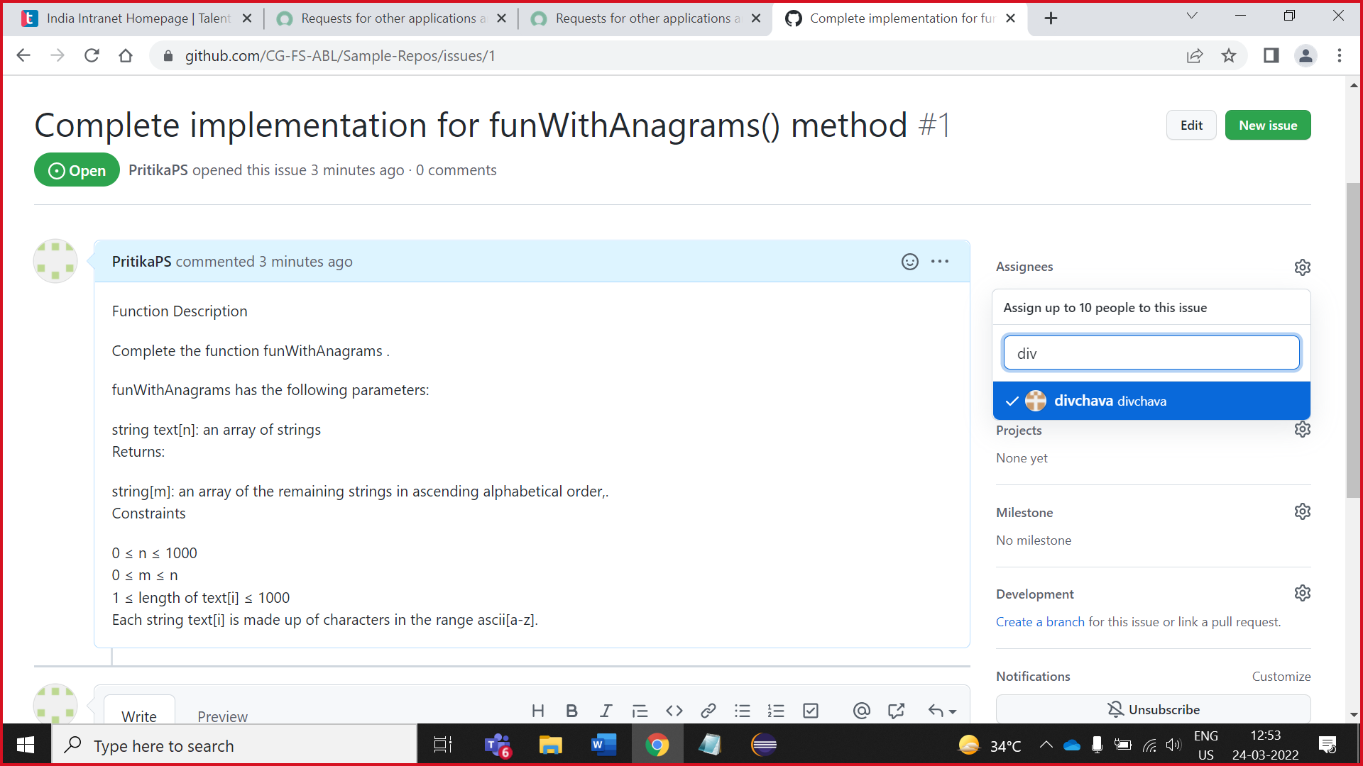

3.tick on collaborator name

Assign task successfully

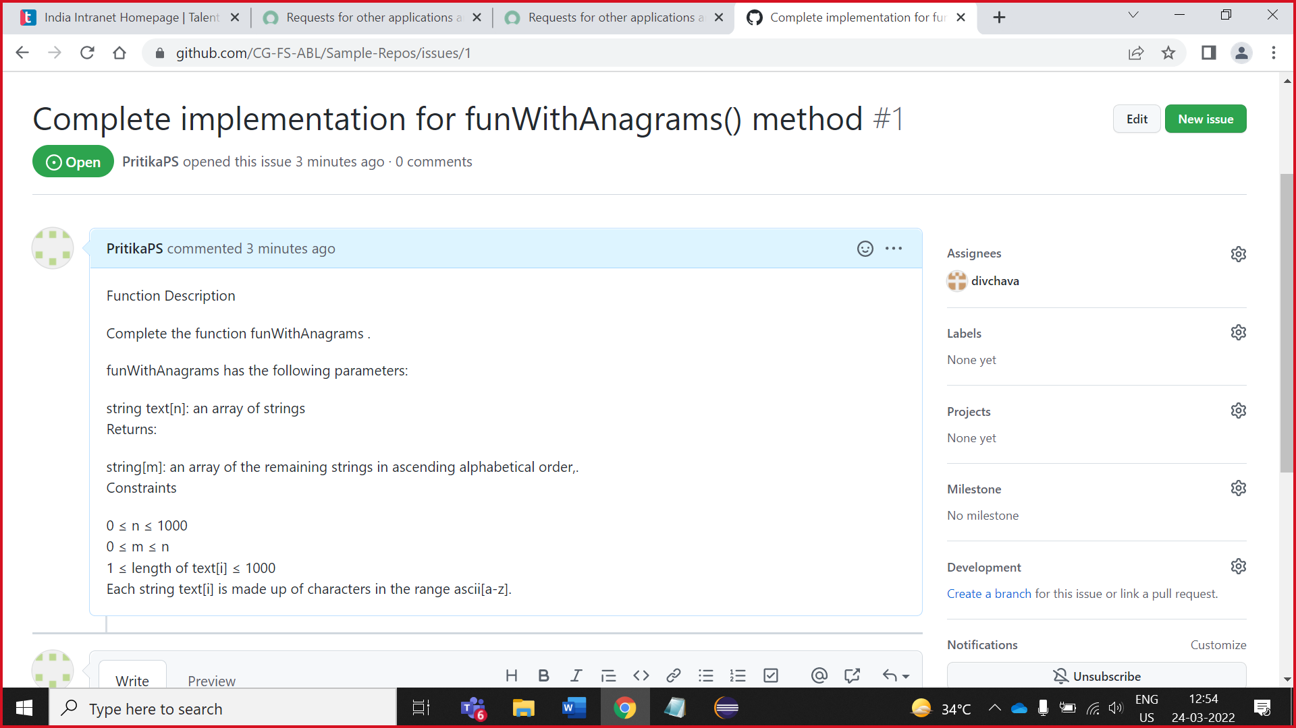

# **Add GitHub repository in Eclipse**

1.Click on code and copy HTTPS github link. Which is show in below image

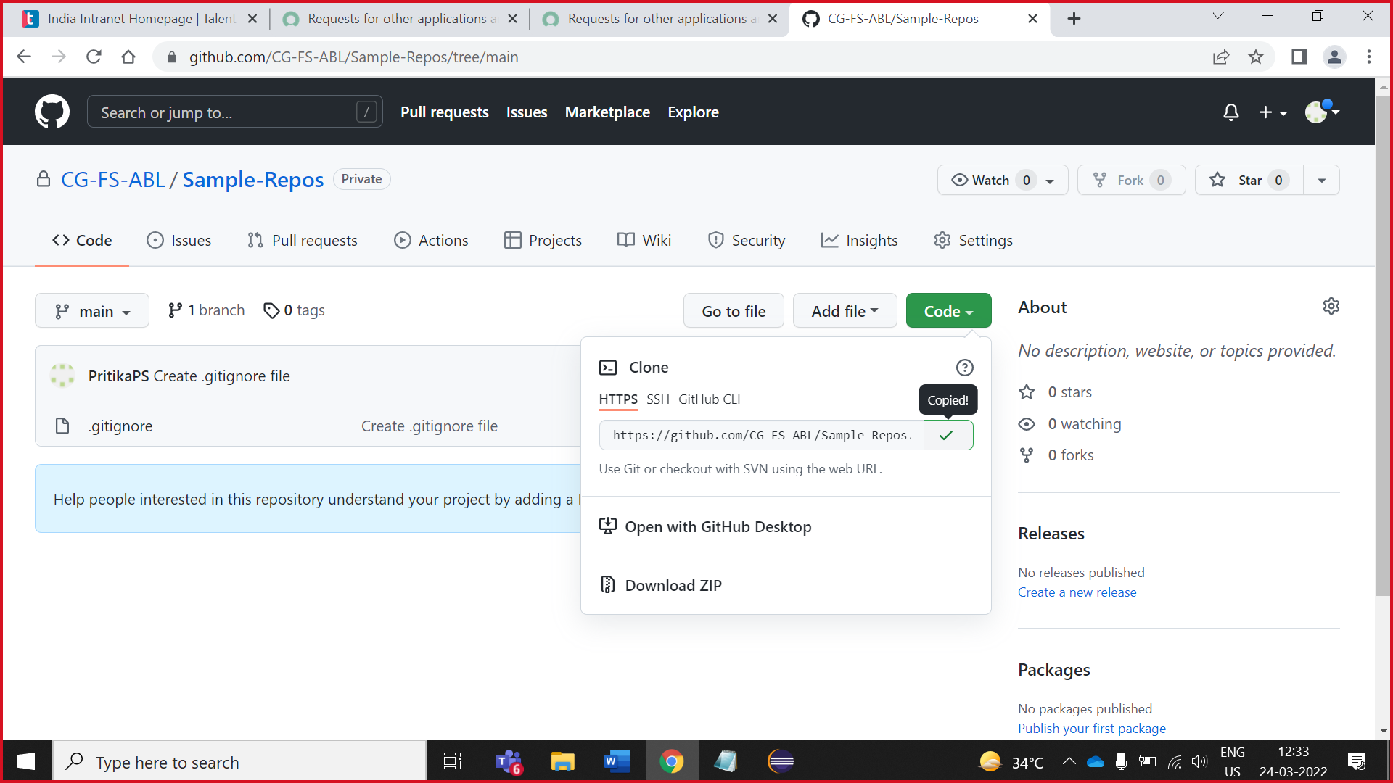

2.Open eclipse and search git repositrory

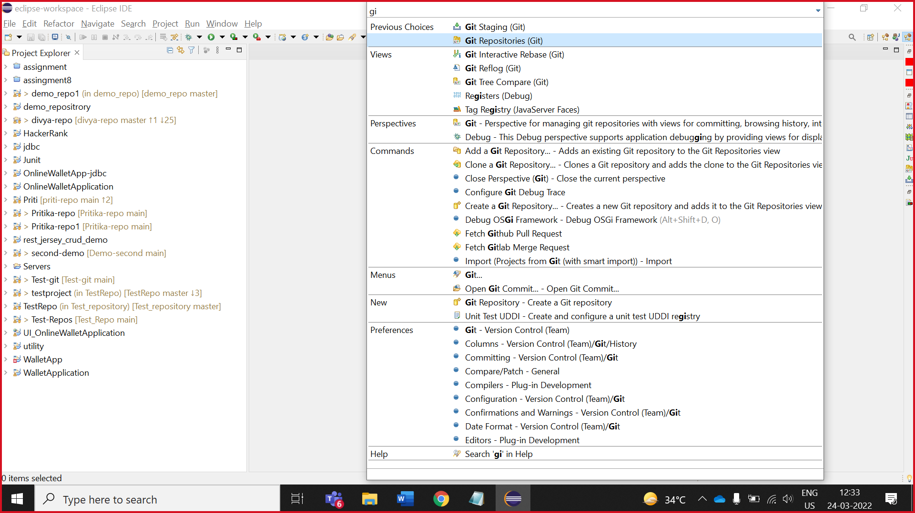

1. In git repository, right click and paste the HTTPS github link.

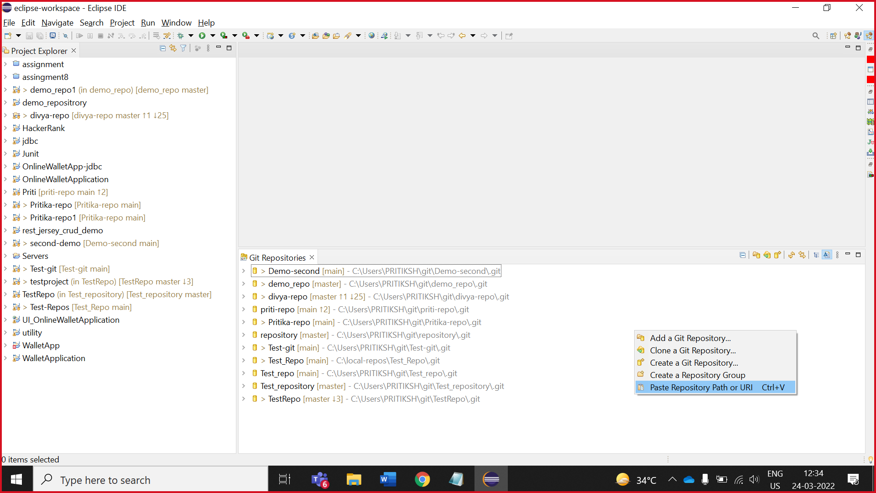

1. Enter your usename and password.

NOTE: **Password is your token which is we create previously**.

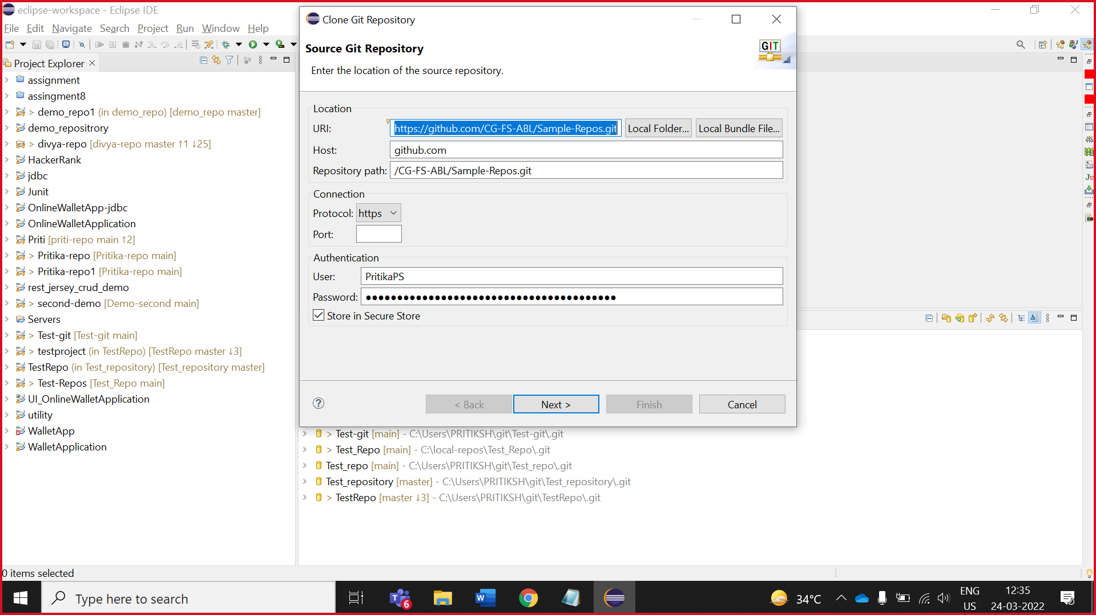

1. Click on next

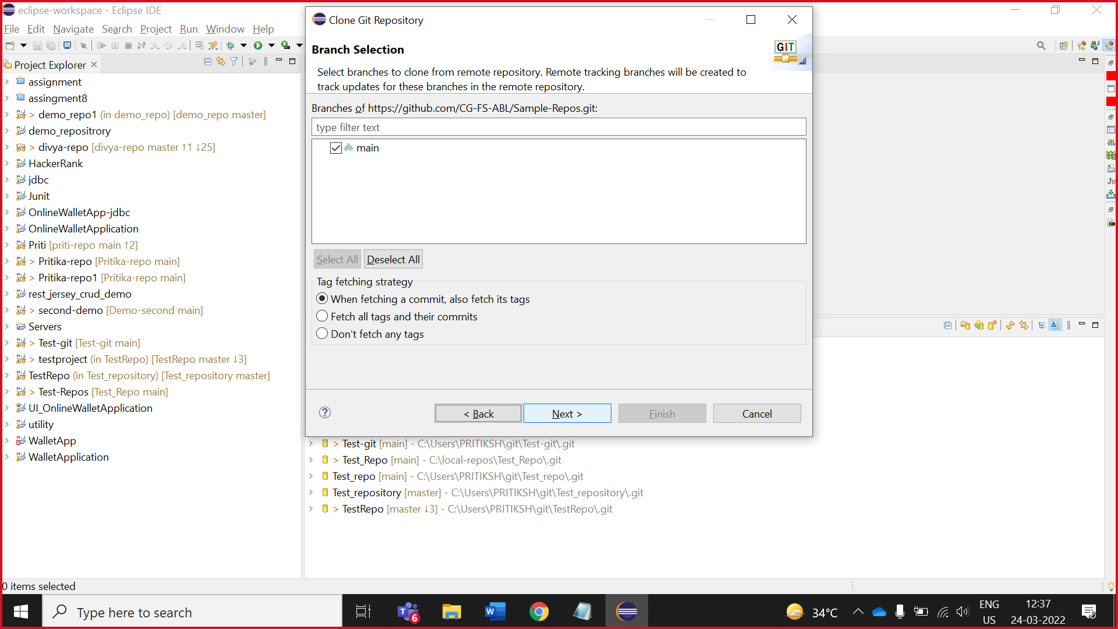

5.Change directory location

(first you create local repository folder in your C:// drive )

Click on Browse and change repository location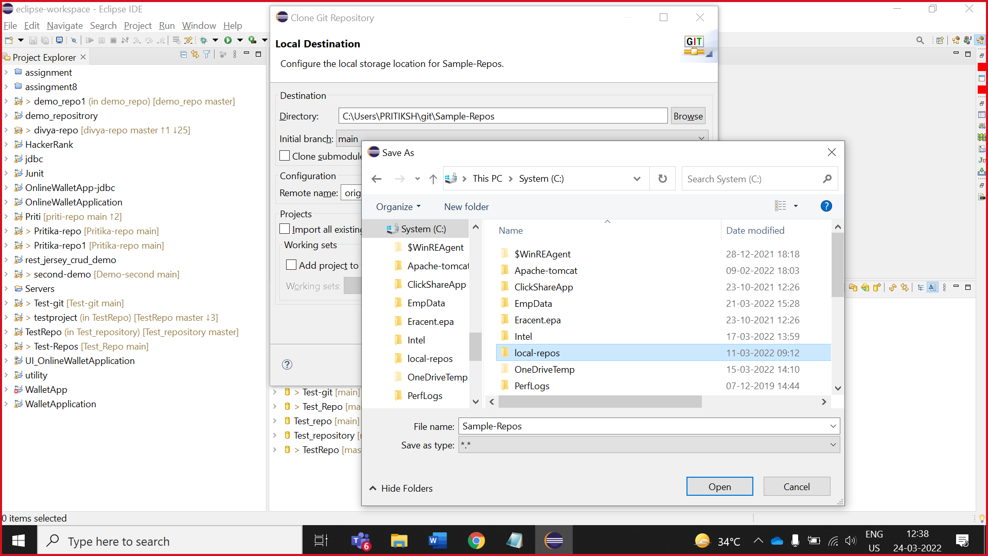

5.Click finish

(repository added succesufully)

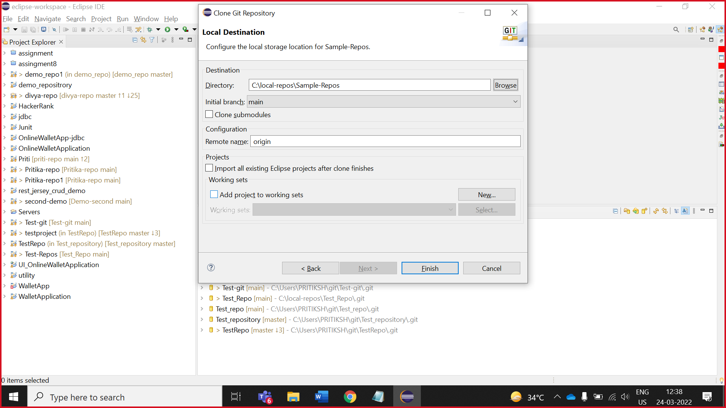

**Create Maven Project**



2. Owners creates maven project

1.Owner copy HTTPS path of repository

1.click on added repository

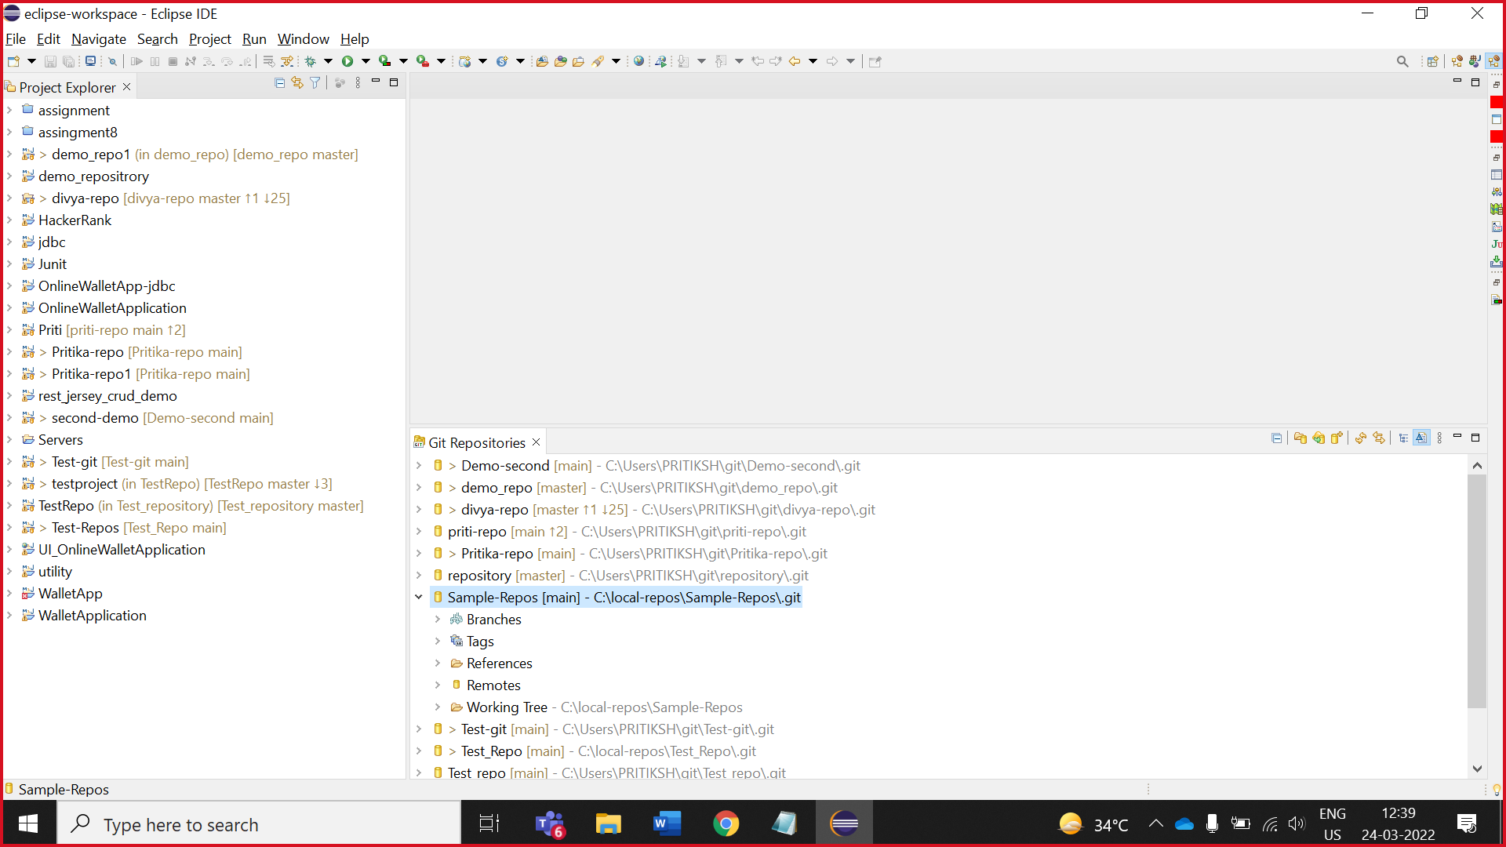

2.**Copy the working tree path**

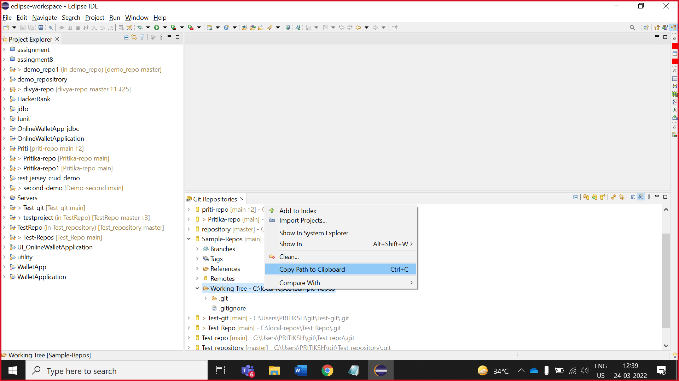

3.click on file -> Maven Project

( when you don’t see Maven project option file -> other -> search Maven project )

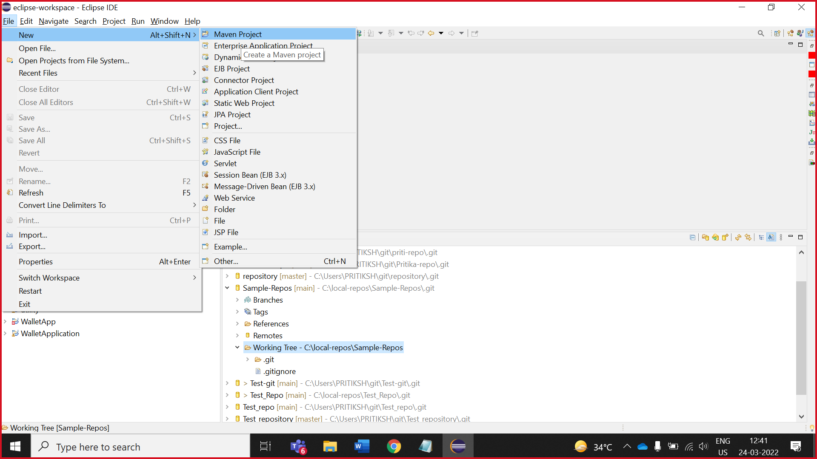

4.**Uncheck** Use default workspace location,

**paste the working tree path** and click on **next**

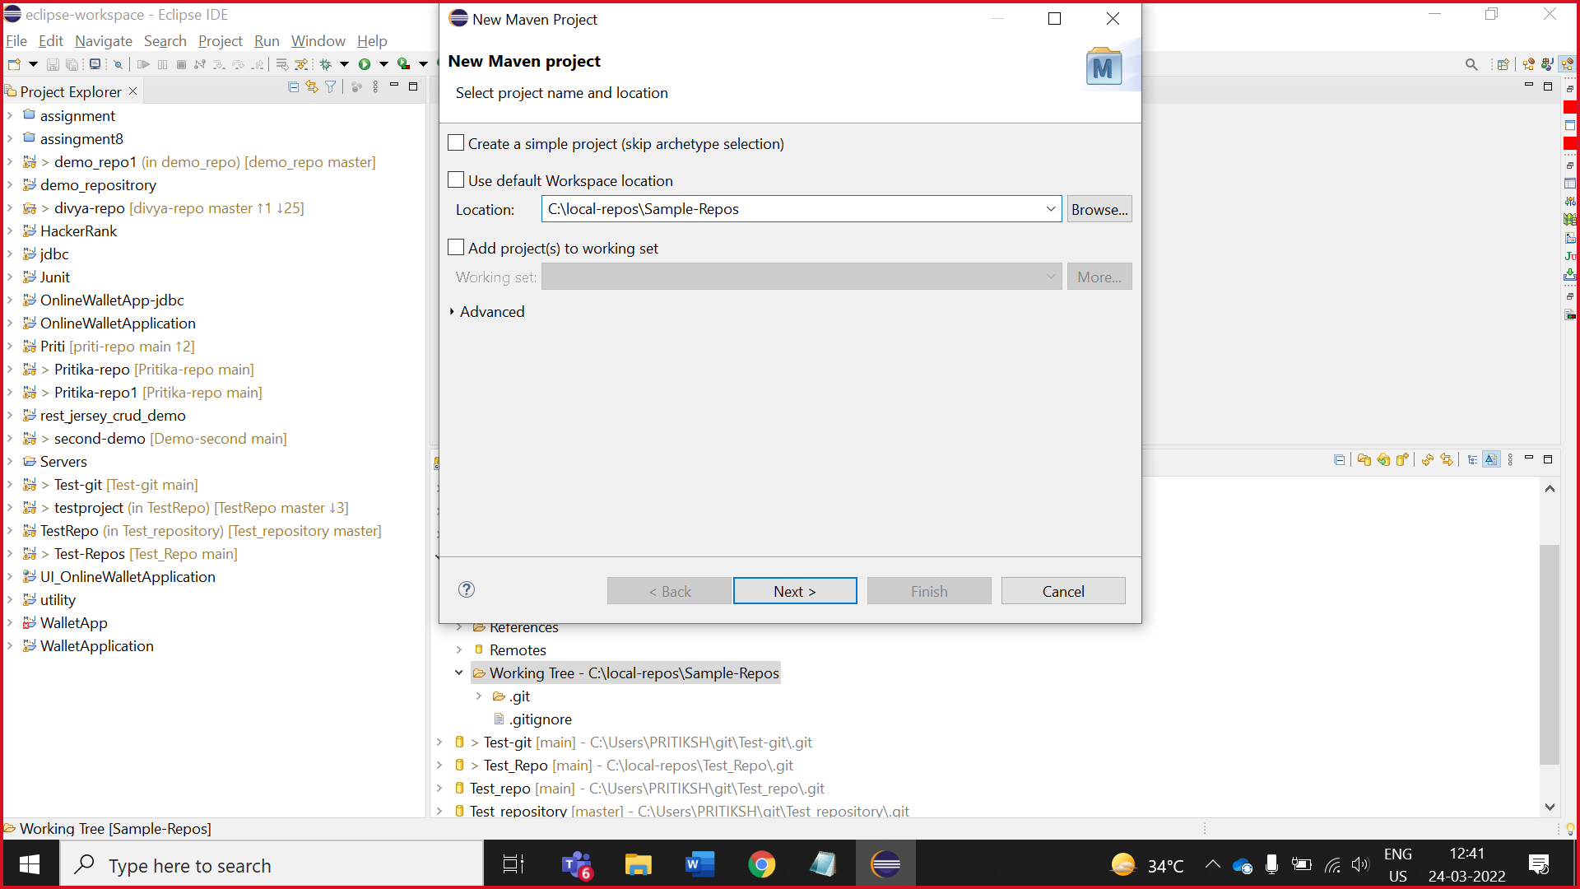

5.In catalog , select All catalogs

In filter search ,groupId : org.apache.maven.archetypes , artifactId : maven-archetyep-quikestart. click on **next**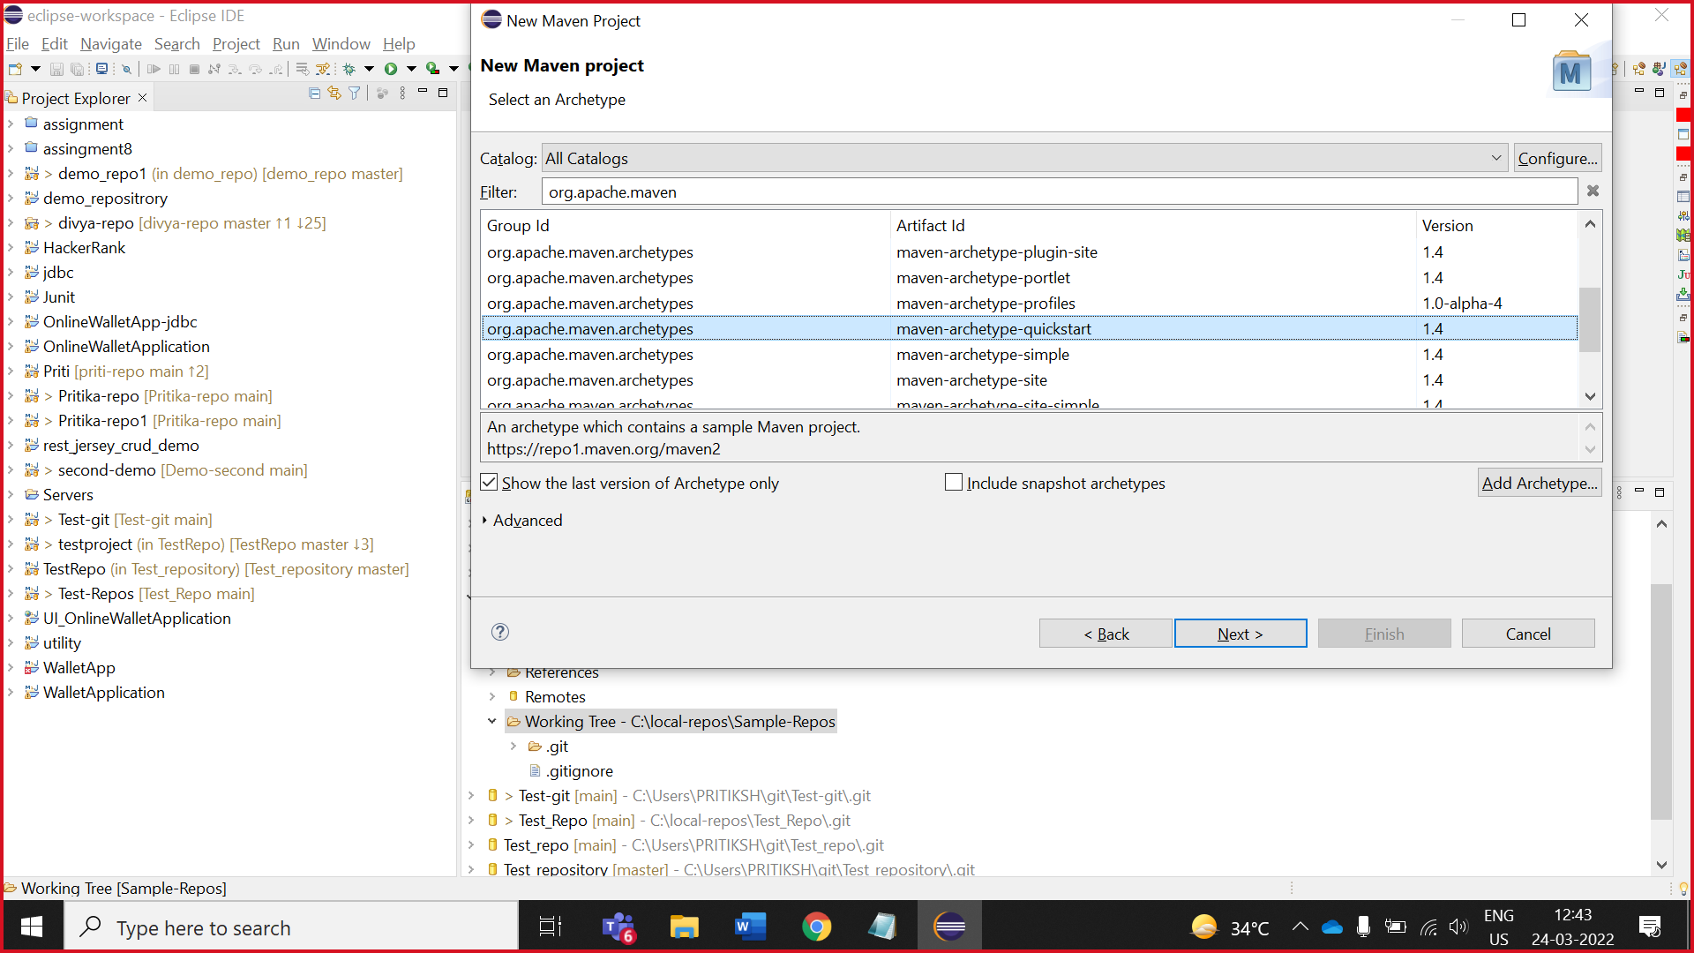

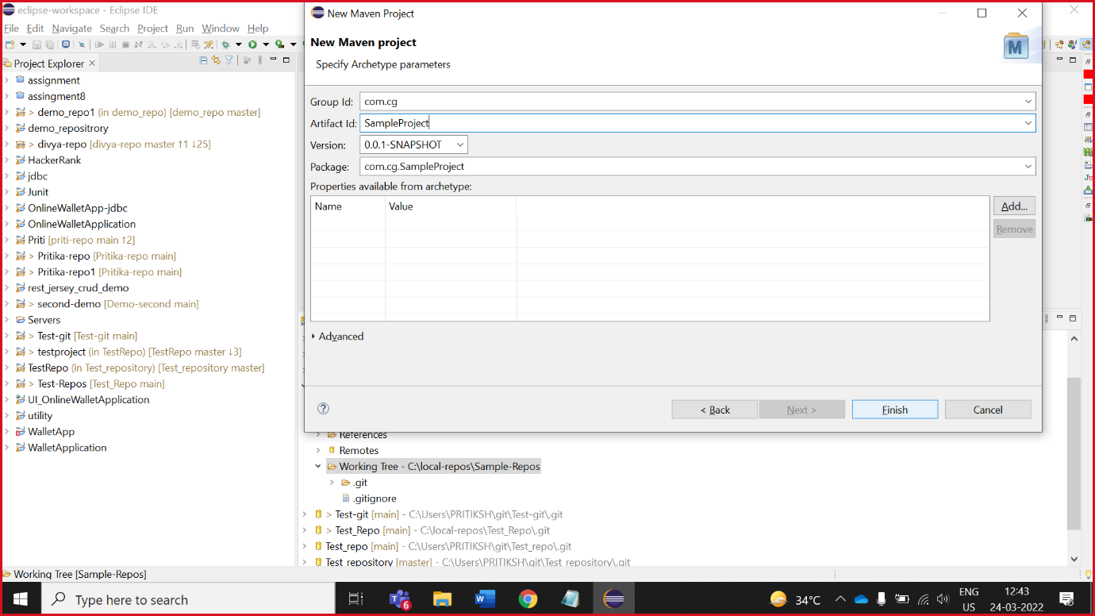6.Enter group Id and artifact Id

7. Add below Plugin in **pom.xml** file 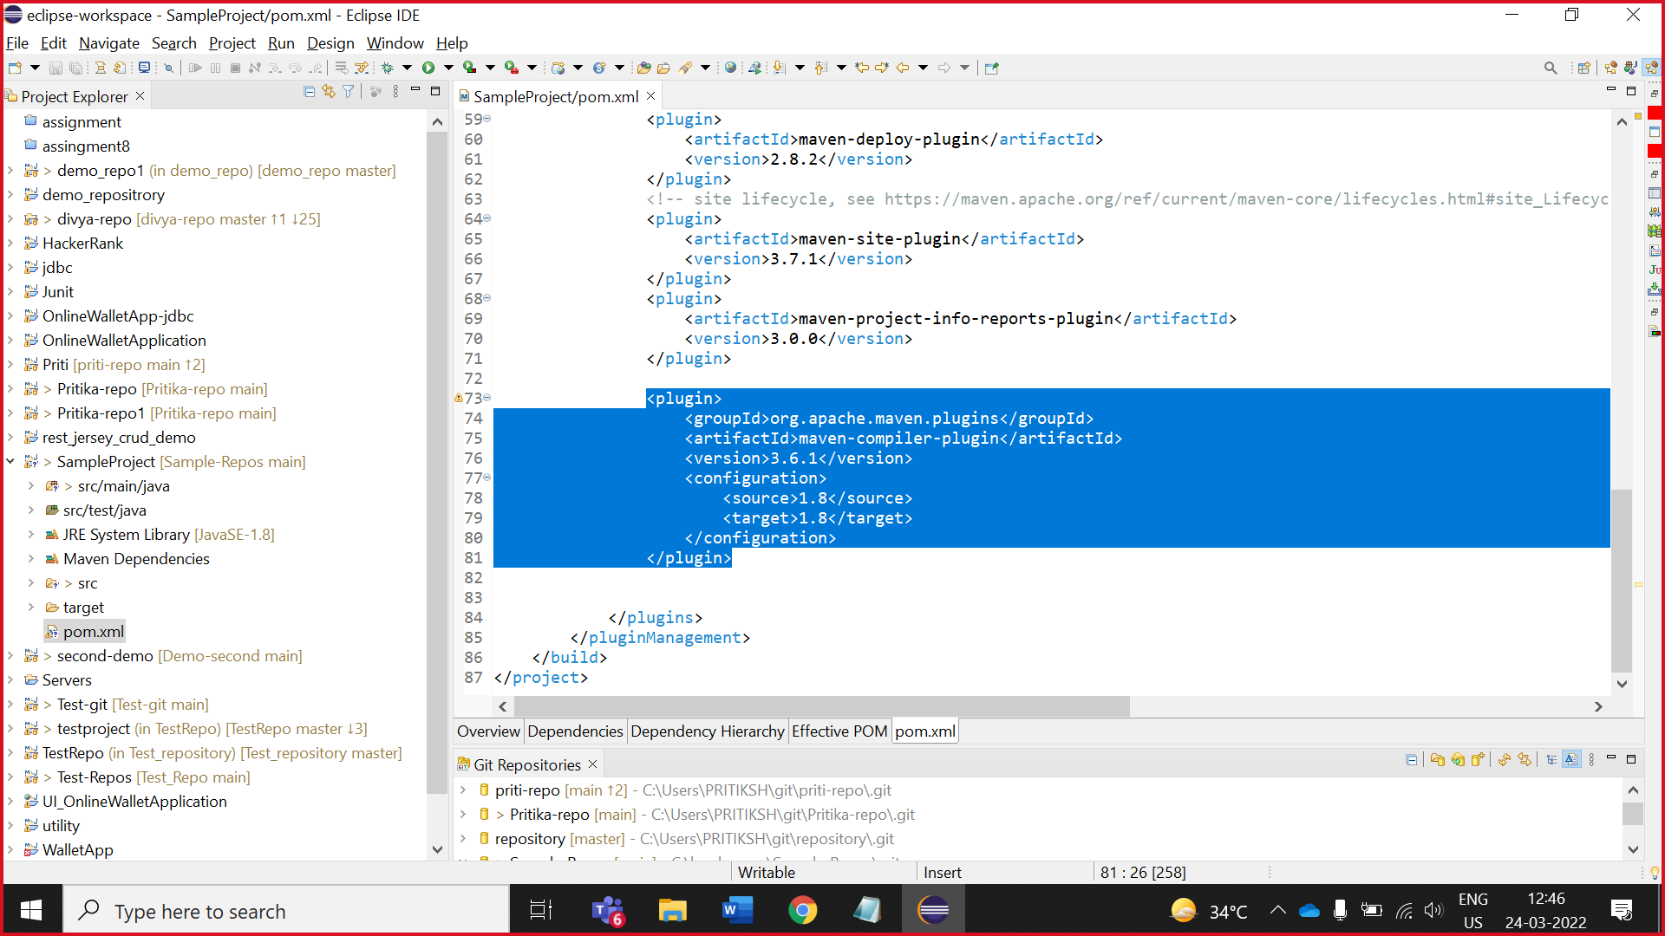

8. Maven update

Right click on project -> maven -> update project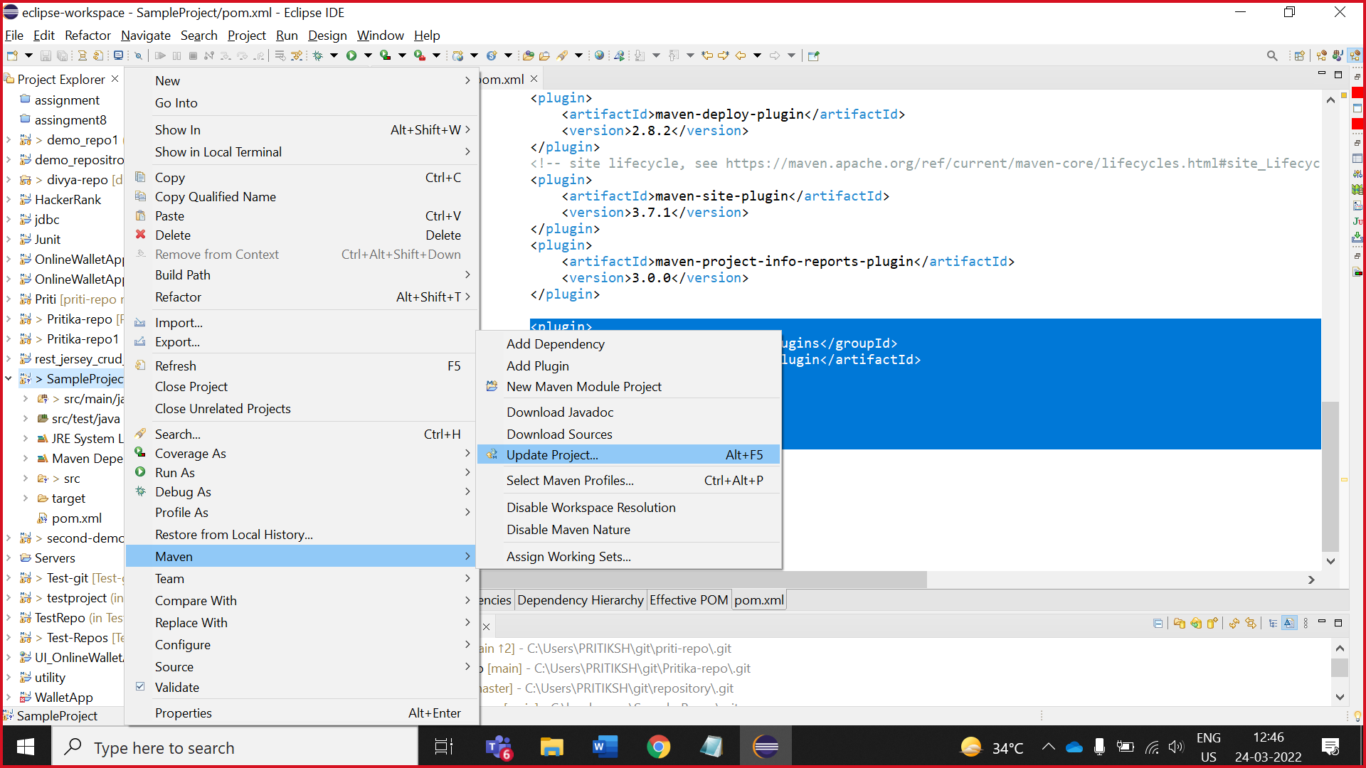

9. tick on force update of snapshopts/release

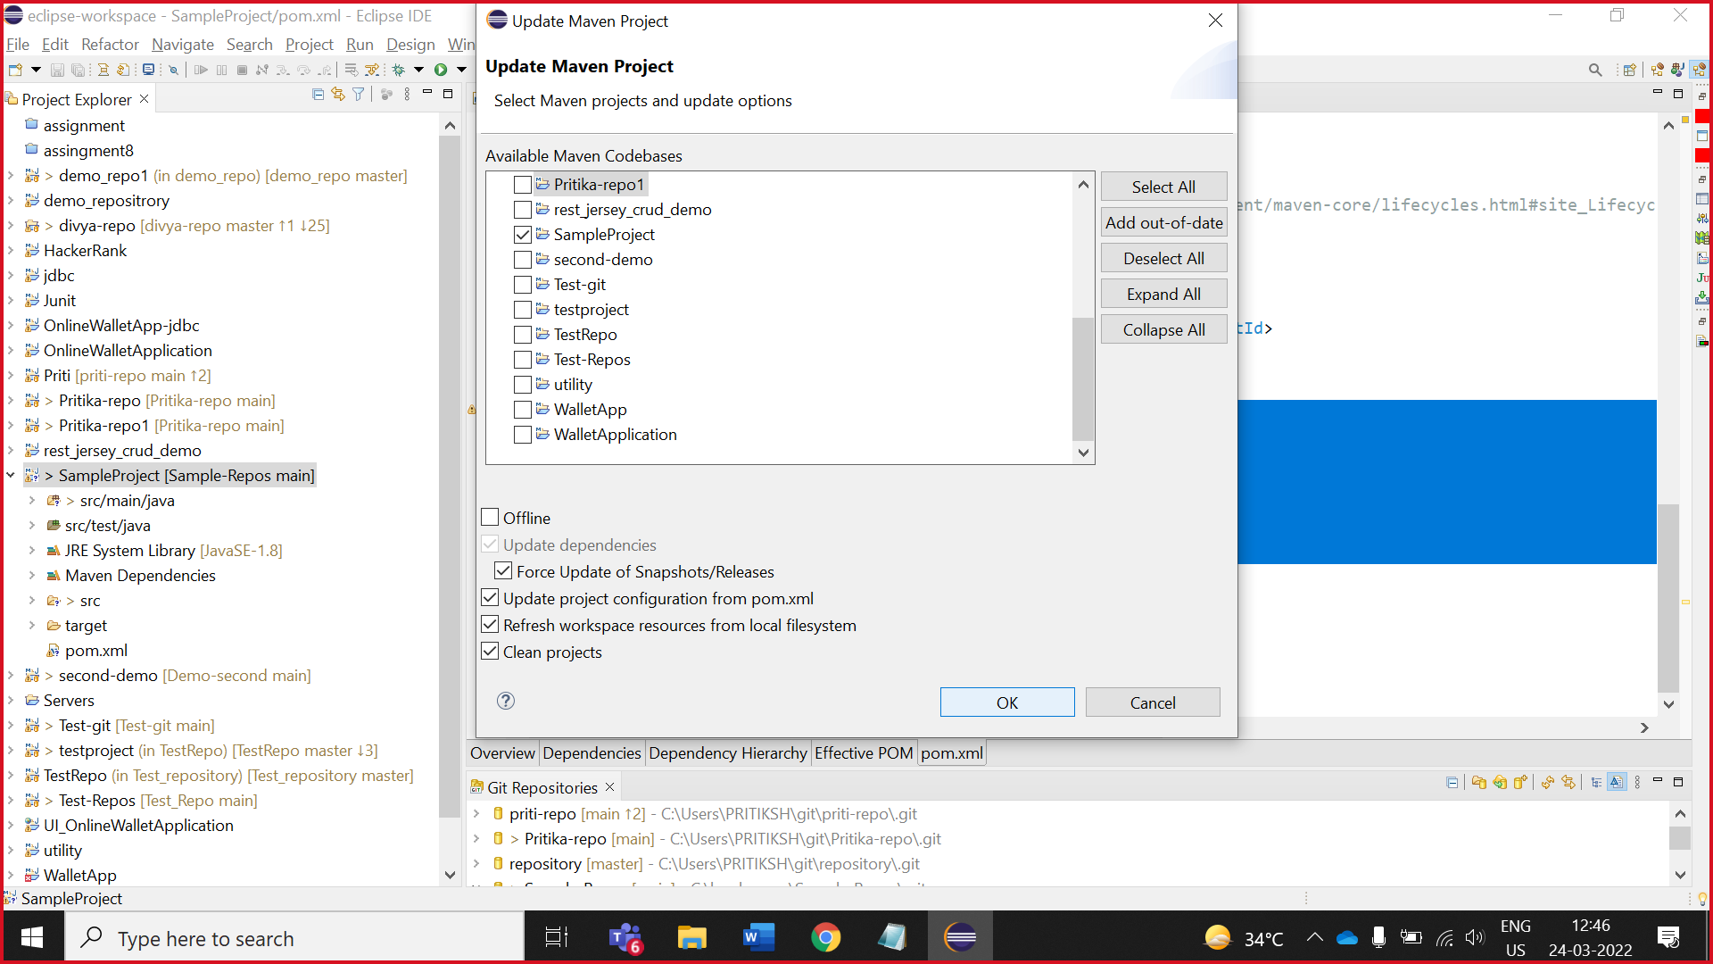

8.Add test-case and Method stub.

And run the test-cases

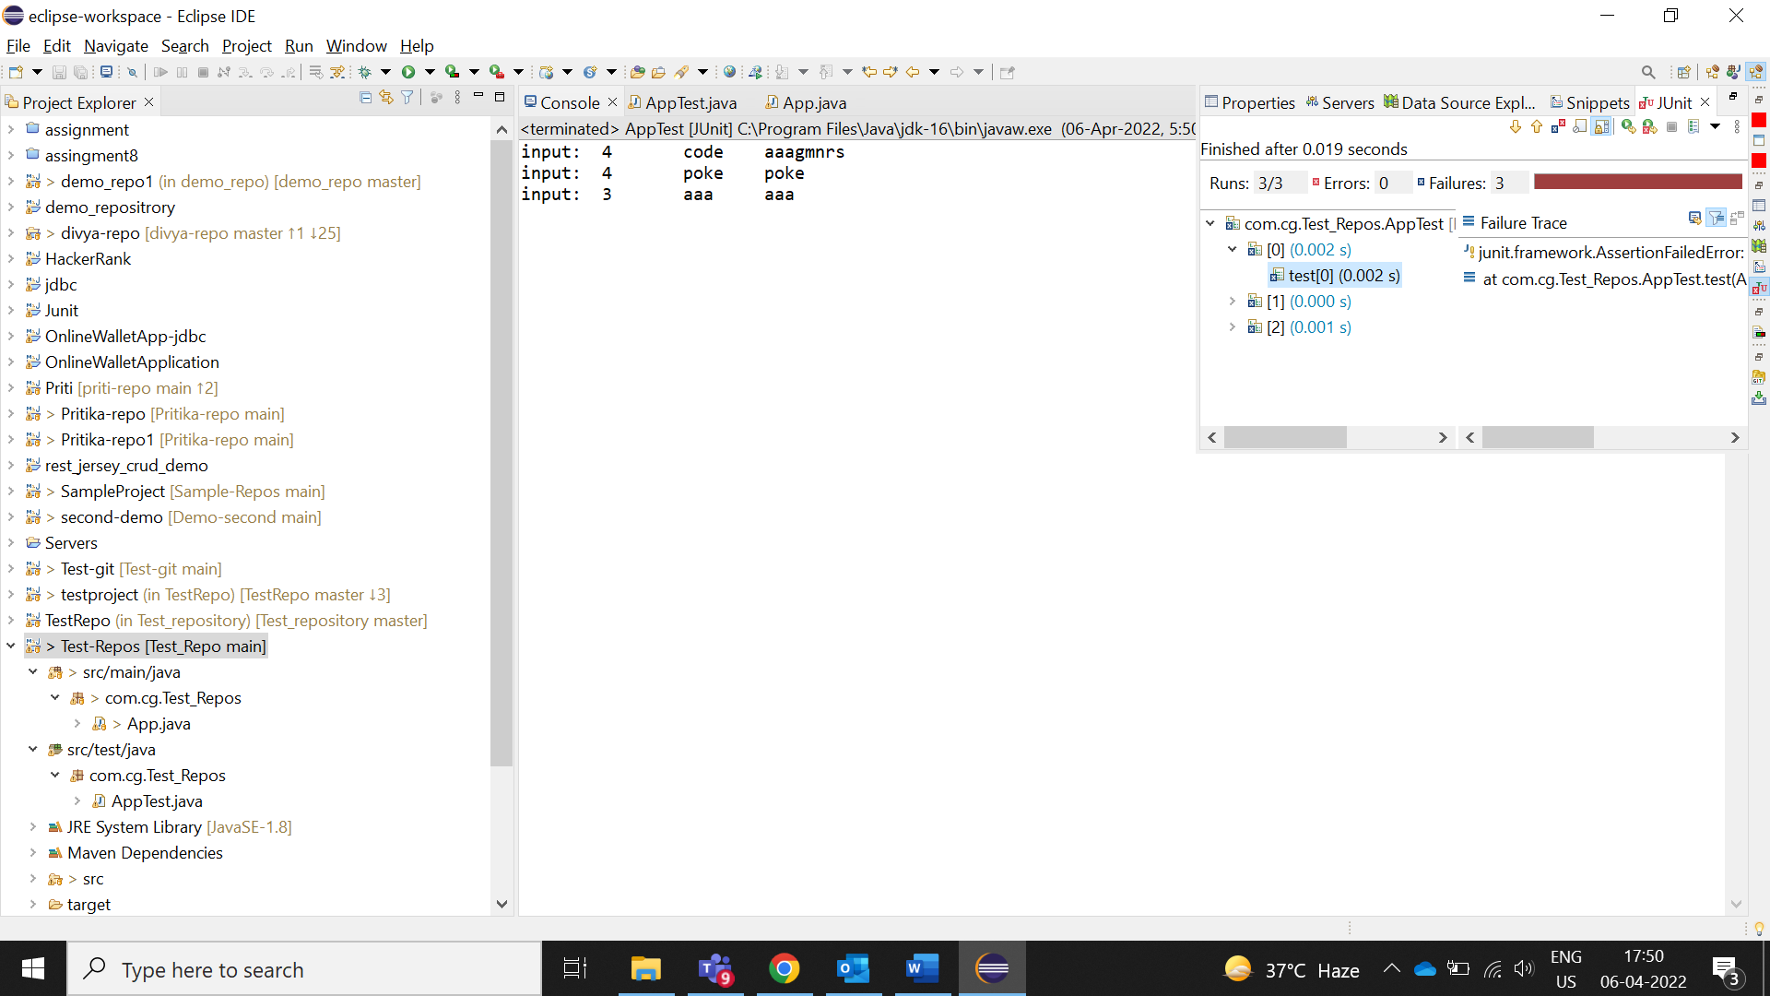

Note: Before collaborator write the code test-cases not pass.

Test-case run successfully depend on collaborator code.

9.Save it and go to the **git stagging**

Git repository -> right click on your repository -> show in -> git stagging

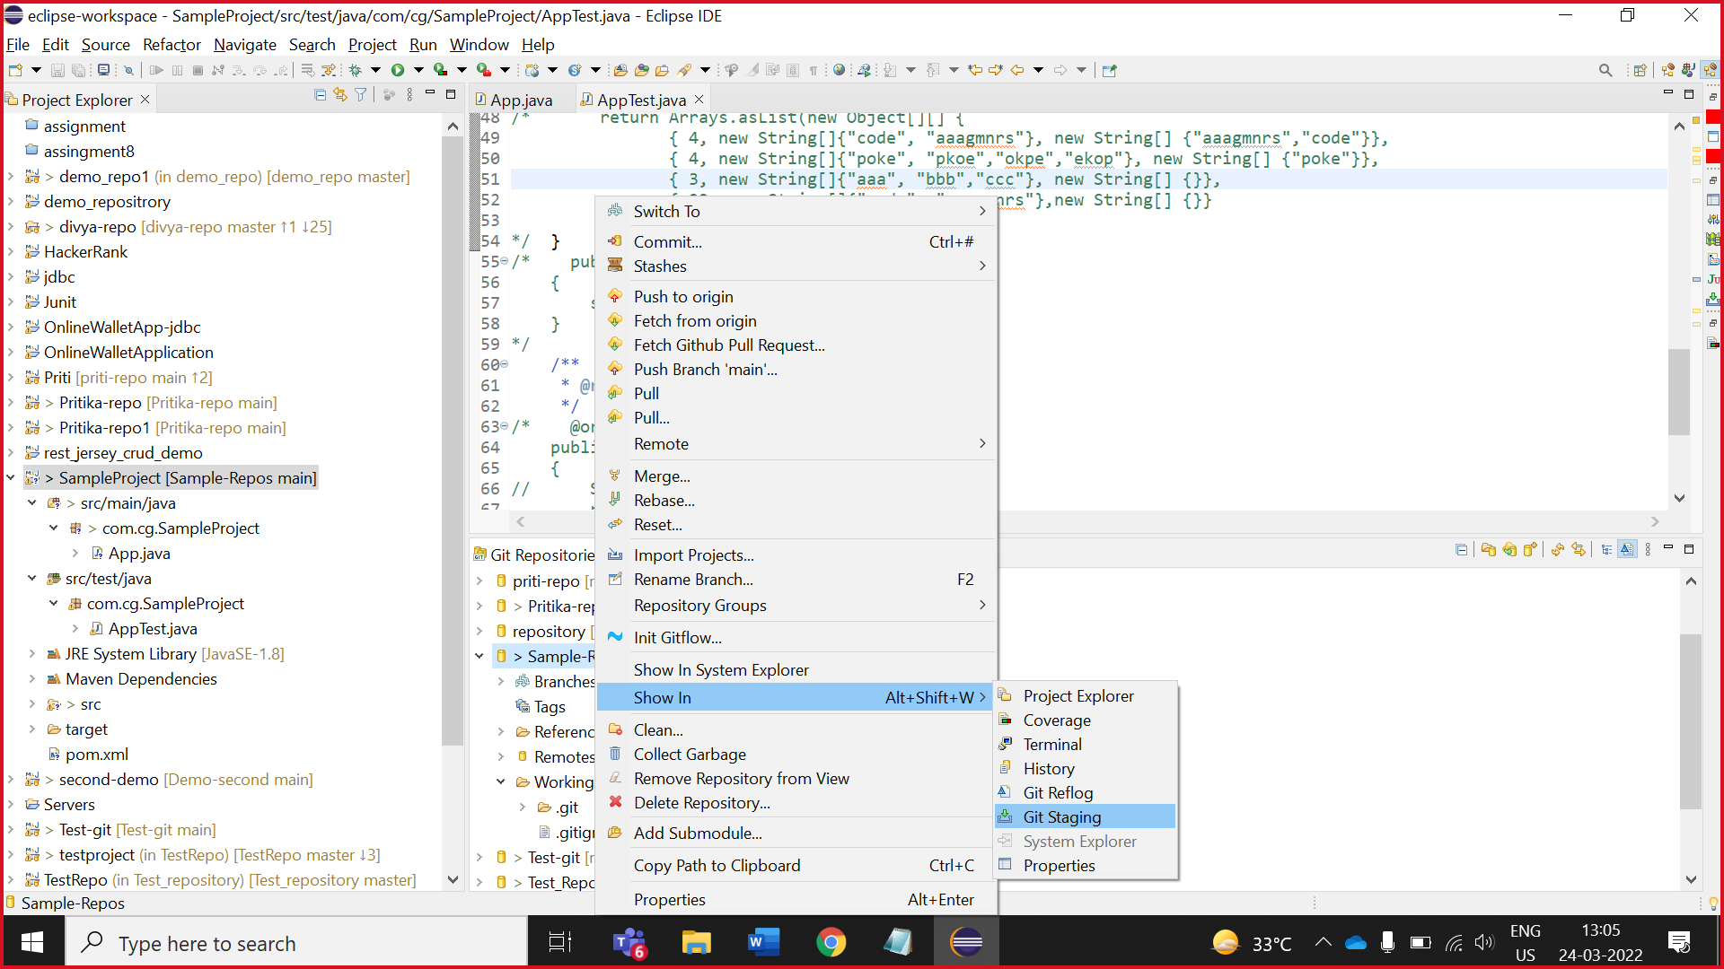

10. Add all file by click on plus mark and don’t add .gitignore file(we made it manually in GitHub).

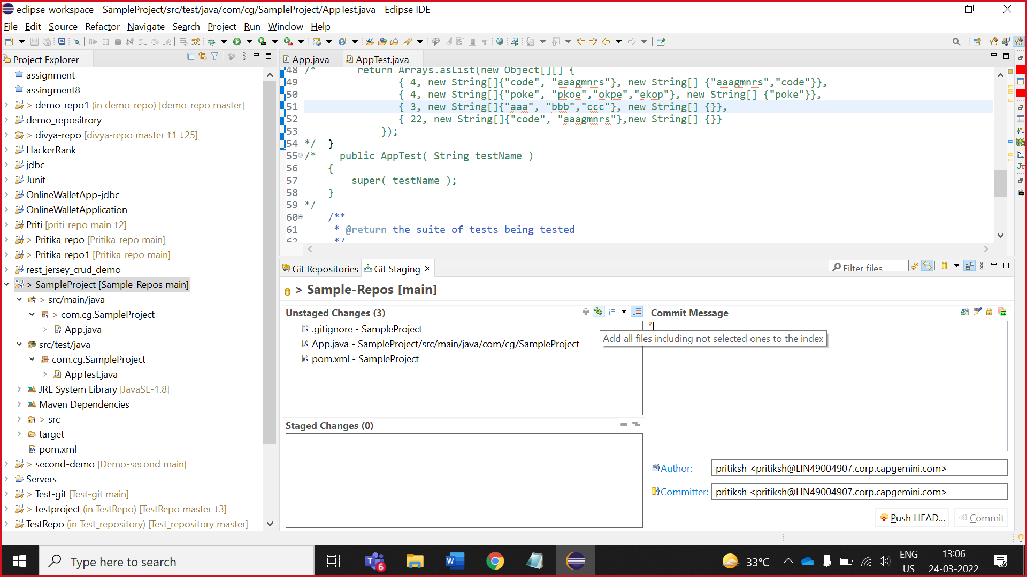

11. Write appropriate comment and click on **commit**.

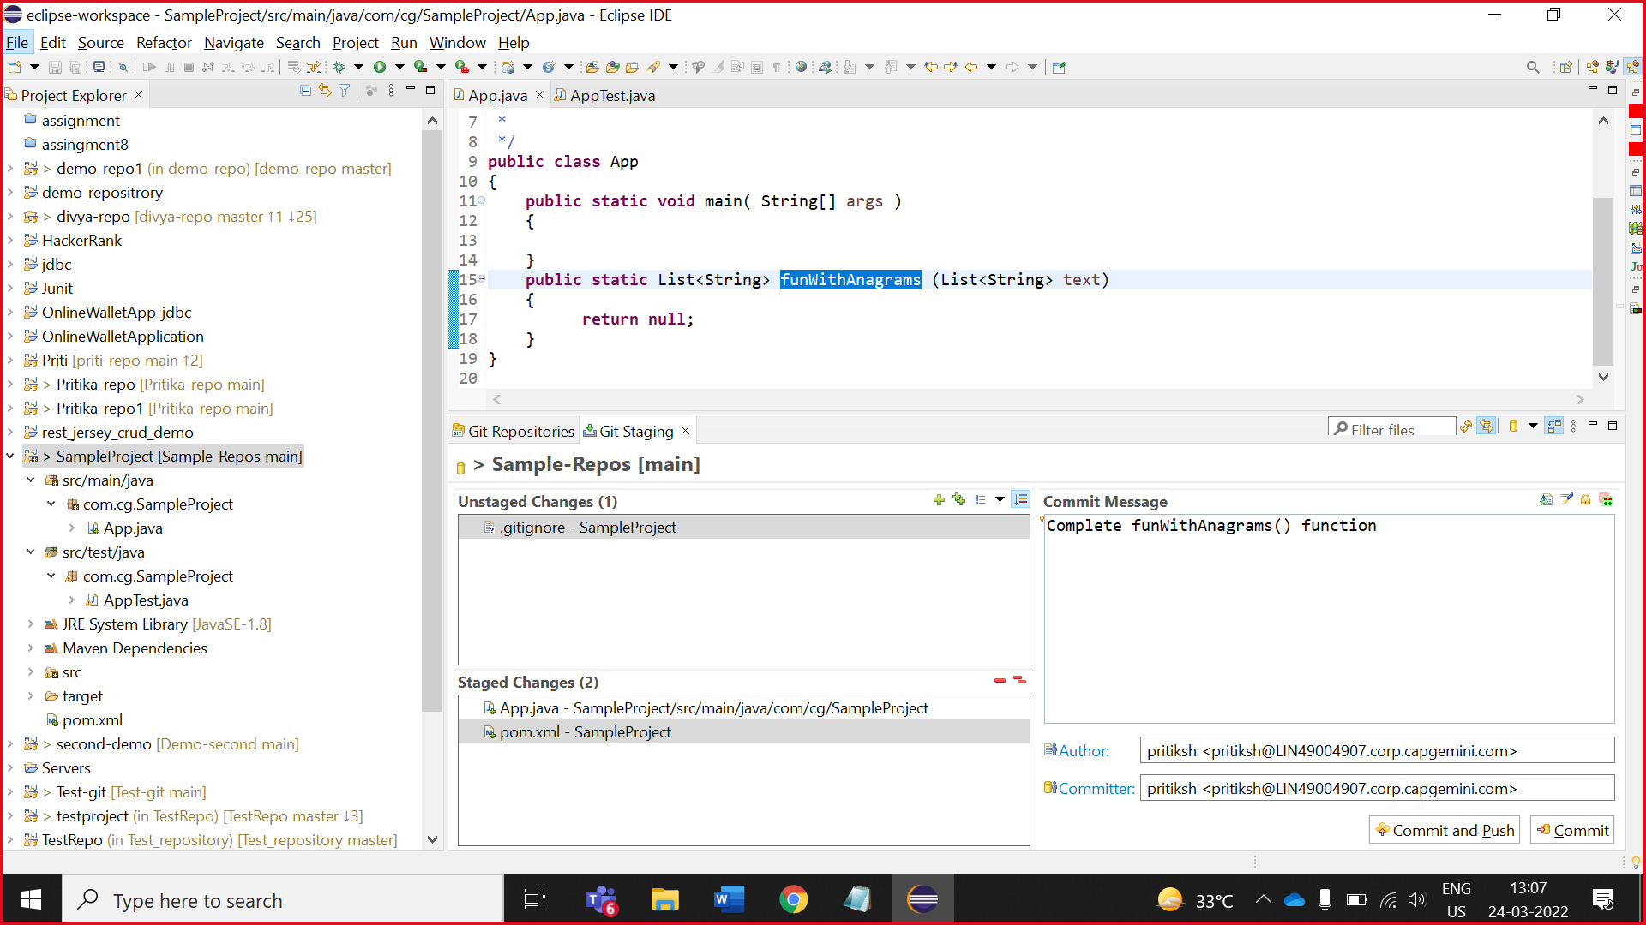

12. And then **push**

Click on preview

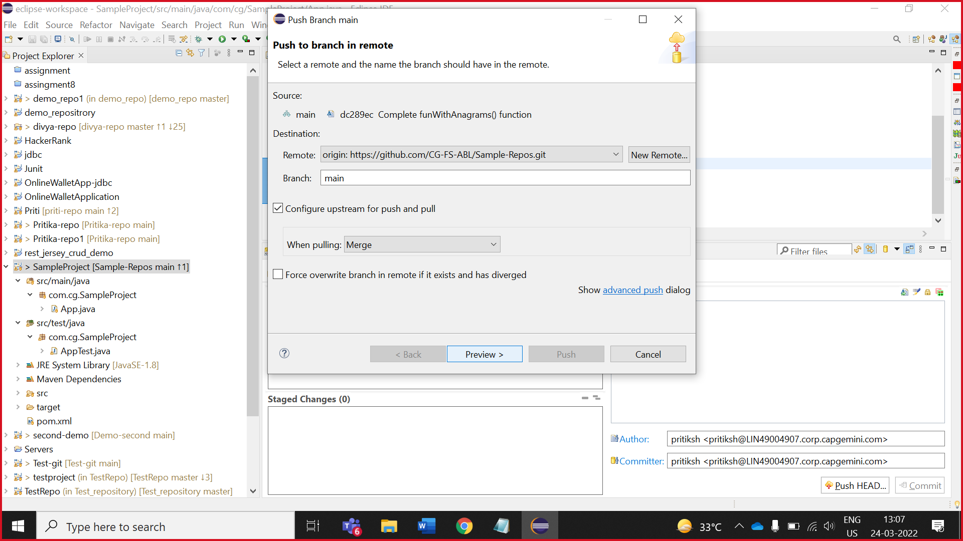

13. click on push

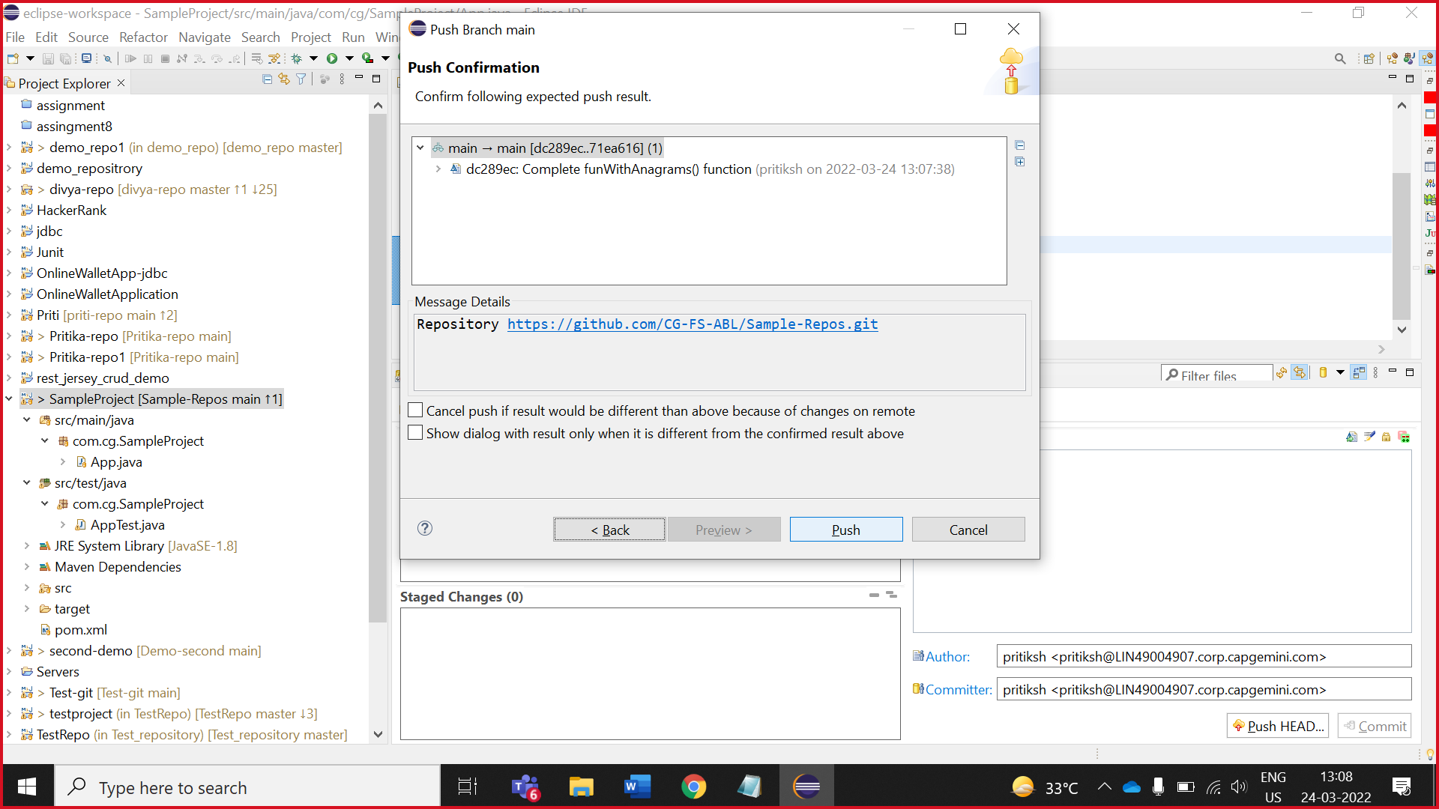

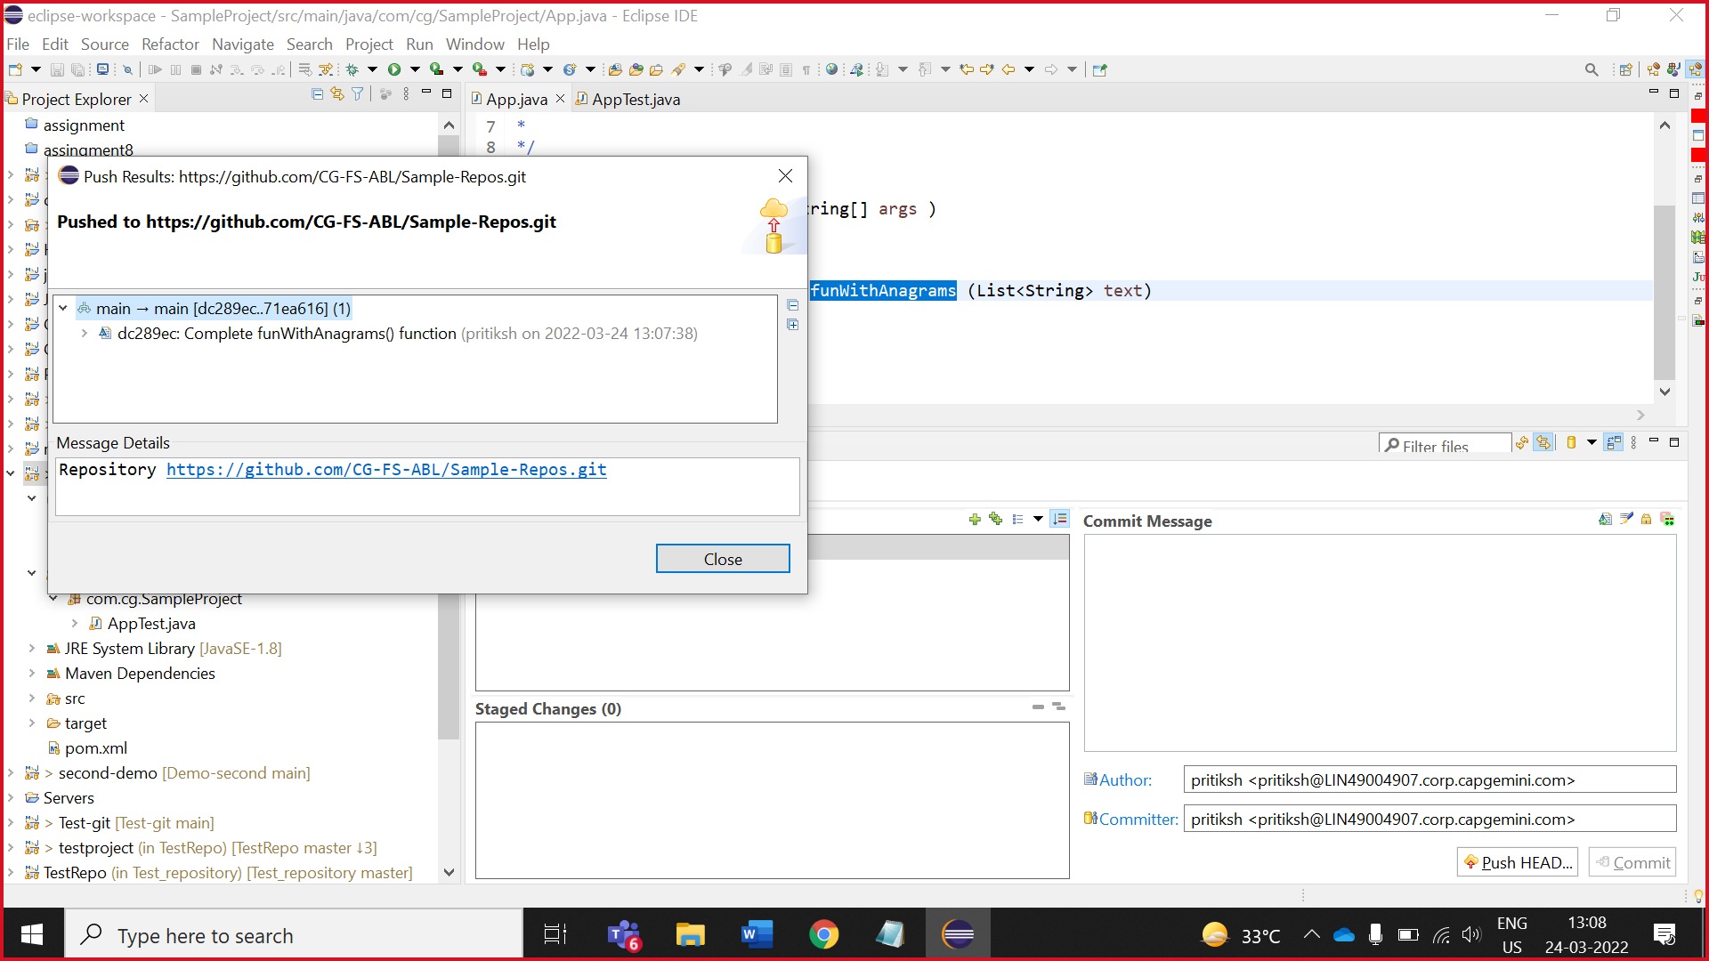

14. Now, check on your github

( code added in you github succefully)

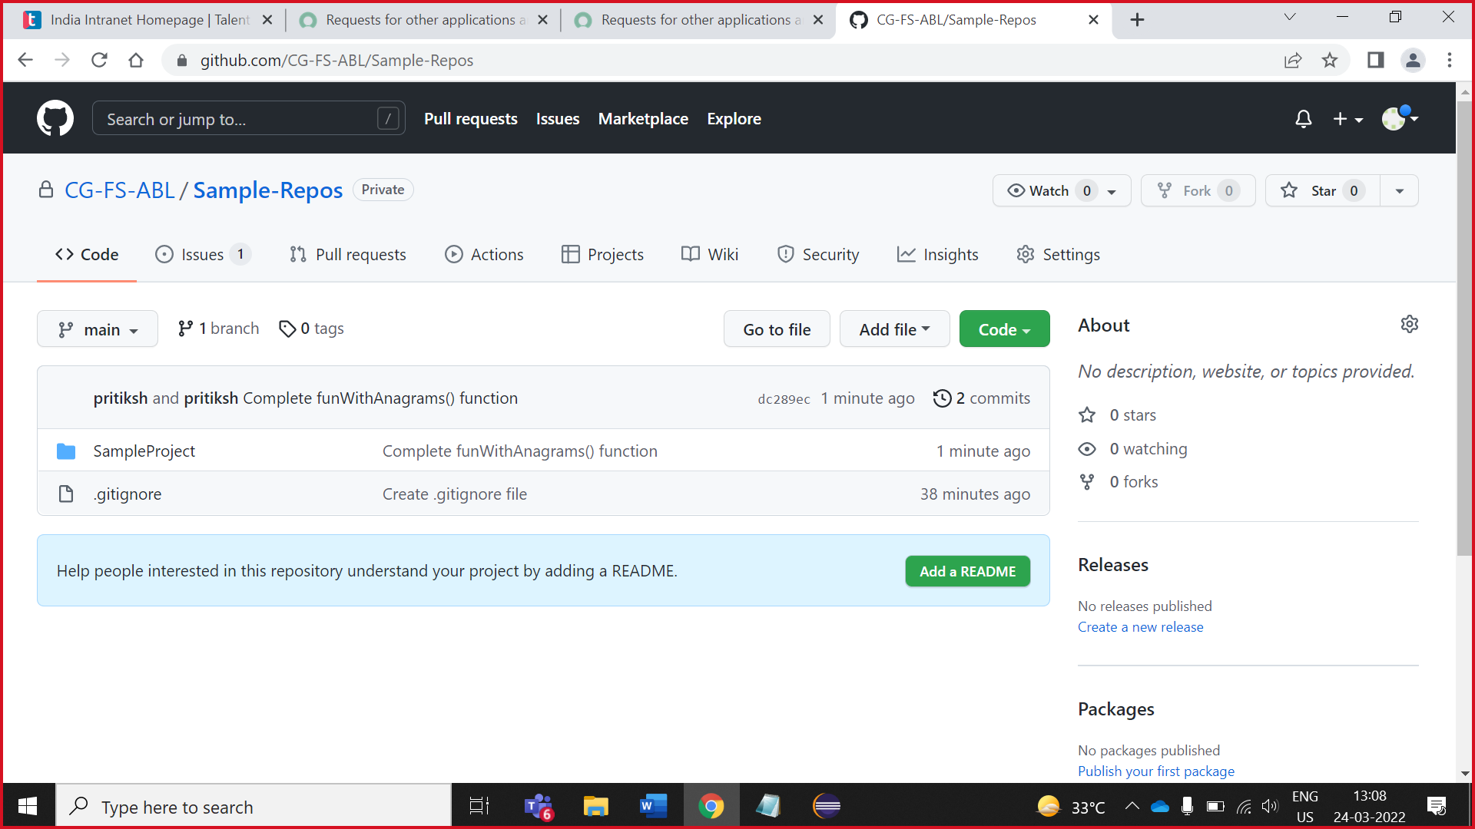

# **Collaborators access the Owner task**



2. Collaborator import the repository project

1.Collaborator copy HTTPS path of repository (created by owner)

1.Collaborator open CG-FS-ABL and click on repository which is made by owner

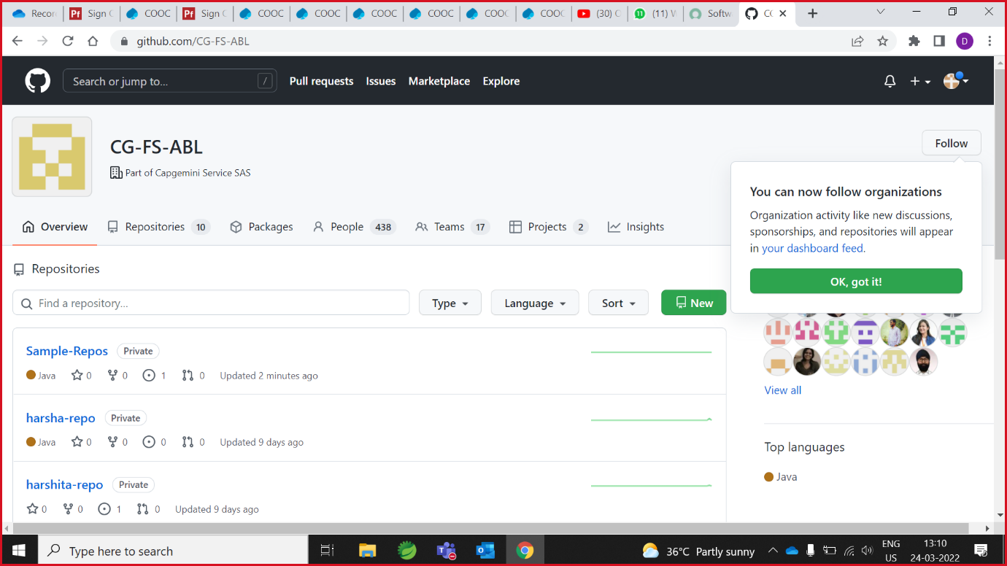

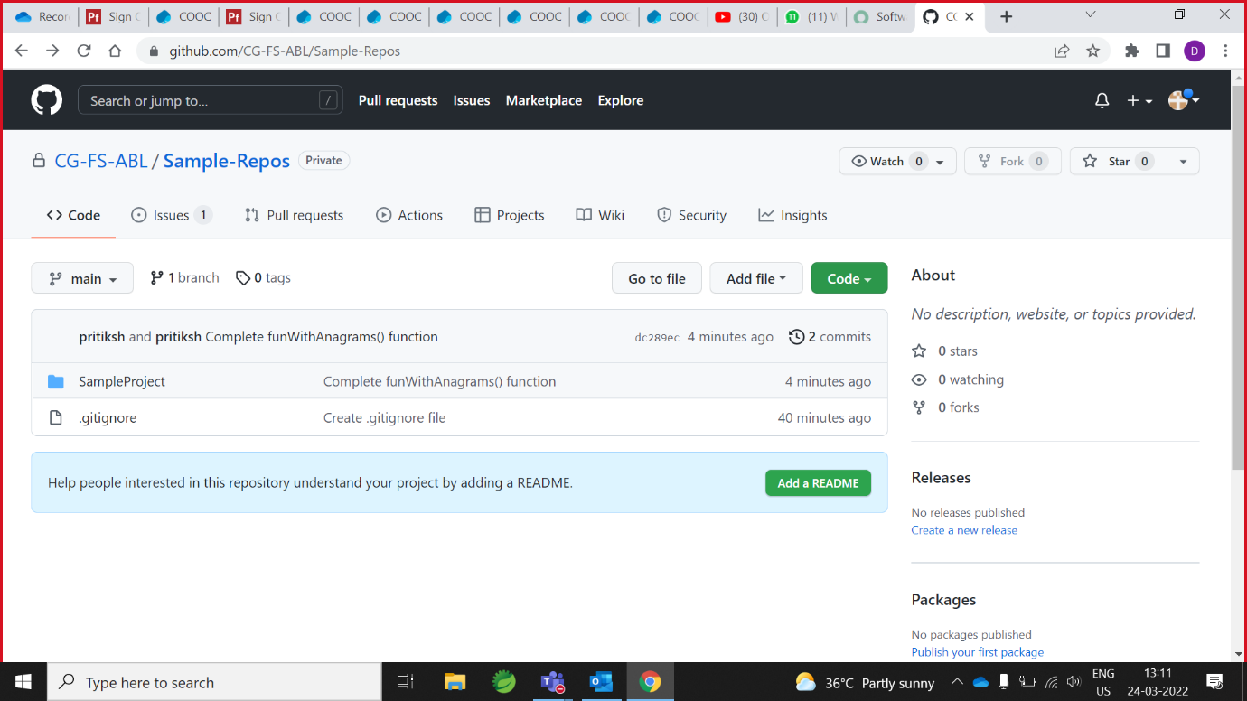

1. Click on code and copy the HTTPS link

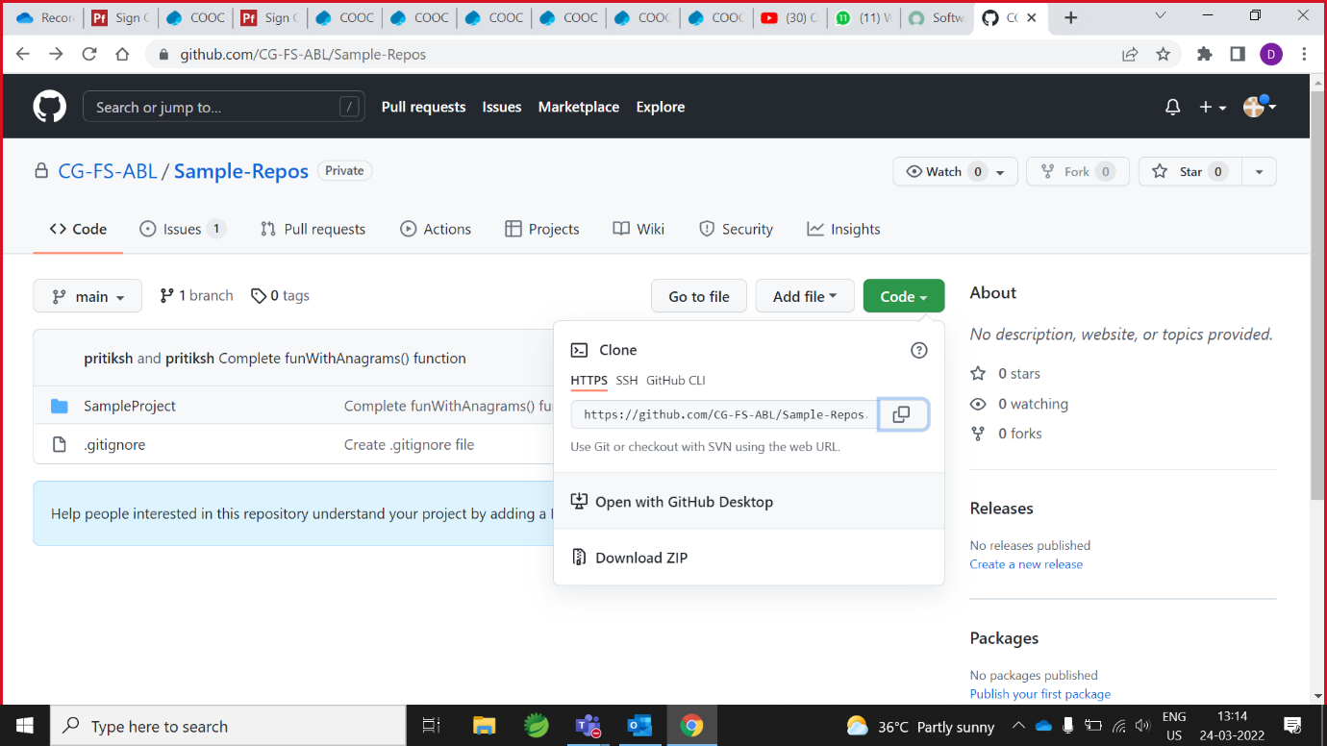

3. open eclipse and search git repository

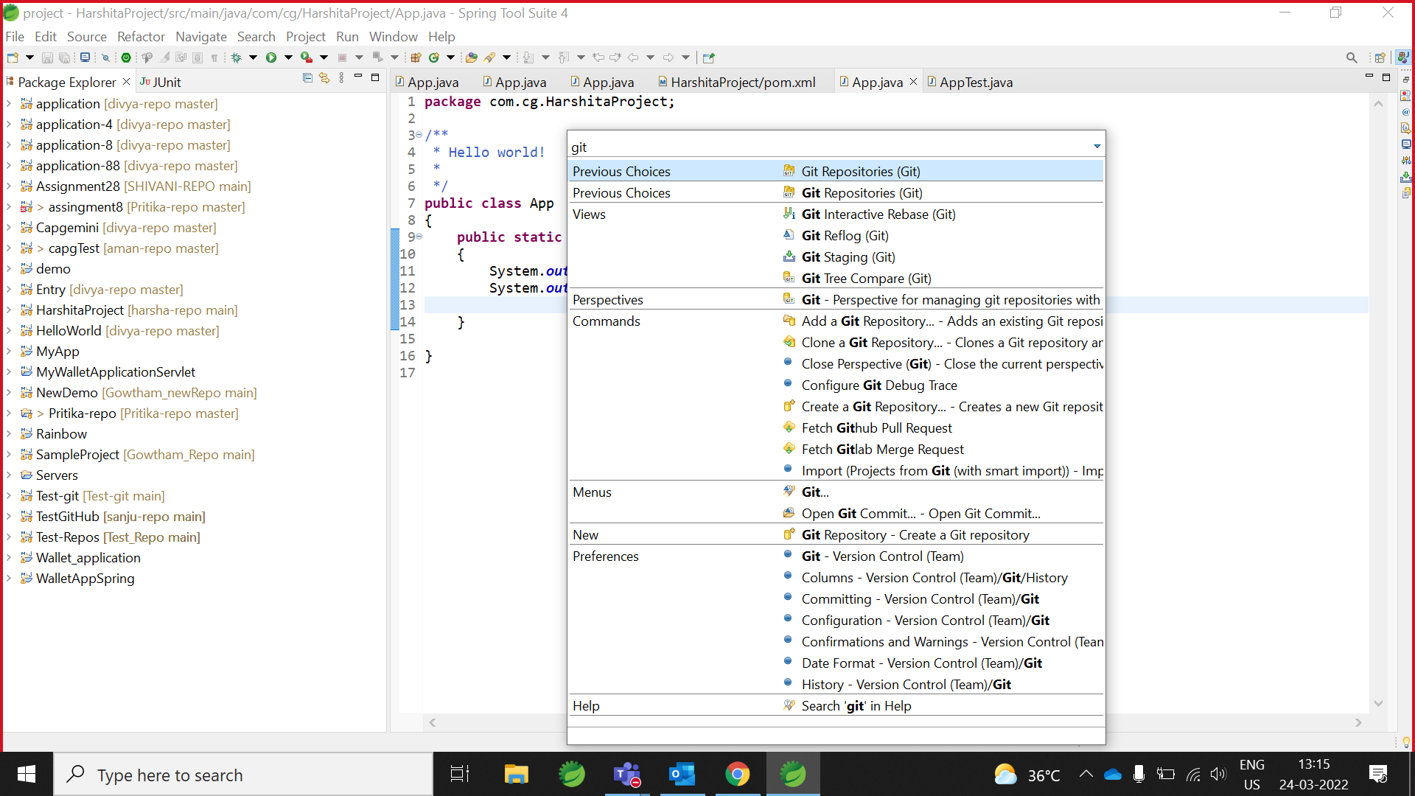

4.Open git repository then, right click and paste the HTTPS path

Enter your user and password

NOTE : password is your token

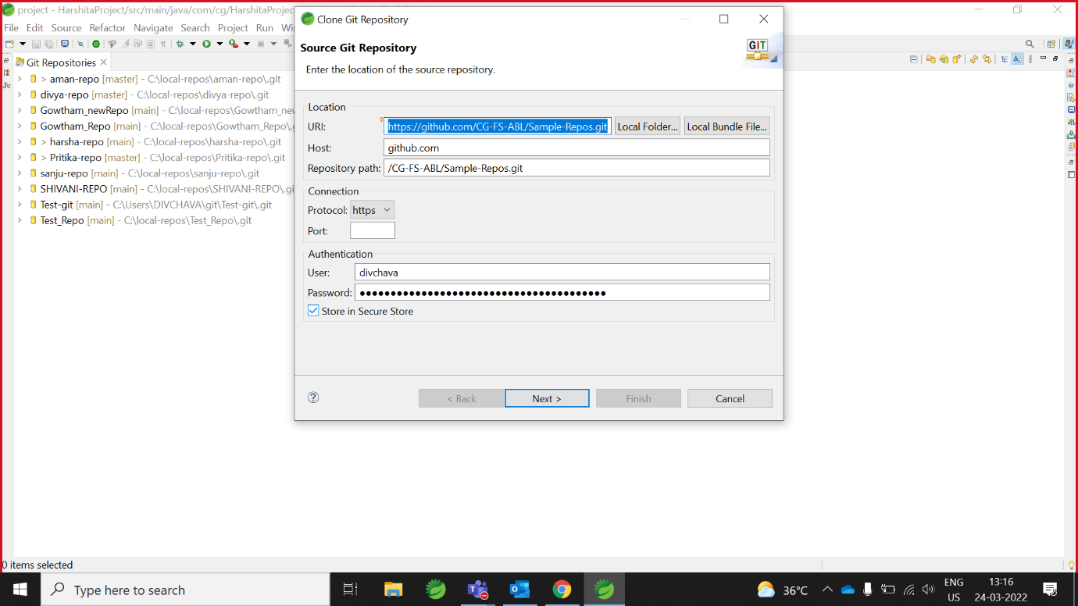

5.Click on **next and change the location**

(First you made the local repository folder in your C:// drive)

And then change the location

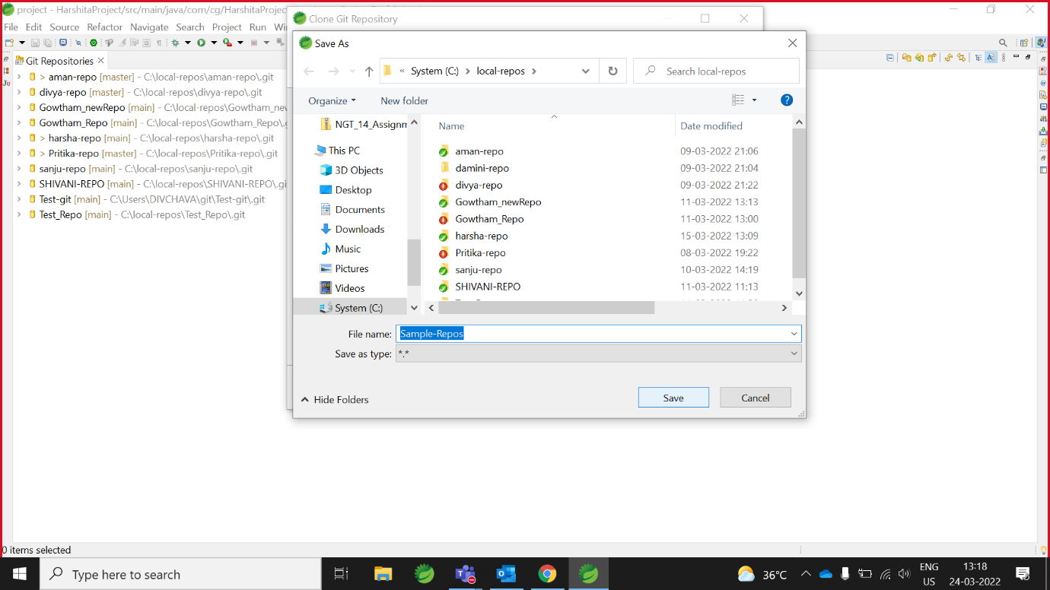

6.Next, then finish.

Owner repository successfully add in collaborator eclipse/site.

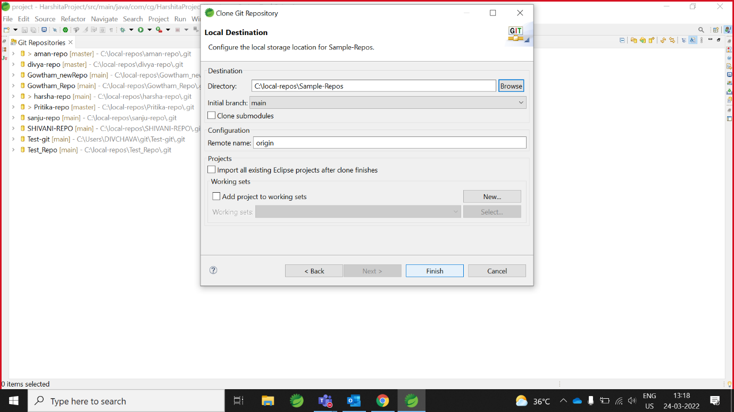

7.git repository -> click on added repository -> working tree -> in project right click -> click on **Import Project**

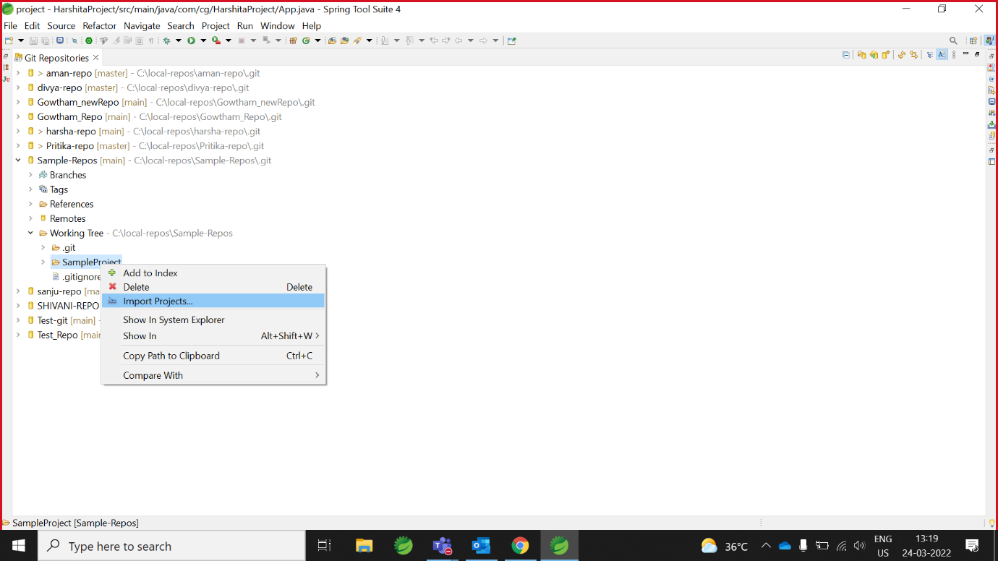

8. click on **finish (maven project imported successfully)**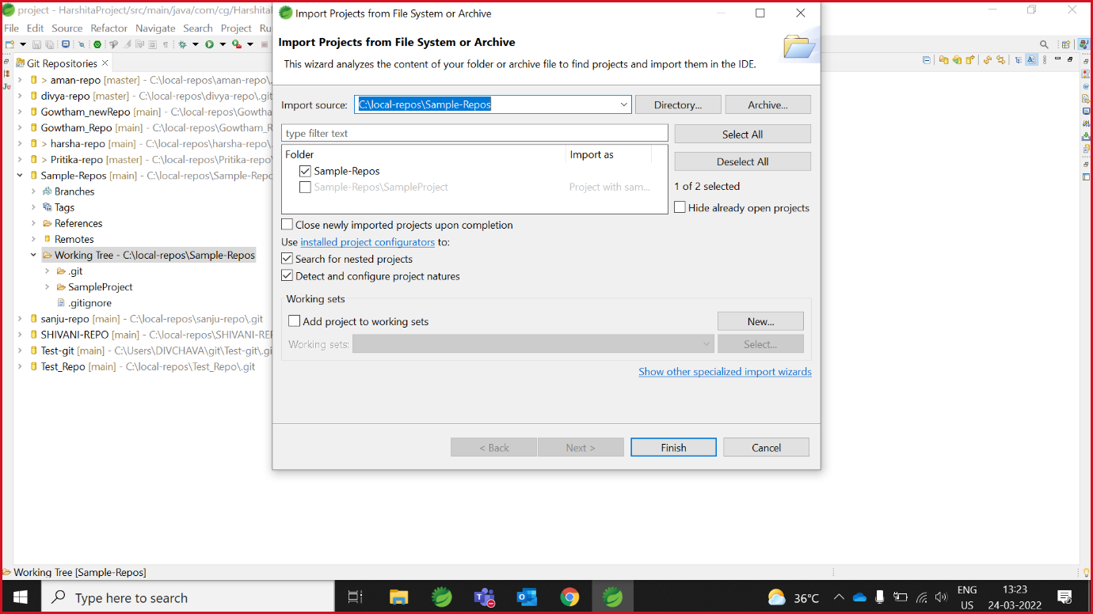

9. open app.java

And complete program/ task (which is assign by Owner).

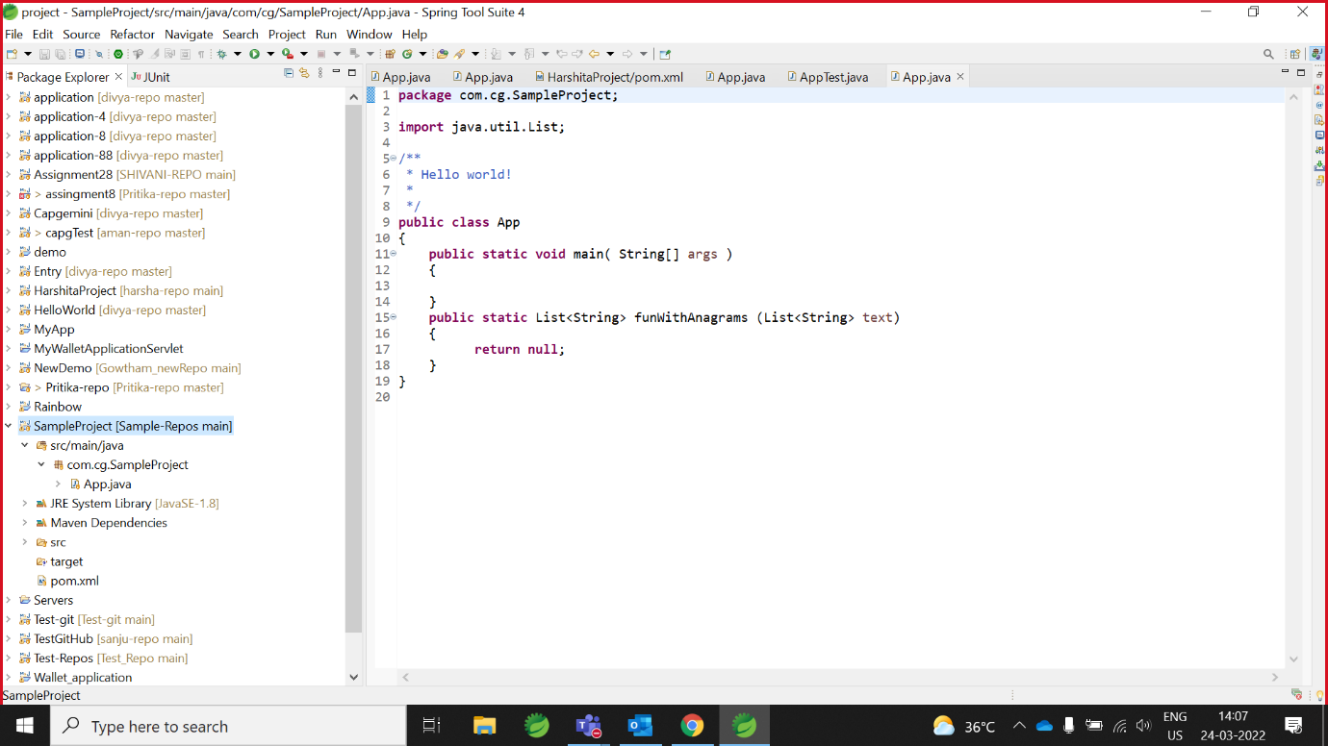

10. collaborator write the code

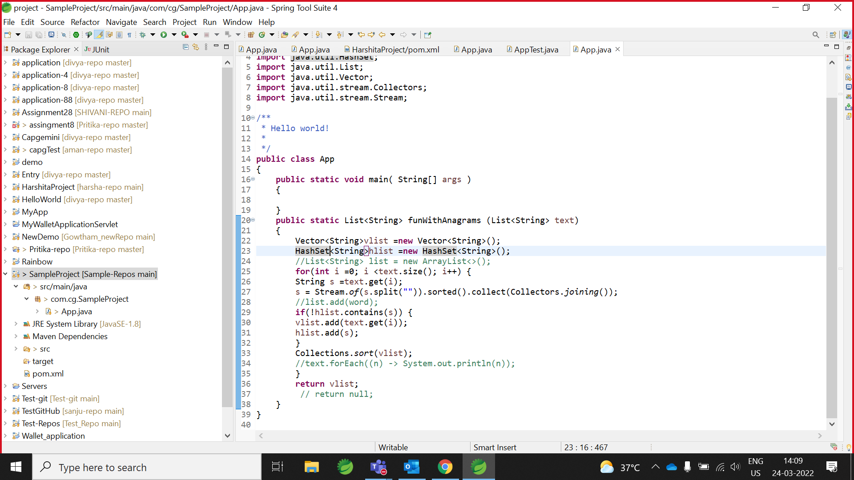

11. right click on project -> show in -> git **staging**

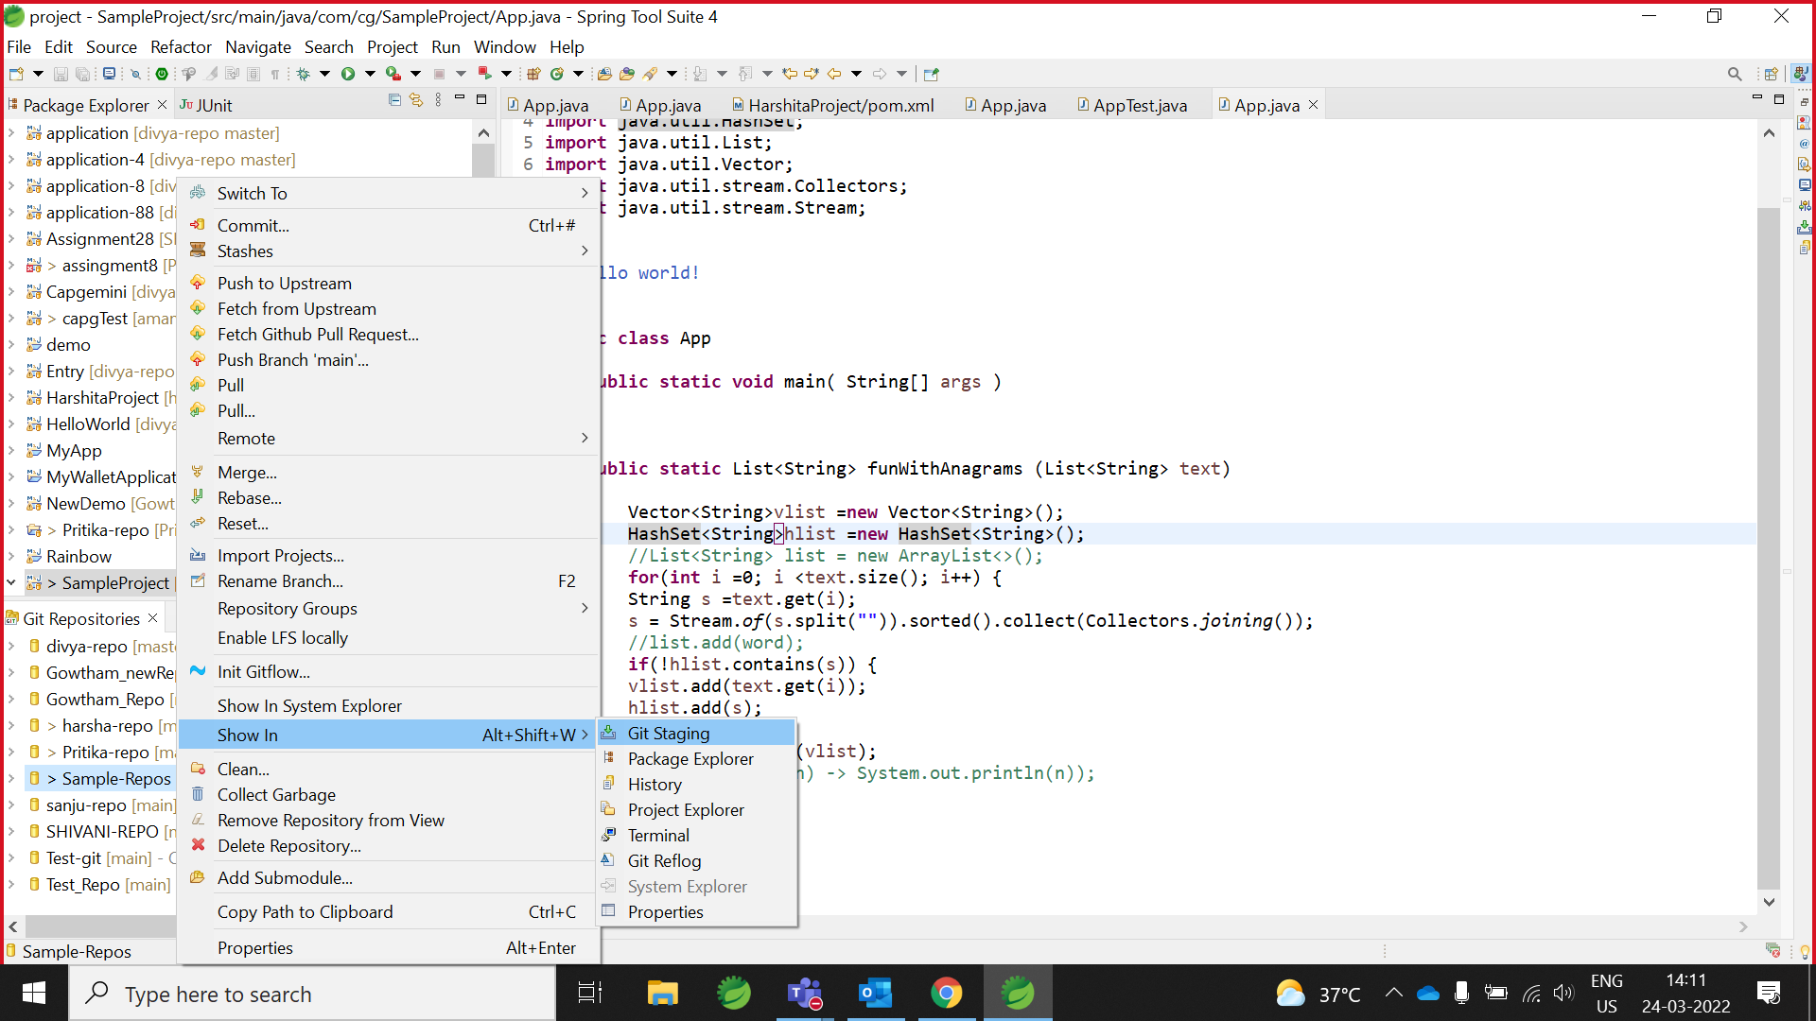

12. open git staging and add app.java file with appropriate comment/message

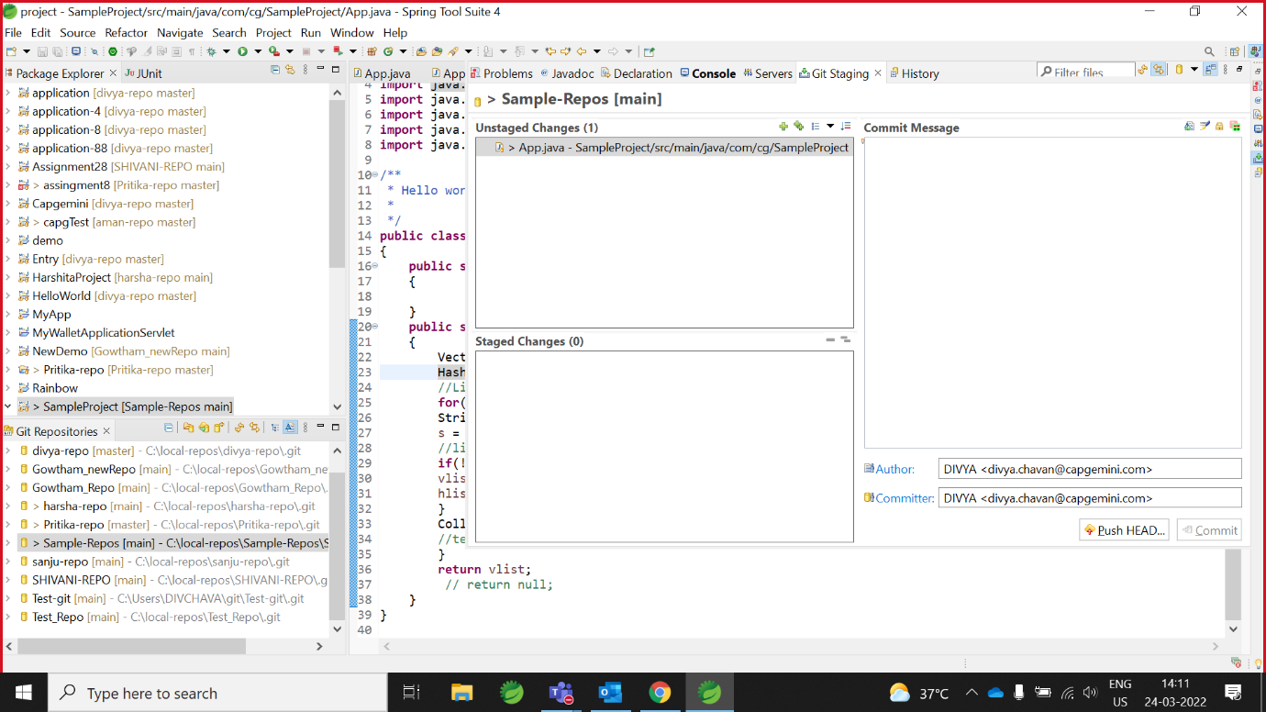Then commit the code/project

13. push the code in GitHub

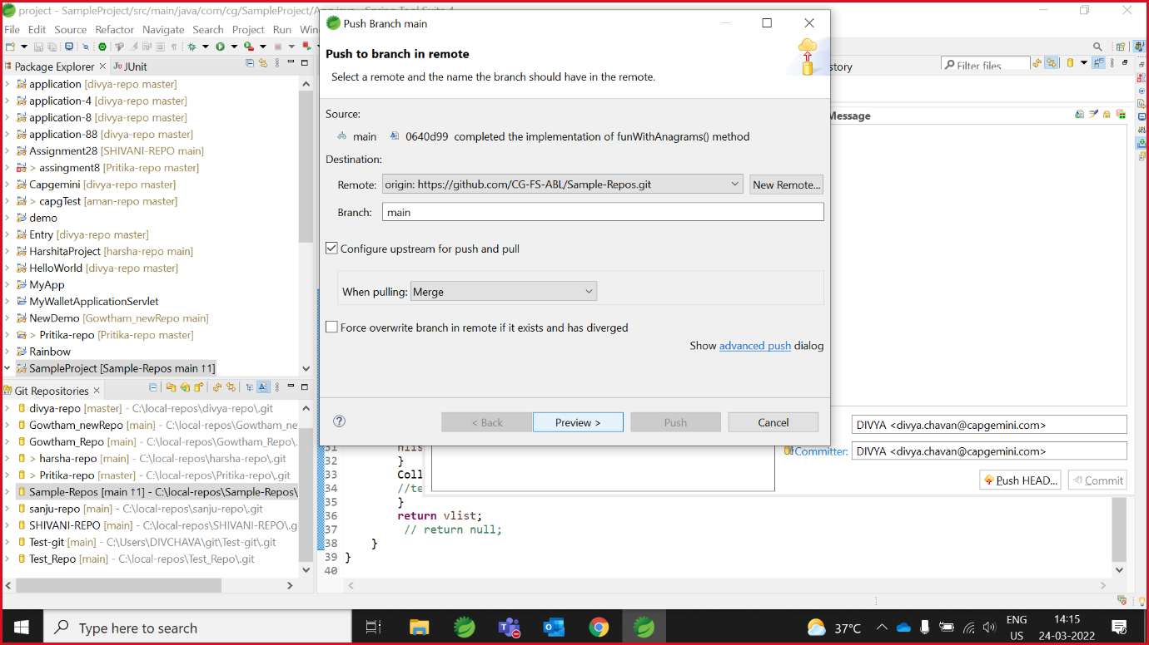

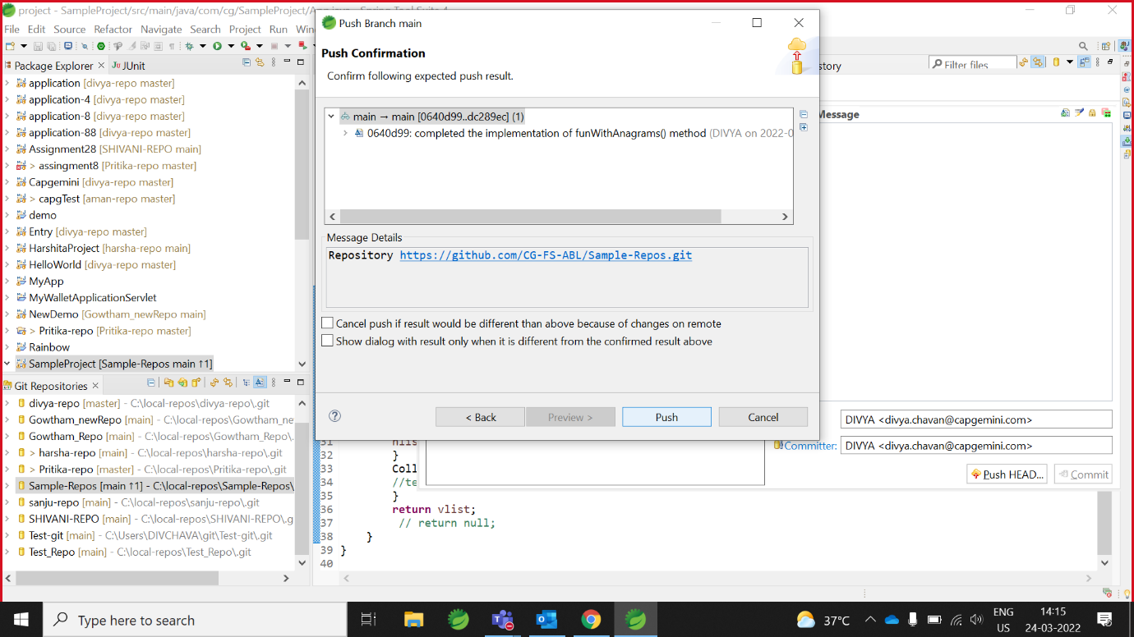

Code reflected on GitHub(which is added by collaborator)

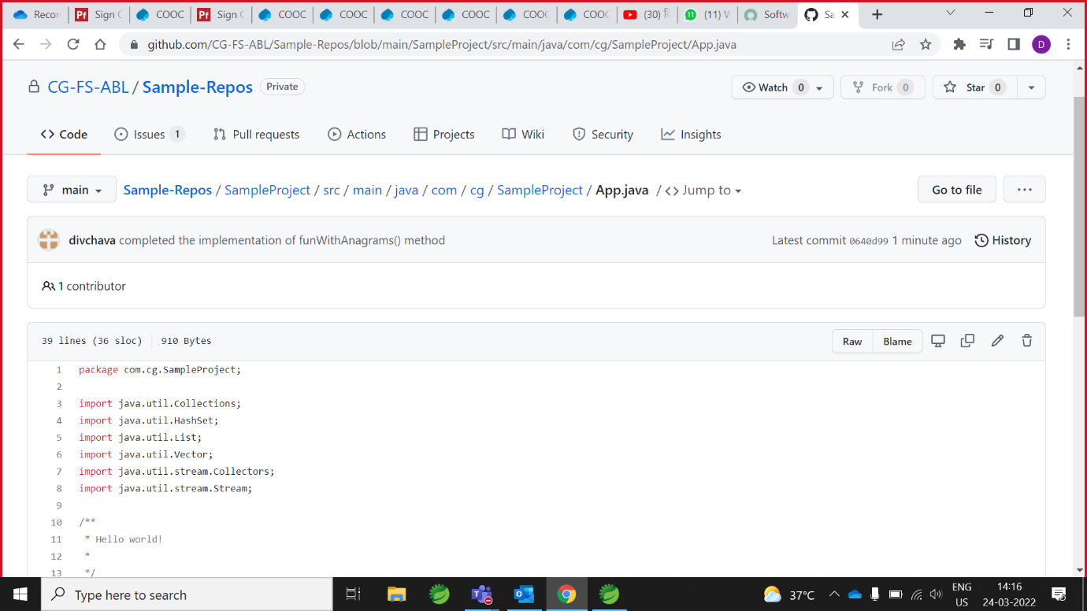

# **Owner pull the code**



Owner pull the collaborator code/work

1.Right click on maven project -> team -> **pull**

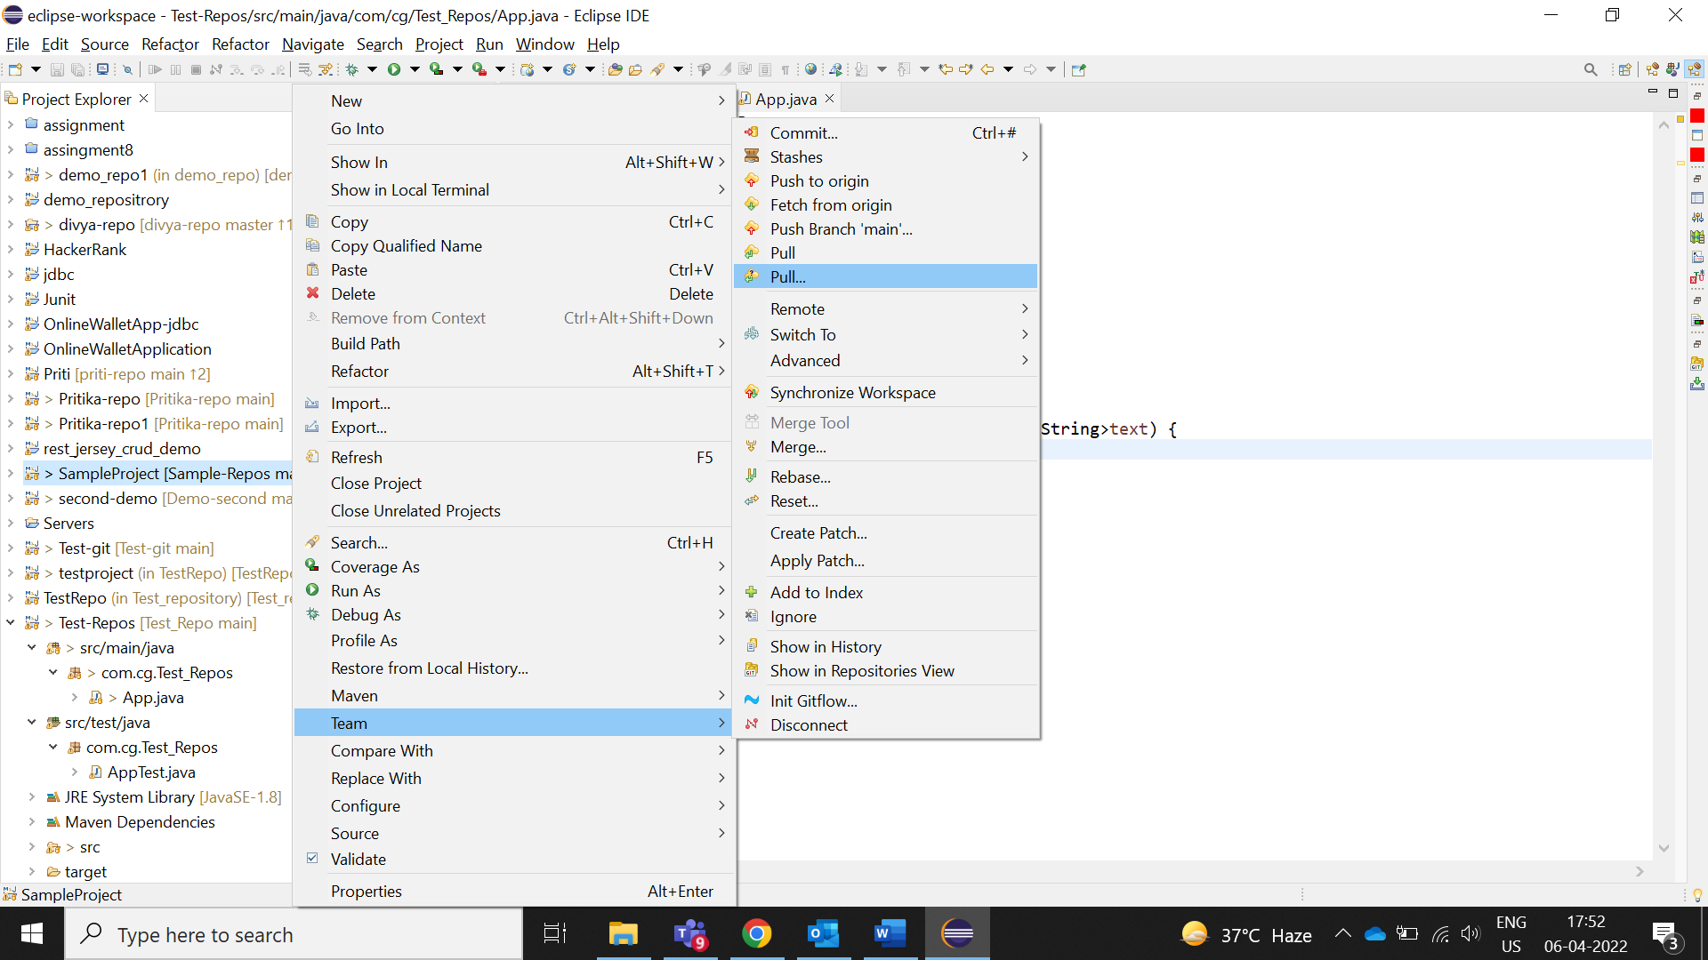

2.Click on pull

Code pulls successfully

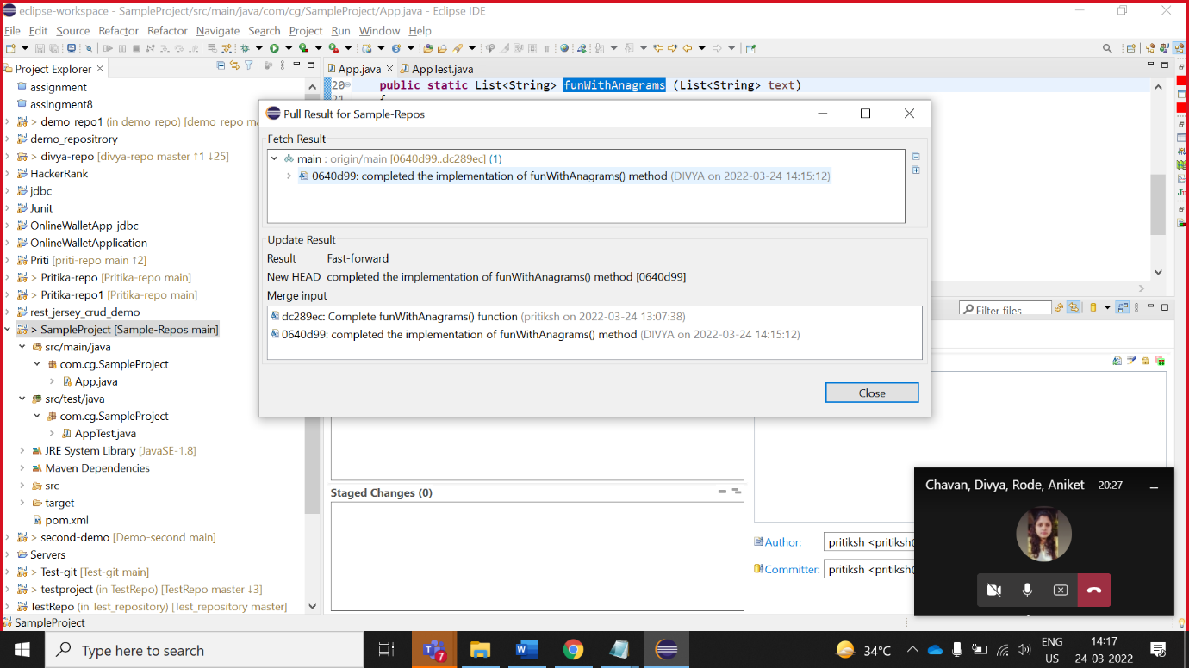

3.below code added by collaborator and owner pull that code

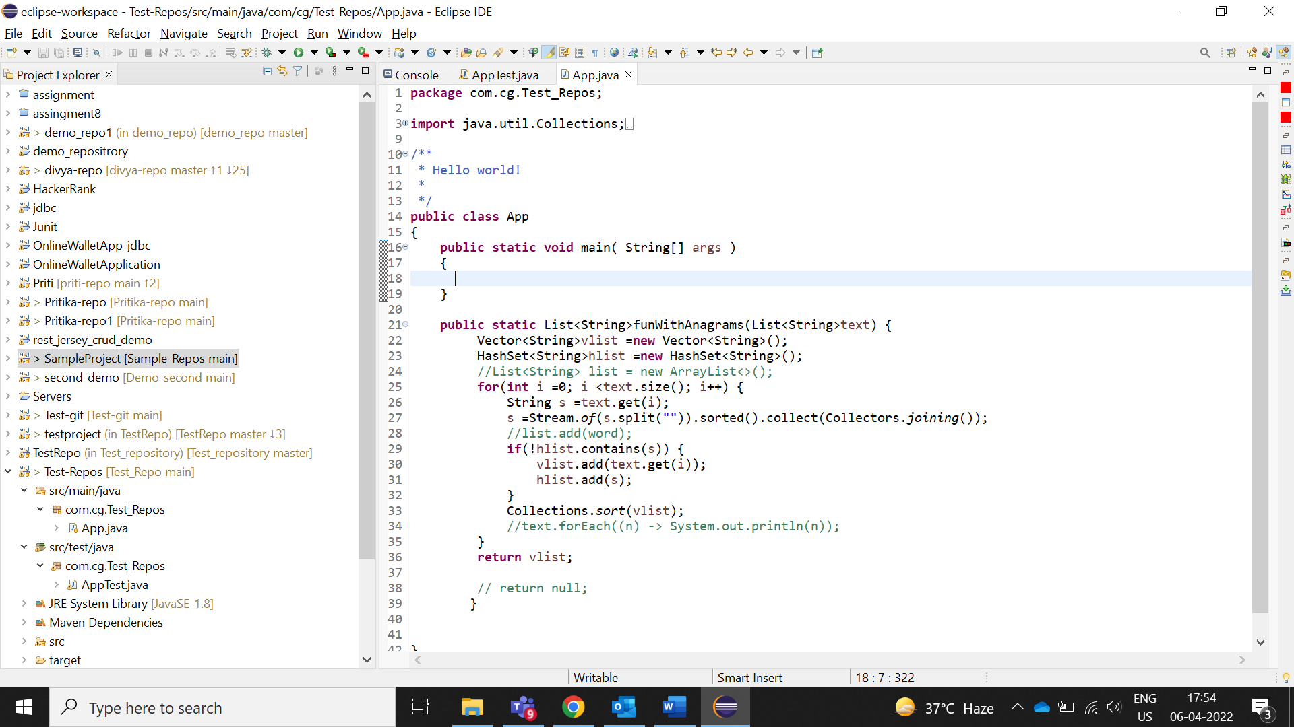

4.Owner run the test-cases

(test-cases run successfully it’s means collaborator wright right code)

